

ITA_ User instruction manual

Ansible-driver

*－* Version 1.9*－*

Copyright © NEC Corporation 2019. All rights reserved.

Disclaimer

All the contents of this document are protected by copyright owned by NEC Corporation.

Unauthorized reproduction or copying of all or part of the contents of this document is prohibited.

The contents of this document are subject to change without prior notice in the future.

NEC Corporation is not responsible for any technical or editorial errors or omissions in this document.

NEC Corporation do not guarantee accuracy, usability, certainty of the content in this document.

Trademark

* Linux is registered trademark or trademark of Linus Torvalds, registered in the U.S. and other countries.
* Red Hat is registered trademark or trademark of Red Hat, Inc., registered in the U.S. and other countries.
* Apache、Apache Tomcat、Tomcat are registered trademarks or trademarks of Apache Software Foundation.
* Ansible is a registered trademark or trademark of Red Hat, Inc.
* AnsibleTower is a registered trademark or trademark of Red Hat, Inc.

The names of other systems, company name and products mentioned in this document are registered trademarks or trademarks of their respective companies.

The ® mark and TM mark is not specified in this document.

※「Exastro IT Automation」is written as「ITA」in this document.

Table of contents

Table of contents 2

Introduction 4

1 Overview of Ansible driver 5

1.1 About Ansible 5

1.2 About AnsibleTower 5

1.3 About Ansible driver 6

2 Variable handling in Ansible driver 7

2.1 Variable type 7

2.2 Extract variables and register specific values 10

2.3 Variable handling according to substitution value registration 12

3 Ansible driver console menu configuration 13

3.1 Menu/screen list 13

4 Ansible driver operation procedure 15

4.1 Workflow 15

4.1.1 Workflow of Ansible-Legacy 15

4.1.2 Workflow of Ansible-Legacy Role 18

4.1.3 Workflow of Ansible-Pioneer 21

5 Ansible driver　function・operation method explanation 25

5.1 Basic console 25

5.1.1 Device list 25

5.1.2 Input operation list 30

5.2 Ansible common console 31

5.2.1 Interface information 31

5.2.2 Ansible Tower host list 36

5.2.3 Global variable list 38

5.2.4 Template list 40

5.2.5 File list 44

5.2.6 Collection interface information 46

5.2.7 Collection item value list 46

5.3 Ansibel-Legacy／Legacy Role／Pioneer console 47

5.3.1 OS type master 47

5.3.2 Movement list 49

5.3.3 Playbook file list (Ansible-Legacy only) 53

5.3.4 Role package list (Ansible-Legacy Role only) 55

5.3.5 Dialog type list (Ansible-Pioneer only) 57

5.3.6 Dialog files (Ansible-Pioneer only) 59

5.3.7 Movement details 61

5.3.8 Nested variable list (Ansible-Legacy Role only) 63

5.3.9 Substitution value auto-registration setting 66

5.3.10 Target host 72

5.3.11 Substitution value list 73

5.3.12 Check operation status 79

5.3.13 Execution list 82

5.3.14 Execution 83

6 How to write construction code 85

6.1 Write Playbook (Ansible-Legacy) 85

6.2 Write Dialog file (Ansible-Pioneer) 86

6.3 Write role package (Ansible-Legacy Role) 104

6.4 Write ITA readme (Ansible-Legacy Role only) 108

6.5 Write translation table (Ansible-Legacy Role only) 110

6.6 ita_readme file and translation table (Ansible-Legacy Role only) 113

6.7 BackYard contents 123

6.8 Ansible usage guideline ITA additional rules 126

7 Application operation 127

7.1 Maintenance 127

7.2 About the maintenance method 128

8 Appendix 129

8.1 The linkage between the input data used during Ansible execution and ITA menu 129

8.1.1 Ansible-Legacy input data 130

8.1.2 Ansible-Pioneer input data 132

8.1.3 Ansible-LegacyRole input data 134

8.1.4 Directly executing the input data 136

8.2 Result data created during Ansible execution 137

8.2.1 Legacy/LegacyRole List of files saved in result data 137

8.2.2 List of files saved in Pioneer result data 138

Introduction

This document explains the function and the operation method of ITA.

# Overview of Ansible driver

This chapter explains Ansible, AnsibleTower and Ansible driver.

## About Ansible

Ansible is a platform construction automation tool that makes deploying applications/systems to many construction management targets easy.

Ansible can implement various operations by describing YAML textfiles called Playbook which record routine operations and executing them.

Tasks are linked to processing programs called modules, and can control various devices.

For the detailed information of Ansible, please refer to the product manual of Ansible.

The version of Ansible is 2.2.1.0. Please note that the notation according to the newest Ansible may not be used.

## About AnsibleTower

AnsibleTower is a management platform that extends the function of Ansible, a platform construction automation tool such as "access control", "job scheduling", "task visualization", etc.

Ansible can combine "project", "inventory", "credentials" to create "job template" and execute with Ansible.

By combining multiple "Job Templates" to create a "Workflow Job Template", a more diverse workflow can be expressed.

For the detailed information of AnsibleTower, please refer to the product manual of AnsibleTower.

For the ITA compatible AnsibleTower version, please refer to "System Configuration/Environment Construction Guide-Ansible-driver".

Please note that the notation according to the newest version may not be used.

## About Ansible driver

Ansible driver operates as options of ITA system. Ansible driver selects using Ansible or AnsibleTower and perfom actual operation configuration automatically according to each construction target server, storage, network device registered on ITA system.

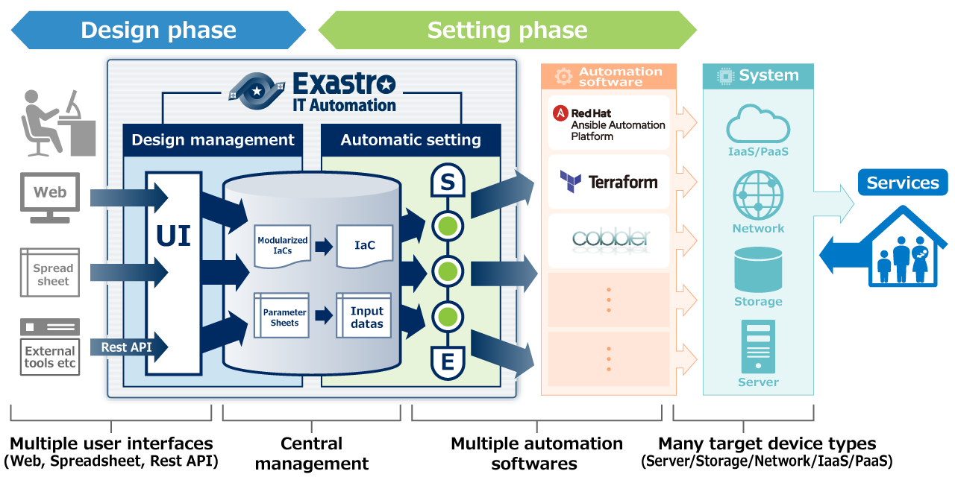

The following 3 modes are available in Ansible driver according to the usage.

1. **Legacy mode**  
   Configure settings to various hosts using the standard function of Ansible.

Register the construction code in a single YAML file and construct the operation pattern with that combination.

This mode is assumed to be used in works such as environment configuration of operation system and network

1. **Legacy Role mode**  
   Similar with the Legacy mode, configure settings to various hosts using the standard function of Ansible.

Register construction code as package and construct work pattern with the combination of Role.

It is assumed that this mode will be used when using the Role package provided by the product department to install product or construct environment, etc.

* + 1. **Pioneer mode**Possible to add individual module to Ansible and input setting in interactive mode.

Supports all devices that can login using Telnet or SSH, regardless of server, storage or

network device.

Since interacting with target device directly is required, appropriate IT skills are required.

In addition, Ansible driver can configure the variables in Playbook from screen. For details please refer to "Variable handling in Ansible driver" in this manual.

# Variable handling in Ansible driver

## Variable type

Ansible driver can set the specific value of Playbook variable in the setting screen in ITA.

**※For the detail of setting method, please refer to "5.3.11****Substitution value list****" in this manual**

8 of the Playbook variables can be used as variables in ITA. See the table below for more information..

**Table2.1 variable type**

|  |  |  |  |  |
| --- | --- | --- | --- | --- |
| Type | Content | Legacy | Pioneer | Legacy  Role |
| Normal variable | A variable that can define one specific value to the variable name.  Please write the variable in Playbook as {{△VAR_xxx△}}.  △:half-width space xxx: half-width alphanumeric character and underscore ( _ )   |  | | --- | | e.g.)  VAR_users: root | | ○ | ○ | ○ |
| Multiple specific value variable | A variable that can define multiple specific value for a variable name.  Please write the variable in Playbook as {{△VAR_xxx△}}.  △:half-width space xxx: half-width alphanumeric character and underscore( _ )   |  | | --- | | e.g.)  VAR_users:  - root  - mysql | | ○ | ○ | ○ |
| Nested variable | Hierarchical variables.  Please write the variable in Playbook as {{△VAR_xxx△}}.  △:half-width space xxx: half-width alphanumeric character and underscore( _ )   |  | | --- | | e.g.)  VAR_users:  - user name: alice  authorized: password  The member variable name can use ascii characters (0x20 ~ 0x7e) except for the following 7 characters.  " . [ ] ' \ :  For more information, please see  [Yaml syntax](https://docs.ansible.com/ansible/latest/reference_appendices/YAMLSyntax.html#gotchas). | | × | × | ○ |
| Global variable | Variable registered from the "Global variable" menu. | ○ | ○ | ○ |
| Template embedded variable | Variable registered from the “Template list” menu. | ○ | ○ | ○ |
| File embedded varaible | Variable registered from the “File list” menu. | ○ | ○ | ○ |

|  |  |  |  |  |
| --- | --- | --- | --- | --- |
| Type | Content | Legacy | Pioneer | Legacy  Role |
| ITA original variable | Original variable defined by ITA.  The following items in the basic console device list can be handled as variables.   |  |  | | --- | --- | | Item name | variable name | | host name | __loginhostname__ | | protocol | __loginprotocol__ | | login user ID | __loginuser__ | | login password | __loginpassword__ |   **The 「__」 surrounding the variable name is a pair of 2 half-width underscore.**  For “device list”, please refer to "User instruct manual_basic console"  Operations when executing can be handled as the following variable.   |  |  | | --- | --- | | Item name | Variable name | | Operation | __operation__ |   Setting value : Scheduled date/time for execution「YYYY/MM/DD HH:MM」_operation  ID : operation name  Directory path when executing can be handled as the following variable.   |  |  | | --- | --- | | Item name | Variable name | | Operation directory path | __workflowdir__ |   By creating a file under the operation directory path in Playbook, users can download the result data file of "operation execution" menu.  The directory path shared by each Movement during Symphony execution can be handled as following variable.   |  |  | | --- | --- | | Item name | Variable name | | Symphony  Operation directory path | __symphony_workflowdir__ |   By creating files under the Symphony operation directory path in Playbook, files can be shared between each Movement. Also, when operation is executed from ansible driver, _workflowdir_will be set to same path.  The directory path shared by each Movement during Conducror execution can be handled as following variable.   |  |  | | --- | --- | | Item name | Variable name | | Conductor  Operation directory path | __conductor_workflowdir__ |   By creating files under the Conductor operation directory path in Playbook, files can be shared between each Movements. Also, when operation is executed from ansible driver, _workflowdir_will be set to same path.  Each file path of the collect function can be handled as the following variables.   |  |  | | --- | --- | | Item name | Variable name | | Operation directory (in) 「_parameters」 path | __parameters_dir_for_epc__ | | Operation directory (in) 「_parameters_file」 path | __parameters_file_dir_for_epc__ | | Operation result directory (out) 「_parameters」 path | __parameter_dir__ | | Operation result directory (out) 「_parameters_file」 path | __parameters_file_dir__ |   「_parameters」 : Source file (parameter) for storage destination.  「_parameters」: Collected file for storage destination.  ※File placement when the target of the parameter is a file upload collumn.  For more information about the collect function, please refer to the "ITA_User_Instruction_Manual_Collect function". | ○ | ○ | ○ |
| Substitution variable | Variable "LCA_XXX" that used to handle variables in Defaults variable definition file or ITA readme other than "VAR_XXX" type in ITA.  For details, please refer to "6.5 Write translation table (Ansible-Legacy Role only)". | × | × | ○ |

## Extract variables and register specific values

Users can extract variables from files and playbooks uploaded to ITA and register specific values from the different Ansible menus.The Specific values registered from the Ansible menus are output to the host variable file when executed.

See the section below for extracting variables.

1. **Ansible-Legacy**  
   Extract the varaiable definitions in the following format from the Playbook uploaded in "Playbook file list (5.3.3 Playbook file list (Ansible-Legacy only) in this manual)".

|  |  |
| --- | --- |
| Format | Specific value settings |
| {{△VAR_xxx△}}  {{△VAR_xxx△|△filter△}} | These specific values can be registered from the “5.3.9 Substitute value auto registration settings”and”5.3.11 substitute value management”menus. The specific value registration process is different if the user wants to register multiple values. |
| {{△GBL_xxx△}} {{△GBL_xxx△|△filter△}} | These specific values can be registered from the “5.2.3 Global variable list” menu. |
| {{△TPF_xxx△}} {{△TPF_xxx△|△filter△}} | These specific values can be registered from the “5.2.4 Template list” menu. |
| {{△CPF_xxx△}} {{△CPF_xxx△|△filter△}} | These specific values can be registered from the “5.2.5 File list” menu. |

※ △:half-width space   
xxx: half-width alphanumeric character and underscore ( _ )

1. **Ansible-Pioneer**  
   Extract the same variable definition as Ansible-Legacy from the dialog file uploaded in "Dialog files(5.3.6 Dialog files (Ansible-Pioneer only) in this manual)"

|  |  |
| --- | --- |
| Format | Specific value settings |
| {{△VAR_xxx△}}  {{△VAR_xxx△|△filter△}} | These specific values can be registered from the “5.3.9 Substitute value auto registration settings”and”5.3.11 substitute value management”menus. The specific value registration process is different if the user wants to register multiple values. |
| {{△GBL_xxx△}} {{△GBL_xxx△|△filter△}} | These specific values can be registered from the “5.2.3 Global variable list” menu. |
| {{△TPF_xxx△}} {{△TPF_xxx△|△filter△}} | These specific values can be registered from the “5.2.4 Template list” menu. |
| {{△CPF_xxx△}} {{△CPF_xxx△|△filter△}} | These specific values can be registered from the “5.2.5 File list” menu. |

1. **Ansible-Legacy Role**  
   Extract the variable from the Playbook in role package uploaded in "Role package list(5.3.4 Role package list (Ansible-Legacy Role only)in this manual)"

Please refer to "Role package list (5.3.4 Role package list (Ansible-Legacy Role only)in this manual)" for details.

By creating translation table, ITA can handle the variables other than "VAR_xxx" defined in defaults varaiable definition file and ITA readme. Please refer to "6.5 Write translation table (Ansible-Legacy Role only)" for details.

Defined variables with the following format from Playbooks from uploaded role packages will be extracted.

|  |  |  |  |
| --- | --- | --- | --- |
| Format | Role package directory | | Specific value settings |
| 1. tasks 2. templates 3. handlers   meta | **Other** |
| {{△GBL_xxx△}} {{△GBL_xxx△|△filter△}} | **〇** | **×** | These specific values can be registered from the “5.2.3 Global variable list” menu. |
| {{△TPF_xxx△}} {{△TPF_xxx△|△filter△}} | These specific values can be registered from the “5.2.4 Template list” menu. |
| {{△CPF_xxx△}} {{△CPF_xxx△|△filter△}} | These specific values can be registered from the “5.2.5 File list” menu. |

〇 = Playbook with variable definition extracted  
x = Playbook without variable definition extracted

## Variable handling according to substitution value registration

By using substitution value registration function, it is possible to overwrite the value of variable defined in Playbook.

The relationship between Playbook variable and the variable value registered in substitution value management function is shown as the following figure.

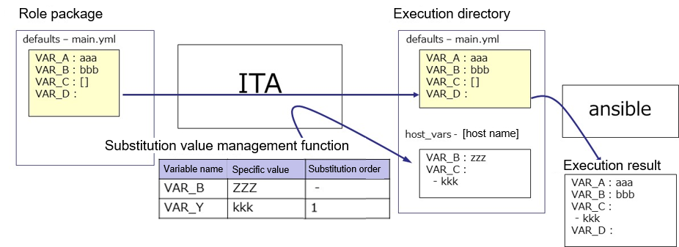

The value of the variable registered in the substitution value management function is output to the variable definition file (host_vars) for each host, and executed on each host by using the original Playbook and variable definition file as input in Ansible.  
  
The priority of variable values in the result is as below.

1. Value registered in substitution value management function
2. Value specified in Playbook variable  
   Please refer to "5.3.11 Substitution value list" for details.

# Ansible driver console menu configuration

This chapter explains the configuration of ITA console menu.

For the method to log in Web console and the components / basic operations of the menu screen, please refer to the "First Step Guide".

## Menu/screen list

1. ITA basic console menu

The menu list of ITA basic console used in Ansible driver is as below.

Table 3.1-1 Basic console menu/screen list

|  |  |  |  |
| --- | --- | --- | --- |
| No | Menu group | Menu・Screen | Descritption |
| 1 | ITA baic console | Device list | Maintain (View/Register/Update/Discard) operation target system list. |
| 2 | Linked menu | Manage the configuration management database linked with Substitution value auto-registration setting menu. |
| 3 | Input operation list | Maintain(View/Register/Update/Discard) input operation list |

1. **Ansible common console menu**

Ansible common console menu list is as below.

Table 3.1-2 Common console menu/screen list

|  |  |  |  |
| --- | --- | --- | --- |
| No | Menu group | Menu・Screen | Description |
| 1 | Ansible common console | Interface information | Select whether to use Ansible or Ansible Tower server as the execution engine for the construction operation.  Manage the path of directory shared by ITA system, Ansible driver server, and execution engine server and the connection interface information to the execution engine server. |
| 2 | Ansible Tower host list | Manage the information needed to execute AnsibleTower's RestAPI and the information needed to transfer construction files to AnsibleTower. |
| 3 | Global variable list | Manage the variable commonly used in Playbook or dialog file, etc. (referred to as global variable hereafter) and their specific values. |
| 4 | Template list | Manage template files and embedded variables used in the template modules, etc. in Playbook. |
| 5 | Contents list | Manage the files and embedded variable used in each module in Playbook. |

1. **Ansible console menu**

The menu list according to each Ansible console is as below.

Table 3.1-3 Ansible driver console menu/screen list

| No | menu group | | | Menu・Screen | Description |
| --- | --- | --- | --- | --- | --- |
| **Ansible console** | | |
| Legacy | Legacy Role | Pioneer |
| 1 |  |  | **○** | OS type | Manage the type of OS of the devices. |
| 2 | **○** | **○** | **○** | Movement list | Manage the list of Movements registered in Symphony. |
| 3 | **○** |  |  | Playbook files | Manage Playbook file. |
| 4 |  | **○** |  | Role package list | Manage role package. |
| 5 |  |  | **○** | Dialog type list | Manages the type of grouping dialog files of the same purpose as dialog type. |
| 6 |  |  | **○** | Dialog files | Manage the OS type linked with the dialog type and the ITA system original format work procedure file (referred to as dialog file in the following). |
| 7 | **○** | **○** | **○** | Movement-Playbook link (Movement - Dialog file type link, Movement-Role link) | Manage links between Movements and Playbook files. |
| 8 |  | **○** |  | Nested variable list | Manage the maximum iteration array count if nested variable is configured as iterative array. |
| 9 | **○** | **○** | **○** | Substitution value auto-registration setting | Manage Movement and variable linked to every item value of operation and host registered in the configuration management database menu. |
| 10 | **○** | **○** | **○** | Target host | Manage the host used in Movement. |
| 11 | **○** | **○** | **○** | Substitution value list | Manage the substitution value of variable. |
| 12 | **○** | **○** | **○** | Execution | Select the Movement and Operation for work execution and indicate the execution. |
| 13 | **○** | **○** | **○** | Check operation status | Displays the operation execution status. |
| 14 | **○** | **○** | **○** | Execution list | Manage the operation execution history. |

※ Since user operations such as configuration are not perfomed in Ansible RestAPI, the description is omitted here.

# Ansible driver operation procedure

This chapter explains the operation procedure for using each Ansible console.

## Workflow

The standard workflow of each Ansible console is as follow.

The details of each operation is writed in the next section.

Please refer to "User instruction manual_Basic console" for how to use the ITA basic console.

### Workflow of Ansible-Legacy

The workflow of executing operation using Ansible-Legacy is as follows.

1. **Set Ansible usage information in device list**

**④ Register work pattern(Movement)**

**⑤ Register playbook**

**⑨ Specify operation target gost ※**

**⑩ Set variable value**

**⑪ Operation execution**

**⑫ Check execution status**

**⑦ Register content file**

**⑥ Register template file**

**⑬ Check operation history**

**※Once Movement is configured, it is possible to start the operation from the following procedure from the next time.**

**Required task**

**Optional task**

**【Legend】**

**⑧　Specify Playbook file to Movement**

**②　Register input operation name**

**③** **Set interface information**

* **Workflow details and references**

1. **Set Ansible usage information in device list**

Set the Ansible usage information to each devices in the device list screen of ITA basic console.  
Please refer to “5.1.1 Device list” for details.

1. **Register input operation name**

Register the input operation name for work from the input operation list screen of ITA basic console.

Please refer to “5.1.2 Input operation list” for details.

1. **Set interface information**

Select using whether Ansible or AnsibleTower server as the execution engine and register the connection information of the execution engine server from the interface information screen of Ansible common console.

Please refer to “5.2.1 Interface information” for details.

1. **Register work pattern (Movement)**Register the Movement for operation from the Movement list screen of Ansible-Legacy console.

Please refer to “5.3.2 Movement list” for details.

1. **Register playbook**Register the Playbook used in operation from the Playbook files screen of Ansible-Legacy console.  
   Please refer to “5.3.3 Playbook file list (Ansible-Legacy only)” for details.
2. **Register template file (execute if necessary)**

Register/Update/Discard the template file (src) and the template embedded variable used in the template module, etc. of Playbook from the template list screen of Ansible common console.

Please refer to “5.2.4Template list ” for details.

1. **Register content file (execute if necessary)**Register the file used to configure the operation target server from the contents list screen of Ansible common console.

Please refer to “5.2.5 Contents list” for details.

1. **Specify Playbook file to Movement**In the Ansible-Legacy Console -> Movement-Playbook link (Movement-Dialogue file type link, Movement-Role link) screen, specify a Playbook to the registered Movement.

Please refer to “5.3.7 Movement-Playbook link (Movement - Dialog file type link, Movement-Role link)” for details.

1. **Specify operation target host**Specify the operation target host from the target host screen of Ansible-Legacy console.  
   Please refer to “5.3.10 Target host” for details.
2. **Set variable value (execute if necessary)**Set the value of the variable in the Playbook which has been registered to Movement from the substitution value list screen in Ansible-Legacy console. If variable is not used, then configuration is not required.

Please refer to “5.3.11 Substitution value list” for details.

1. **Operation execution**Select and set execution date, input operation and indicate operation execution from the execution screen of Ansible-Legacy console.

Please refer to “5.3.14 Execution” for details.

1. **Check operation status**The status of executed operation is displayed in real time in the "Check operation status" screen of Ansible-Legacy console. In addition, users can perform emergency stop on operation and monitor the execution log and error log.  
   Please refer to “5.3.12 Check operation status” for details.
2. **Check operation history**The list of executed operation is displayed in the execution list screen of Ansible-Legacy console and users can check the execution history.

Please refer to “5.3.13 Execution list” for details.

### Workflow of Ansible-Legacy Role

The workflow of executing operation using Ansible-Legacy Role is as follows.

1. **Set Ansible usage information in device list**

**④ Register work pattern(Movement)**

**⑤ Register role package**

**⑩ Specify operation target gost**

**⑫ Operation execution**

**⑬ Check execution status**

**⑧ Specify role package to Movement**

**⑭ Check operation history**

**Required task**

**Optional task**

**【Legend】**

**※ Once Movement is configured, it is possible to start the operation from the following procedure from the next time.**

**⑪ Set variable value**

**⑨ Specify the maximum iteration count 　of nested variable※**

**②　Register input operation name**

**⑦ Register content file**

**③ Set interface information**

**⑥ Register template file**

* **Workflow details and references**

1. **Set Ansible usage information in device list**Set the Ansible usage infromation according to each devices in the device list screen of ITA basic console.  
   Please refer to “5.1.1 Device list” for details.
2. **Register input operation name**

Register the input operation name from the input operation list screen of ITA basic console.

Please refer to “5.1.2 Input operation list” for details.

1. **Set interface information**

Select using whether Ansible or AnsibleTower server as the execution engine and register the connection information of the execution engine server from the interface information screen of Ansible common console.

Please refer to “5.2.1Interface information” for details.

1. **Register work pattern (Movement)**

Register the Movement for operation from the Movement list screen of Ansible-Legacy Role console.

Please refer to “5.3.2 Movement list” for details.

1. **Register role package**Register the role package used in operation from the role package list screen of Ansible-Legacy Role console.  
   Please refer to “5.3.4 Role package list (Ansible-Legacy Role only)” for details.
2. **Register template file (execute if needed)**

Register/Update/Discard the template file (src) and the template embedded variable used in the template module, etc. of Playbook from the template list screen of Ansible common console.

Please refer to “5.2.4 Template list” for details.

1. **Register content file (execute if needed)**

Register the file used to configure the operation target server from the contents list screen of Ansible common console.

Please refer to “5.2.5 Contents list” for details.

1. **Specify role package to Movement**

Specify the Playbook file to the registered Movement from Movement details screen of Ansible-Legacy Role console.

Please refer to “5.3.7 Movement details” for details.

1. **Specify the maximum iteration count of nested variable**Specify the maximum iteration count of the array of member variables defined in nested variables from Nested variable list screen of the Ansible-Legacy Role console.

Please refer to “5.3.8 Nested variable list (Ansible-Legacy Role only)” for details.

1. **Specify operation target host**Specify the operation target host from the target host screen of Ansible-Legacy Role console.  
   Please refer to “5.3.10 Target host” for details.
2. **Set variable value (execute if needed)**Set the value of the variable in the Playbook which has benn registered to Movement from the substitution value list screen in Ansible-Legacy Role console. If variable is not used, then configuration is not required.

Please refer to “5.3.11 Substitution value list” for details.

1. **Operation execution**Select and set execution date, input operation and instruct operation execution from the execution screen of Ansible-Legacy Role console.

Please refer to “5.3.14 Execution” for details.

1. **Check operation status**The status of executed operation is displayed in real-time in the "Check operation status" screen of Ansible-Legacy console. In addition, users can perform emergency stop on operation and monitor the execution log and error log.  
   Please refer to “5.3.12 Check operation status” for details.
2. **Check operation history**The list of executed operation is displayed in the execution list screen of Ansible-Legacy Role console and users can check the execution history.

Please refer to “5.3.13 Execution list” for details.

### Workflow of Ansible-Pioneer

The workflow to execute the operation in Ansible-Pioneer is as follows.

**①Set Ansible usage information in device list**

**④ Register work pattern(Movement)**

**⑥ Register dialog file**

**⑩ Specify operation target host ※**

**⑪ Set variable value**

**⑫ Operation execution**

**⑬ Check execution status**

**⑧ Register content file**

**⑦ Register template file**

**⑭ Check operation history**

**※Once Movement is configured, it is possible to start the operation from the following procedure from the next time.**

**Required task**

**Optional task**

**【Legend】**

**⑨　Specify dialog file to Movement**

**②　Register the input operation name**

**⑤ Register dialog type**

**③ Set the interface information**

* **Workflow details and references**

1. **OS type registration**

Set the OS type of the device to be operated from Pioneer.

1. **Set Ansible usage information in device list**Set the Ansible usage information for each device from the device list screen of the ITA basic console.  
   For details, please refer to “5.1.1 Device list”.
2. **Register the input operation name**

Register the input operation name from the input operation list screen of ITA basic console.

Please refer to “5.1.2 Input operation list” for details.

1. **Register the interface information**

Select using whether Ansible or AnsibleTower server as the execution engine and register the connection information of the execution engine server from the interface information screen of Ansible common console.

Please refer to “5.2.1Interface information ” for details.

1. **Register work pattern (Movement)**Register the Movement for operation from the Movement list screen of Ansible-Pioneer console.

Please refer to “5.3.2 Movement list” for details

1. **Register dialog type**

Register dialog type from the dialog type list screen of Ansible-Pioneer console.

Ansible-Pioneer defines the differences for each OS type in each dialog file, and combines the same purpose dialog file as dialog type to absorb (abstract) the device difference.

Please refer to “5.3.5 Dialog type list (Ansible-Pioneer only)” for details.

1. **Register dialog file**

Register dialog file according to the combination of dialog type and OS type from the dialog files screen of Ansible-Pioneer console.

Please refer to “5.3.6 Dialog files (Ansible-Pioneer only)” for details.

1. **Register template file (execute if needed)**

Register/Update/Discard the template file (src) and the template embedded variable used in the template module, etc. of Playbook from the template list screen of Ansible common console.

Please refer to “5.2.4 Template list” for details.

1. **Register content file (execute if needed)**

Register the file used to configure the operation target server from the contents list screen of Ansible common console.

Please refer to “5.2.5 Contents list” for details.

1. **Specify dialog file to Movement**Specify dialog file to the registered Movement from movement details screen of Ansible-Legacy Role console.

Please refer to “5.3.7 Movement details” for details.

1. **Specify operation target host**Specify the operation target host from the target host screen of Ansible-Pioneer console.  
   Please refer to “5.3.10 Target jost” for details.
2. **Set variable value (execute if needed)**Set the value of the variable in the Playbook which has been registered to Movement from the substitution value list screen in Ansible-Pioneer console. If variable is not used, then configuration is not required.  
   Please refer to “5.3.11Substitution value list ” for details.
3. **Operation execution**Select and set execution date, input operation and indicate operation execution from the execution screen of Ansible-Pioneer console.

Please refer to “5.3.14 Execution” for details.

1. **Check operation status**The status of executed operation is displayed in real time in the Check operation status screen of Ansible-Pioneer console. In addition, users can perform emergency stop on operation or monitor the execution log and error log.  
   Please refer to “5.3.12 Check operation status” for details.
2. **Check operation history**The list of executed operation is displayed in the execution list screen of Ansible-Pioneer console and users can check the execution history.

Please refer to “5.3.14 Execution list” for details.

**■Legend of Registration screen item list**

The content of the Registration screen item list are writed in the next section.

**②②**

|  |  |  |  |  |
| --- | --- | --- | --- | --- |
|  | **②** | **③** | **④** | **⑤** |
| **Item** | **Description** | **Input**  **required** | **Input type** | **Restrictions** |
|  |  |  |  |  |

1. **Item**

　・The item name in the submenu.

1. **Description**

　・The description for the item.

1. **Input required**

　・○： Items that entering contents are required for them.

　・‐ ： Items that entering contents are optional for them.

1. **Input type**

　・Manual： Items that require manual input.

　・Auto：Items whose content are entered automatically.

　・Checkbox: Check box format item.

　・Button: Radio button format item.

　・List: List box format item.

1. **Restrictions**

　・The restrictions for the item(Limitation on number of characters, etc.)

# Ansible driver　function・operation method explanation

This chapter explains each console function used in Ansible driver.

## Basic console

This section writes the operation of ITA basic console.

Please refer to the ITA basic console manual for this operation and perform the operation in the ITA basic console screen.

### Device list

1. Registration/Update/Discarding information of operation target host is performed in the "Device list" menu.  
   This document explains the items (red frame) in the device list required for Ansible driver operations.  
   Please see the “Exastro-ITA_User_Instruction_Manual_Basic_Console.pdf” together with this document.

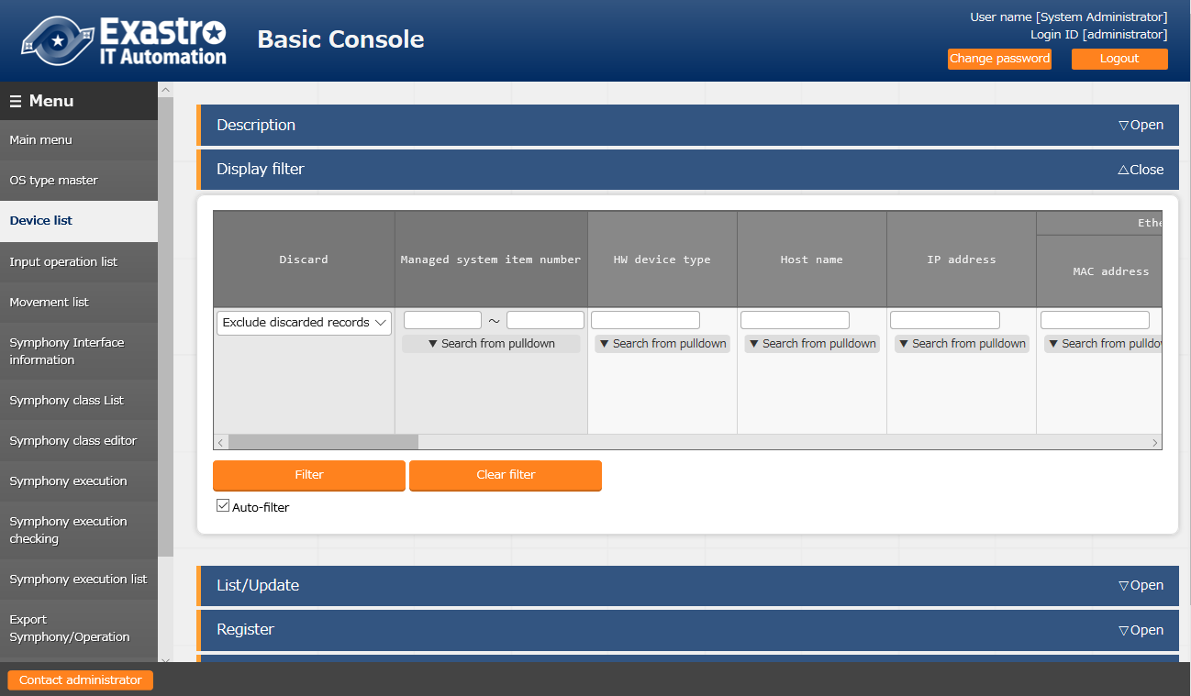

Figure 5.1-1 Submenu screen (Device list)

1. Click the "Register" - "Start Registration" button to register the device information.

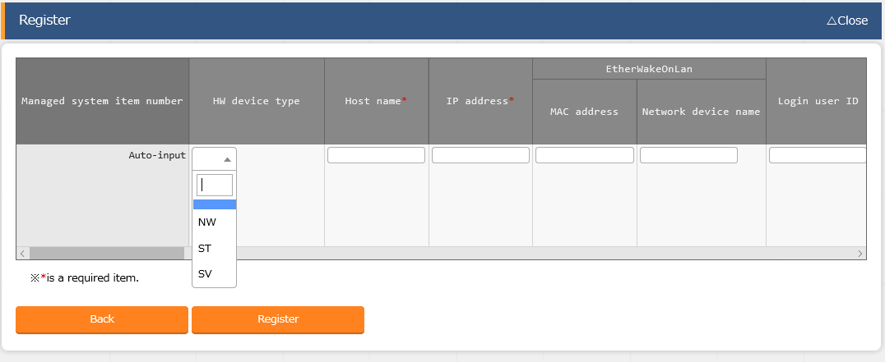

Figure 5.1-2 Registration screen(Device list-common item)

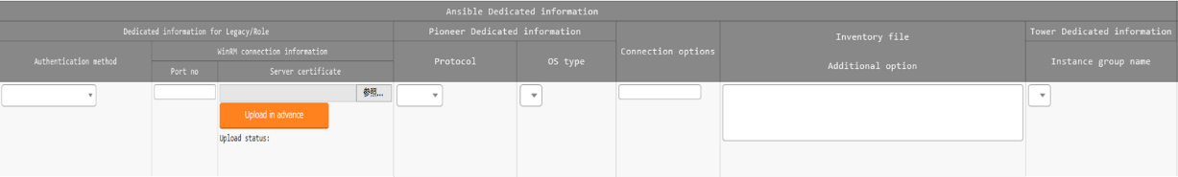

Figure 5.1-3 Registration screen(Device list-Ansible usage information)

1. The list of common item in registration screen is as follows.  
   Input of the columns with a red asterisk (*) after their column name in the web screen is required. In the case of using Ansible driver, please enter the usage information of Ansible.

If operation is executed while required column is not entered, unexpected errors may occur.

**Table 5.1-1 Registration screen item list (Device list)**

| Item | | | | **Description** | **Input required** | **Input type** | **Restrictions** |
| --- | --- | --- | --- | --- | --- | --- | --- |
| Managed system item number | | | | A unique ID that identifies the registration information is entered automatically. | - | Auto | - |
| host name | | | | Enter host name.  If you set the hostname to localhost and use pioneer as the working host, you may get an error when executing the operation.  In that case, please add the path to the python3 file installed on the ansible server in the following parameter to the add inventory file option.  Exp)  ansible_python_interpreter: /usr/bin/python3 | ○ | Manual | Maximum length 128 bytes |
| IP address | | | | Enter IP address in xxx.xxx.xxx.xxx format. | ○ | Manual | Maximum length 15 bytes |
| EtherWake  OnLan | | MAC address | | Enter MAC address. | - | Manual | Maximum length 17 bytes |
| Network device name | | Enter network device name. | - | Manual | Maximum length 256 bytes |
| Login user ID | | | | Enter network device name. | ○ | Manual | Maximum length 30 bytes |
| Login password | | Management | | Select "●" when using ITA to manage password. | ○ | List | - |
| Login password | | Specify password. | ○ | Manual | Maximum length 30 bytes |
| ssh authentication key file | | | | Specify the ssh authentication key file and enter the file when using key authentication.  Required when specifying the ssh authentication key file if authentication method is the key authentication. | - | File | Maximum size 10K bytes |
| Ansible dedicated information | Dedicated information for Legacy/Role | Authentication method | | Select the authentication method used when connecting from Ansible/AnsibleTower to the target device.  ●Password Authentication  If you also choose ● for Login password Management, you will be required to input a login password.  ●Key Authentication (No passphrase)  You must upload an SSH secret key file (id_ras).  ●Key Authentication (With passphrase)  You must upload an SSH seccret key file (id_ras) and input a passphrase.  ●Key Authentication (Key Exchanged)※1  You will not be required to upload an SSH secret key file (id_ras)  ●Password Authentication (winrm)  If necessary, input the WinRM connection information.  If you choose anything else than Password authentication (winrm), you must configure the following settings for the target device.  -Set the Login-user's sudo permissions to /etc/sudoers with NOPASSWD  Example)  Demo_user ALL=(ALL) NOPASSWD:ALL | ○○ | List | As writed in the description column. |
| WinRM connection information | Port no. | Enter the port number when connecting to WindowsServer with WinRm.  If the column is left not entered, Ansible will connect to the default (5985) WinRM. | - | Manual | As writed in the description column |
| Server certificate | Enter the server certificatie when https port number is specified as the WinRM connection port  To omit server certificate authentication, add the following to the inventory file additional option. ansible_winrm_server_cert_validation=ignore | - | File | Maximum size 10K bytes |
| Pioneer dedicated information | Protocol | | Select the protocol (ssh/telnet) for when logging in to the target device.  ●If you selected ssh  Select something other than "Password Authentication (winrm)" for Authentication method.  ●If you selected telnet  you will connect to telnet without using the set value for Authentication method. | ○○ | List | - |
| OS type | | Select the OS of target device.  The OS types registered in the OS type master are displayed in list. | ○○ | List | - |
| Connection options | | | 1. (In the case of connecting via ssh)   If users want to set options other than the ssh options set in /etc/ansible.cfg/ssh_args , please enter the desired option.  (In the case of connecting via telnet)  If users want to set options when connecting via telnet, please enter the desired option. | - | Manual | Maximum length 512 bytes |
| Inventory file addition option | | | Enter the option parameter of inventory file that is not set in ITA.  e.g. )   1. ansible_connection: network_cli   ansible_network_os: nxos | - | Manual | Maximum length 512 bytes |
| Tower dedicated information | Instance group name※2 | | If the AnsibleTower is a Cluster configuration, select which Ansibletower instance group it should be executed in.  The instance group set here will be set to the Tower's Evently Objects.  If nothing is selected, the detault AnsibleTower value ("Tower") will be used.  If the AnsibleTower in use is not a cluster configuration, you can leave this blank. | ○ | List | - |
|  |  | Connection type | | Set the connection type for Ansible tower authentication cedentials. Normally Machine is selected.In the case where Ansible_Connection needs to bet to local Network OS, Choose Network.  If a Network is selected the user must set Platform Options other than (ansible_cnnection) for the additional inventory file options  Exp)  Example of Inventory file addition option settings.  Set value when Network OS is ios.  ansible_network_os: ios  ansible_become: yes  ansible_become_method: enable  For the connection type of an AnsibleTower authentication, see Tower Document Authentication Type.  About the relationship between Platform Options of ansible_connection and OS Network please refer to the Ansible document [Platform Options](https://docs.ansible.com/ansible/devel/network/user_guide/platform_index.html#platform-options). | ○ | List |  |
| Remarks | | | | Free description field. | - | Manual | Maximum length 4000 bytes |

※1 Distribution of public key file required when the authentication method is key authentication (key exchanged).

・For Ansible Engine

Make an ssh connection to the target host from the "Ansible common console=>User set in the interface information" of the server where ansible is installed.

Copy the user's public key to the user that will log in to the device's "Authorized keys".

・For Ansible Tower

Connect from the Ansible Tower's awx user to the Operation host with SSH.

Copy the awx user's public key to the user that will log in to the devices' "Authorized keys"

You will also need to configure settings in the Tower web's "Setting"->"Job"->"paths to expose to isolated jobs".

For more information, please refer to the "Exastro-ITA_System_Configuration_Enviroment_Construcion_Guide_Ansible-driver" chapter 5, AnsibleTower Initial settings.

※2 You can select from the data acquired from the Ansible Driver Backyard function, "AnsibleTower Data Synchronization".

### Input operation list

1. In the "Input operation list" screen, the operations for the target host to be executed by the orchestrator are managed. Operations are selected from the menu in ITA basic console

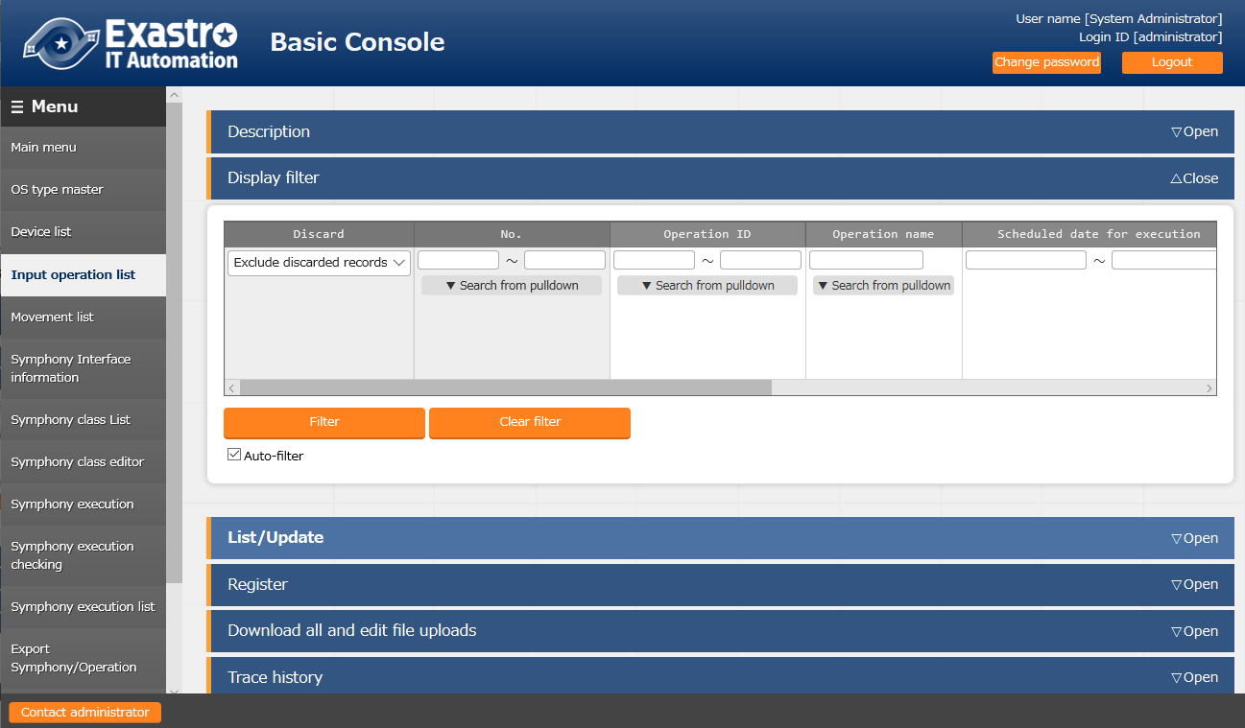

**Figure 5.1-4 Submenu screen (Input operation list)**

Please refer to the related manual "User instruction manual_Basic console" for the details of registration method.

## Ansible common console

This section writes the operation of　Ansible common console.

### Interface information

1. In the ”interface information" menu, select using whether Ansible or AnsibleTower server as the execution engine and register/update/discard the shared directory path between ITA system, Ansible driver server, and execution engine server , and the connection interface information of the execution engine server.

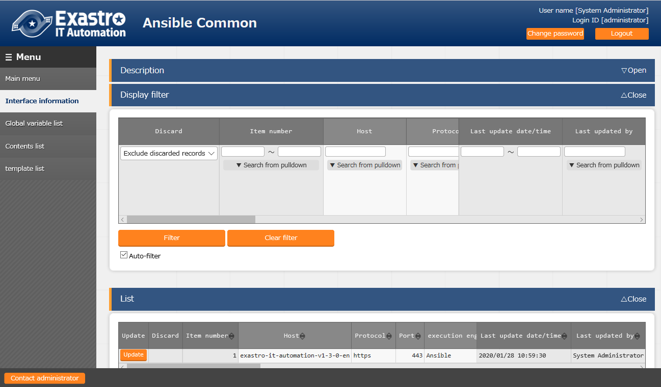

**Figure 5.2-1 Submenu screen (interface information)**

1. Click the "List" - "Update" button to register the interface information.

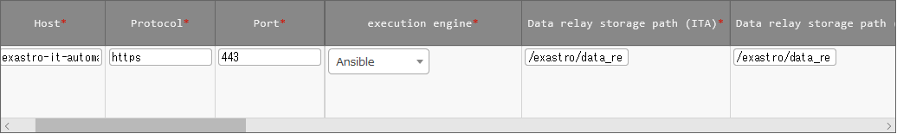

Figure 5.2-2 Registration screen (Interface information)

1. The item list of interface information screen is as follows.  
   If operation is executed while interface information not registered or multiple information is registered, unexpected errors may occur.

**Table 5.2-1 Registration screen item list (Interface information)**

| Item | | **Description** | **Input required** | **Input type** | **Restrictions** |
| --- | --- | --- | --- | --- | --- |
| Execution engine | | Select the execution engine between Ansible and AnsibleTower.  Whem AnsibleTower is selected, in order to execute ansible-vault command, Ansible Engine interface is also needed. | ○ | List |  |
| Ansible Engine interface | Host | Enter the host name (or IP address) of Ansible server.  It is recommended to enter host name when using HTTPS communication. | ○ | Manual | Maximum length 128 bytes |
| Protocol | Enter either http/https as the protocol with Ansible, AnsibleTower server. | ○ | Manual | - |
| Port | Enter the connection port (80/443) of Ansible, AnsibleTower. The port is usually HTTPS (443). | ○ | Manual | - |
| Execution user | Enter the execution user to execute ansible-playbook/ansible-vault command with sudo. | - | Manual | Maximum length 64 bytes |
| ACCESS_KEY_ID | Enter the access key used for authentication when connecting to the Ansible server. | - | Manual | Maximum length 64 bytes |
| SECRET_ACCESS_KEY | Enter the secret access key used for authentication when connecting to the Ansible server. | - | Manual | Maximum length 64 bytes |
| Ansible Tower interface  information | Host | Select AnsibleTower that will connect to ITA.  You can select from the list of hosts that are registered in the AnsibleTower Host list. | ○ | Manual | Maximum length 128 bytes  Required when the execution engine is AnsibleTower |
| Protocol | Enter either http/https as the protocol with Ansible, AnsibleTower server. | ○ | Manual | Required when the execution engine is AnsibleTower |
| Port | Enter the connection port (80/443) of Ansible, AnsibleTower. The port is usually HTTPS (443). | ○ | Manual | Required when the execution engine is AnsibleTower |
| Organization name | Enter the organization name registered in AnsibleTower. | - | List | Required when the execution engine is AnsibleTower |
| Authentication token | Enter the user authentication token when connecting AnsibleTower server from ITA. | - | Manual | Maximum length 128 bytes.  Required when the execution engine is AnsibleTower |
| Delete runtime data | Select whether to delete the data automatically generated by AnsibleTower during operation execution after operation is done.  Select “Delete” from the pulldown list to delete. | - | List | Required when the execution engine is AnsibleTower |
| Data relay storage path (ITA) ※1 | | Enter the directory viewed from the ITA system / Ansible driver server. | ○ | Manual | Maximum length 128 bytes |
| Data relay storage path (Ansible/Ansible Tower) | | Enter the directory viewed from the Ansible RestAPI and AnsibleTower servers. | ○ | Manual | Maximum length 128 bytes |
| Symphony instance data relay storage path  (Ansible/Ansible Tower) | | Enter the directory which shares the shared directory between each movement when executing Symphony with Ansible RestAPI, AnsibleTower server.  The path viewed from the ITA system is set from the Symphony interface information menu.  Please refer to the "User instruction manual_ITA basic console" for the Symphony interface information. | ○ | Manual | Maximum length 128 bytes |
| Conductor instance data relay storage path  (Ansible/Ansible Tower | | When executing Conductor, enter the directory shared by each Movement.  The path viewed from the ITA system is set from the Conductor interface information menu.  For the Conductor interface information, please refer to "ITA User_Instruction_Manual_Conductor”. | ○ | Manual | Maximum length 128 bytes |
| Optional parameter ※2 | | Enter the Movement-common optional parameter of Ansible-Playbook command.  Movement-specific optional parameters are entered in the Movement list menu.  In the case that the execution engine is Ansible:  Enter the optional parameter of Ansible-Playbook command.  　The -i option is set by ITA.  In the case that the execution engine is AnsibleTower:  　The following option parameters can be set:  　　-verbosity  　　-f FORKS,--forks=FORKS  　　-l SUBSET,--limit=SUBSET  　　-e EXTRA_VARS,--extra-vars=EXTRA_VARS  EXTRA_VARS: Variable name=specific value Variable name=specific value.....  　　-t TAGS,--tags=TAGS  　　-b,--become  　　-D,--diff  　　--skip-tags=SKIP_TAGS  　　--start-at-task=START_AT_TASK  　The original optional parameters of AnsibleTower are as follows.  　　-ufc,--use_fact_cache　 use fact cache  　　-as,--allow_simultaneous enable simultaneous job execution  　　-jsc,--job_slice_count=　　job slice count  For the original optional parameters of AnsibleTower, please refer to the description of job template in the Ansible Tower user guide. | - | Manual | Maximum length 512 bytes |
| Number of parallel executions | | Enter the maximum numbers of Movement (Legacy/Pioneer/Legacy-Role) that can be executed at the same time. | ○ | Manual |  |
| Status monitoring cycle(milliseconds) | | Enter the refresh interval of the log displayed in "5.3.12 Check operation status".  Usually the value around 3000 milliseconds is recommended. | ○ | Manual | Minimum value 1000 milliseconds |
| Number of rows to display progress status | | Enter the maximum display line count of the execution log, errorlog in "5.3.12 Check operation status".  Usually the value around 1000 lines is recommended. | ○ | Manual | - |
| NULL link | | Set whether to register NULL (blank) value to substitution value list menu if the specific value in parameter sheet is NULL (blank) in the substitution value auto-registration setting menu.  This value will be applied when “NULL link” in the substitution value auto-registration setting menu is blank.  ・If the "Valid" is set, any value in the parameter sheet will be registered in the substitution value list menu. (NULL value will be registered)  ・If the "Invalid" is set, only specific value in the parameter sheet will be registered in the substitution value list menu(NULL value will not be registered) | ○ | List | - |
| Remarks | | Free description field | - | Manual | Maximum length 4000 bytes |

※1 If the data relay storage paths are operating on different servers, they will be managed seperately (as they're likely to have different directory paths). For more information, please refer to the "Exastro- ITA_System_Configuration_Enviroment_Construcion_Guide_Ansible-driver" document.

※2 If the executing engine is Ansible,

You can also set optionial parameters in "Movement list"->"Optionial Parameter".

If you have defined the same parameters multiple times, Ansible will interpret it differently depending on the parameter.

---forks only allows single values.

--forks=1 --forks=10 -- forks=10 will be applied.  
 --tags allows multiple parameters.

---tags=step1 ---tags=step2 ---tags will have both step1 and step2 applied.

---verbose uses the biggest value

---verbose=3 ---verbose=1 ---verbose=3 will be applied.

ITA sets optional parameters for ansible-playbook in the following order, so if you define multiple parameters that allow only a single value, the parameter in the Movement list=>optional parameters will be valid.

・Ansible common ->Interface Information -> Optionial Parameter

・Movement list -> Optionial Parameter

If the executing engine is Ansible Tower, you can also set option parameters in "Movement list"->"Optionial Parameter".

If the same parameter is defined multiple times, an error will occur when executing the operation.

### Ansible Tower host list

In [Ansible Tower Host List], register/update/abolish the information required to execute Rest API of Ansible Tower and the information required to transfer the construction materials to Ansible Tower.

If Ansible Tower is built in a cluster configuration, it is necessary to register all host information in the cluster. If it is not a cluster configuration, register the host information of the Ansible Tower to be corresponded.

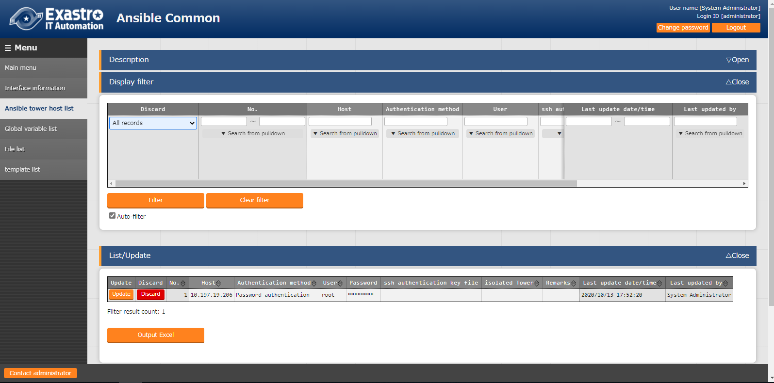

**Figure 5.2-3 Submenu screen (Ansible Tower host list)**

(1) Click the "List"-"Update" button to register the Ansible Tower host information.

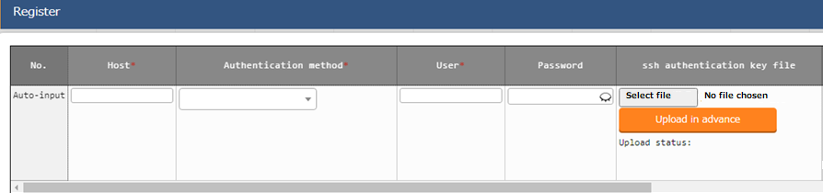

**Figure 5.2-4 Registration screen (Ansible Tower host)**

(2) The list of items on the Ansible Tower host list screen is as follows.

**Table 5.2-2 Registration screen item list (Ansible Tower host list)**

| Item | | **Description** | **Input required** | **Input type** | **Restrictions** |
| --- | --- | --- | --- | --- | --- |
|  | |  |  |  |  |
| Host | | Enter the host name (or IP address) of the Ansible Tower server.  For HTTPS communication, the host name is recommended. | ○ | Manual input | Maximum length 128 bytes |
| Authentication method | | Select the authentication method used when connecting from Ansible/AnsibleTower to the target device.  ●Password Authentication  If you also choose ● for Login password Management, you will be required to input a login password.  ●Key Authentication (No passphrase)  You must upload an SSH secret key file (id_ras).  ●Key Authentication (With passphrase)  You must upload an SSH seccret key file (id_ras) and input a passphrase.  ●Key Authentication (Key Exchanged)※1  You will not be required to upload an SSH secret key file (id_ras) | ○ | Manual input | Maximum length 30 bytes |
| Login user | | Enter the login user for connecting to the Ansible Tower server via file transfer (scp).  Set and use a password for the login user and the awx user generated when installing Ansible Tower. | ○ | Manual input | Maximum length 30 bytes |
| Password | | This is required when password authentication is selected as the authentication method. Specify the password of the login user. | － | Manual input | Maximum length 30 bytes |
| Ssh key authentic information | ssh authentication key file | When key authentication is selected in the authentication method, enter the file for key authentication by specifying the ssh authentication key file. | - | File | Maximum size 4gb |
| Passphrase | If passphrase is set to the secret key file, input the passphrase. | - | Manual input | Maximum 256 bytes |
| isolated Tower | | Select {「●」 for isolated Tower when it is built in a cluster configuration. | － | Select |  |
| Remarks | | Free description field. | － | Manual input | Maximum length 4000 bytes |

※1 Distrubution of the public key file required when the authentication method is Key authentication (key exchanged)

With ssh, connect to the from the root of the server where ITA is installed to AnsibleTower's awx user.

Copy the root's public key to the AnsibleTower's AWX User's authorized keys.

### Global variable list

1. In the "Global variable list" menu, register/update/discard the global variable name used in Playbook, dialog files, etc.

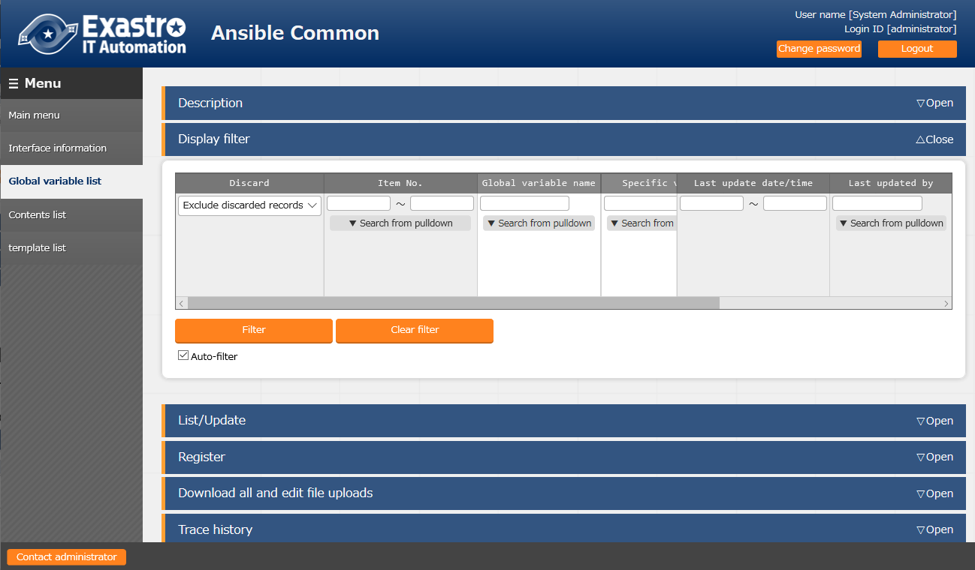

**Figure 5.2-5 Submenu screen (Global variable list)**

1. Click the "Register" - "Start Registration" button to register the operation information.

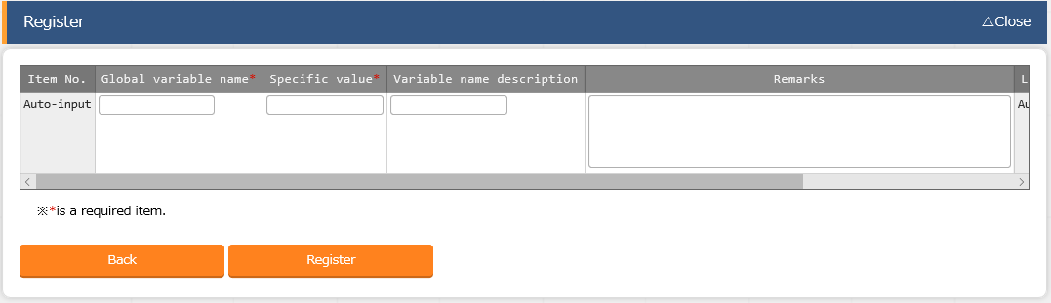

**Figure 5.2-6 Registration screen (Global variable list)**

1. The item list of global variable list screen is as follows.

**Table 5.2-3 Registration screen item list (Global variable list)**

|  |  |  |  |  |
| --- | --- | --- | --- | --- |
| Item | **Description** | **Input required** | **Input type** | **Restrictions** |
| Global variable name | Enter the variable name.  Enter the variable name in the "GBL_****" format.  Half-width alphanumeric character and underscore (_) can be used.  (Minimum length: 1 byte, maximum length: 128 bytes) | ○ | Manual | As writed in the description column. |
| specific value | Enter the specific value  File embedded variable "CPF_" and template embedded variable "TPF_" can be entered in the specific value column.  When describing the variables, enclose the variable names with {{}} as describing the variables in the Playbook.  e.g. )  Entering TPF_sample for specific value  '{{△TPF_sample△}}' △: half-width space  ‘: recommended | ○ | Manual | Maximum length 8192 bytes |
| Variable name discription | Enter the description or comment of the variable. | - | Manual | Maximum length 256 bytes |
| Remarks | free description field | - | Manual | Maximum length 4000 bytes |

### Template list

1. In the "template list" menu, register/update/discard the Jinja2 template file and the template embedded variable used in the parameter of template module and ios_config module, etc. defined in the Playbook.

If template module is registered in the template list, the template file used in the template module etc. defined in the playbook can be specified by template embedded variable.

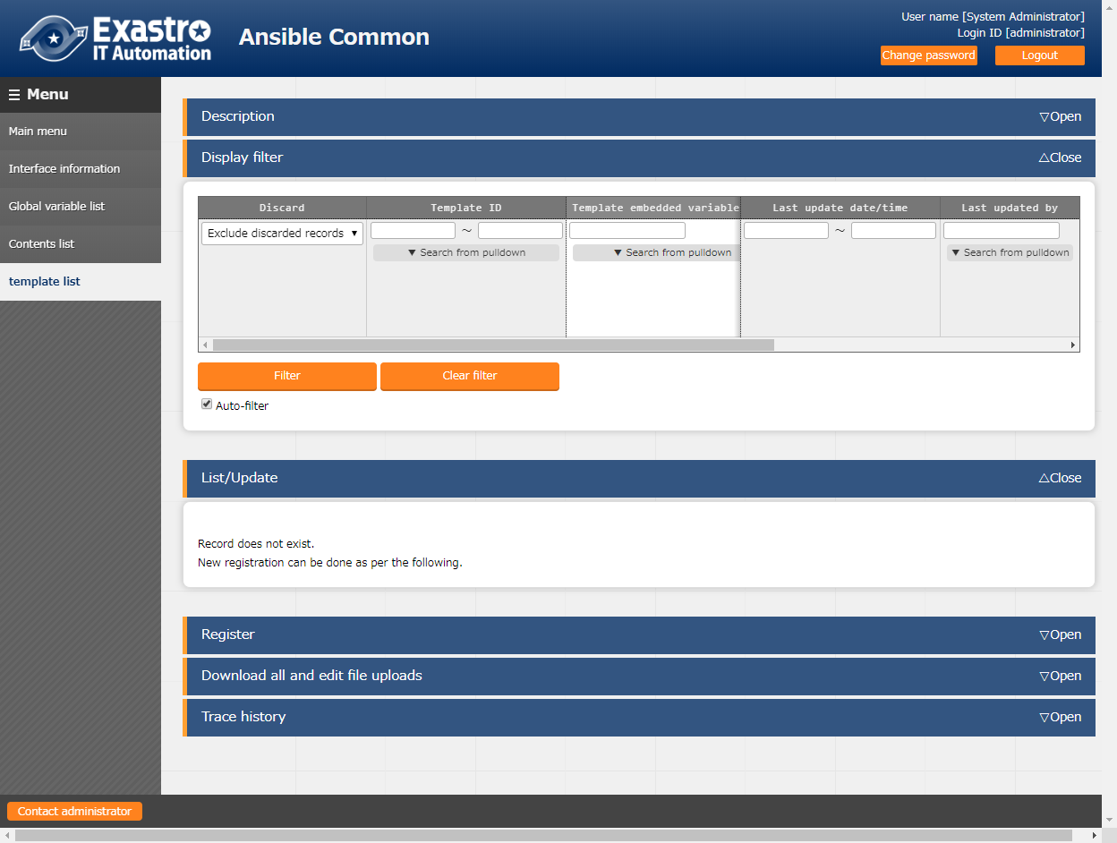

**Figure 5.2-7 Submenu screen　(Template list)**

**(2)** Click the "Register" - "Start Registration" button to register the file management information.

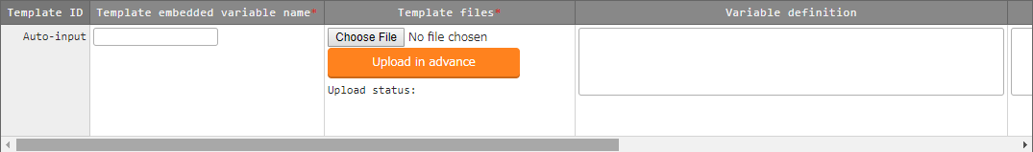

Figure 5.2-8 Registration screen (Template list)

**(3)** The items of registration screen are as follows.

Table 5.2-4 Registration screen item list (template list)

| **Item** | **Description** | **Input required** | **Input type** | **Restrictions** |
| --- | --- | --- | --- | --- |
| Template embedded variable name | Enter the variable name embedded in parameters such as template module or ios_config module, etc.  Enter the variable name in the "TPF_****" format.  Half-width alphanumeric character and underscore (_) can be used.(Minimum length: 1 byte, maximum length: 128 bytes) | ○ | Manual | As writed in the description column. |
| Template files | Upload the Jinja2 template file used as the parameter of module. | ○ | File | Text format Maximum size 4GB |
| Variable definition | Define the variable used in the template file.  If the template is used only in Ansible-Role and the variable is defined in the default variable definition file, then the variable definition column can be omitted.  If the template is used only in Ansible-Role and the variable is defined in the default variable definition file, then the variable definition column can be omitted.  If the variable with same name is used in multiple template, the variable definitions have to match. Error will occur during registration if the variable definitions do not match.  Although the variable definition is based on the specification of Ansible, there is own specification of ITA.The notes of variable definition is writed in 5.2-5-1. | - | Manual | Maximum length 4000 bytes |
| Remarks | Free description field. | - | Manual | Maximum length 4000 bytes |

Please "Upload in advance (①)" the "template files" before "register".

Please click the "Register" button after checking the Playbook file name displayed in the "Upload status(②)".

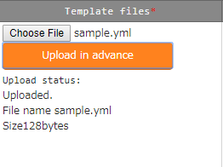

Table 5.2-5 Notes of variable definition

|  |  |
| --- | --- |
| Type | Notes |
| Normal variable | Specfic value is optional.  e.g.)  VAR_sample_1: none  VAR_sample_2: |
| Multiple specific value variable | Specfic value is optional.  e.g.)  VAR_sample_1:  △- none  VAR_sample_2: []  Please enter 1 or more half-width space(△) before - when defining specific value. The variable definition maybe misinterpreted. |
| Multistage variable | It is possible to define hierarchical variable structures e.g.)  VAR_sample_1:  - item1: none  item2:  VAR_sample_2:  - array:  - item1: none  item2:  The template with nested variable defined can only be used in Ansible-Role  When used in Ansible-Role, if the variable with same name is defined in default variable definition file, etc., the definition of the variables have to match.  If the definition of the variables do not match, an error will occur during registration. |
| Global variable | The definition of specific value is optional  e.g.)  GBL_sample_1: none  GBL_sample_2: |
| ITA original variable | The definition of variable is not required. |
| substitution variable | The 3 kinds of variable that can be defined are as follows.  ・Normal variable  ・Multiple specific value variable  ・Nested variable  The note of each variable definition are the same.  e.g.)  LCA_sample_1:  LCA_sample_2: []  LCA_sample_3:  - item1: none  item2:  The template with substitution variable defined can only be used in Ansible-Role |

For details, Please refer to the attachment "User Instruction Manual - Ansible-driver attachment- Ansible usage guideline with additional rules"

1. Write Playbook

When describing the template registered in template list menu in Playbook, write the appropriate parameter in the template embedded variable name.

If the template embedded variable name is not used, write the variable registered in the substitution list and the path of the file.

|  |  |  |  |  |
| --- | --- | --- | --- | --- |
| e.g. )  **Write Playbook Registration content**   |  |  | | --- | --- | | **Template embedded variable name** | **Template file** | | TPF_hosts | /etc/hosts |   - template: src='{{△TPF_hosts△}}' dest=/etc/hosts  △: half-width space  **Please write the file name in _dest. If the file name is not specified, the work will be executed with the registered template file whose file name is added with the ITA management number in the front of the file name.**  **For example, in the case of dest=/etc/, the file name will be /etc/10-digit-number_hosts** |

1. Write dialog file

In the case of describing the dialog file, write the template embedded variable name.

|  |  |  |  |  |
| --- | --- | --- | --- | --- |
| e.g. )  **Write dialog file**  - expect: '{{△__loginuser__△}}@{{△__loginhostname__△}}'  exec: 'scp △ITA user@ITA host name:{{△TPF_hosts△}}△forwarding destination'  - expect: 'password:'　　　　　　　　　　　　　　　　　　　　　　　　**Registration content**   |  |  | | --- | --- | | **Template embedded variable name** | **Template file** | | TPF_hosts | /etc/hosts |   exec: 'ITAuser password'  △: half-width space  Please write the file name in the forwarding destination.  If the file name is not specified, the work will be executed with the registered template file whose file name is added with the ITA management number in the front of the file name.  For example, in the case of forwarding destination=/etc/, the file name will be /etc/10-digit-number_hosts  {{△TPF_hosts△}} will be replaced by the absolute path during execution. |

By reading the variable definition of template with internal process, it is possible to register specific value in menu "5.3.9 Substitution value auto-registration setting" and menu "5.3.11 Substitution value list".

Since the timing of file reading is not in real time, it may take some time※1 until the variables can be handled in menu "5.3.9 Substitution value auto-registration setting" and menu "5.3.11 Substitution value list".

**※1 The timing of file reading is writed in " 7.2 About the maintenance method", so please refer to it.**

### File list

1. In the "contents list" menu, register/update/discard the file and file embedded variable used in each module defined in the Playbook.

If the files are registered in the contents list, the file used in each module defined in the Playbook can be specified by file embedded variable.

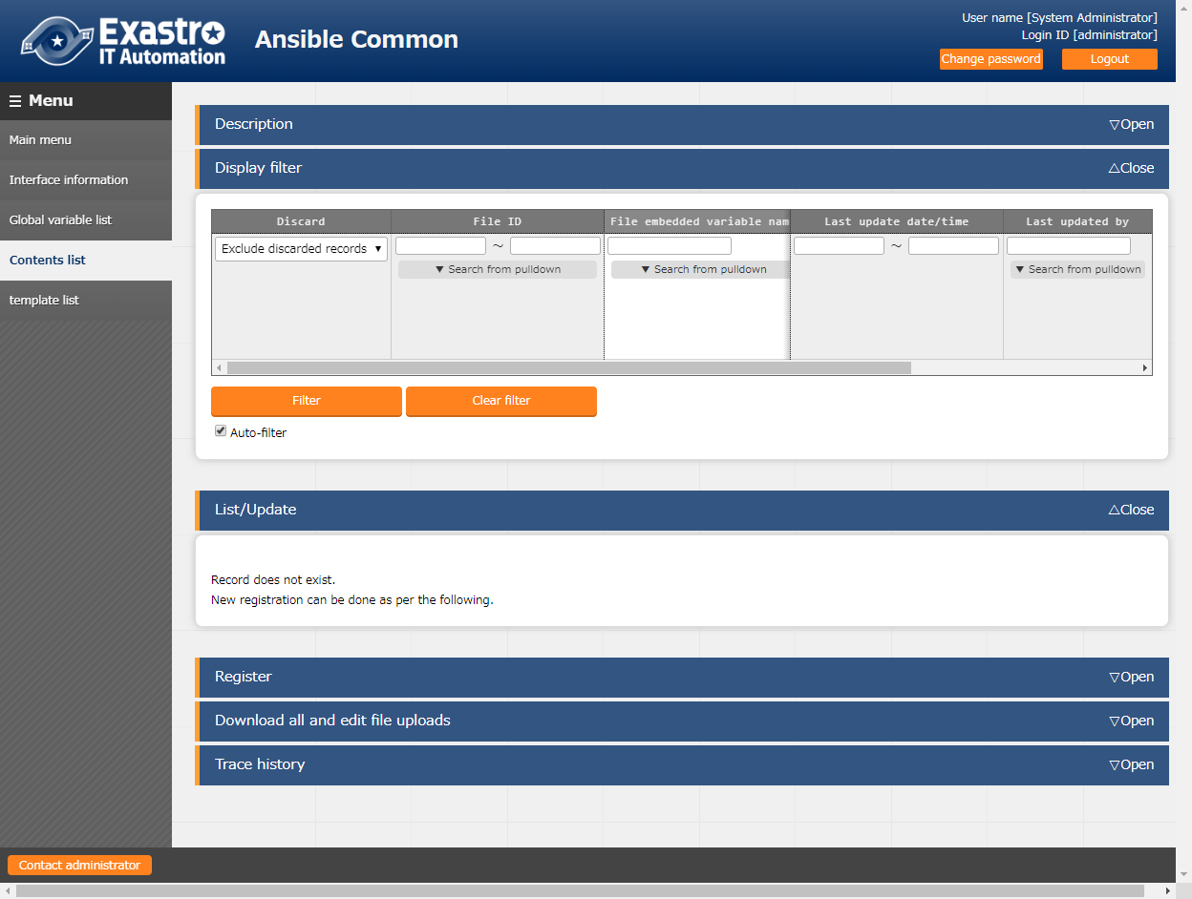

**Figure 5.2-9 submenu screen (Contents list)**

1. Click the "Register" - "Start Registration" button to register the file management information.

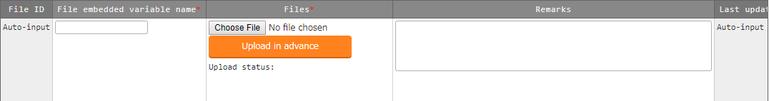

Figure 5.2-10 Registration screen (Contents list)

**(3)** The items of registration screen are as follows.

**Table 5.2-6 Registration screen item list (contents list)**

|  |  |  |  |  |
| --- | --- | --- | --- | --- |
| **Item** | **Description** | **Input required** | **Input type** | **Restrictions** |
| File embedded variable name | Enter the variable names to be embedded in the parameter of each module. Enter the variable name in the "CPF_****" format.  Half-width alphanumeric character and underscore(_) can be used.(Minimum length: 1 byte, maximum length: 128 bytes) | ○ | Manual | As writed in the description column |
| Files | Upload the file used in each module. | ○ | File | Maximum size 4GB |
| Remarks | Free description field. | - | Manual | Maximum length 4000 bytes |

Please "Upload in advance (①)" the "template files" before "register".

Please click the "Register" button after checking the Playbook file name displayed in the "Upload status(②)".



1. Write Playbook

When describing each modules in the Playbook, write the file embedded variable name.

|  |  |  |  |  |  |  |  |  |
| --- | --- | --- | --- | --- | --- | --- | --- | --- |
| e.g)  **Playbook**  Registration content   |  |  | | --- | --- | | File embedded variable name | Files | | CPF_hosts | hosts |   -copy: src='{{△CPF_hosts△}}' dest=/etc/hosts  △: half-width space  Please write the file name for dest. If the file name is not specified, the work will be executed with the registered file whose file name is added with the ITA management number in the front of the file name.  For example, in the case of dest=/etc/, the file name will be /etc/10-digit-number_hosts  -unarchive src={{△CPF_tool_tgz△}} dest=/usr/local/bin   |  |  | | --- | --- | | File embedded variable name | Files | | CPF_tool_tgz | tool.tgz |   △: half-width space |

1. Write dialog file

In the case of describing the dialog file, write the file embedded variable name.

|  |  |  |  |  |
| --- | --- | --- | --- | --- |
| e.g)  **Dialog file**  Registration content  - expect: '{{△__loginuser__△}}@{{△__loginhostname__△}}'  exec: 'scp △ITA user@ITA host name:{{△CPF_hosts△}}△forwarding destination'  - expect: 'password:'  exec: 'exec: ITAuser password'   |  |  | | --- | --- | | File embedded variable name | Files | | CPF_hosts | hosts |   △:half-width space  Please write the file name in the forwarding destination.  If the file name is not specified, the work will be executed with the registered file whose file name is added with the ITA management number in the front of the file name.  For example, in the case of forwarding destination=/etc/, the file name will be /etc/10-digit-number_hosts  {{△CPF_hosts△}} will be replaced by the absolute path of forwarding origin during execution. |

### Collection interface information

In [Collection Interface Information], in order to use the standard RESTAPI of ITA used in the collect function, the connection interface information for RESTAPI access is updated.

For details, please refer to the "Exastro-ITA_User_Instruction_Manual _Collect Function".

### Collection item value list

In [Collection item value list], the item to be collected is linked to the item of the parameter sheet.

For details, please refer to the "Exastro-ITA_User_Instruction_Manual _Collect Function".

(1) Clicking the Menu name or the List/Update Menu ID will move the user to that selected menu.  
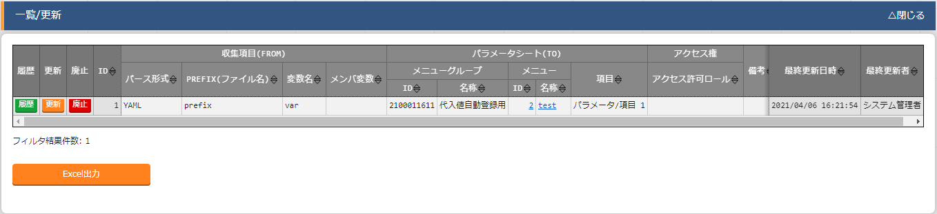

**Figure 5.2‑11 Submenu screen (Collected item value list)**

## Ansibel-Legacy／Legacy Role／Pioneer console

The operation of Ansibel-Legacy／Legacy Role／Pioneer console.

### OS type master

* + - 1. On the [OS Type master] screen, the OS type of the device to be operated is managed from the ITA Pioneer.

※This menu exists only in the Ansible-Pioneer console.

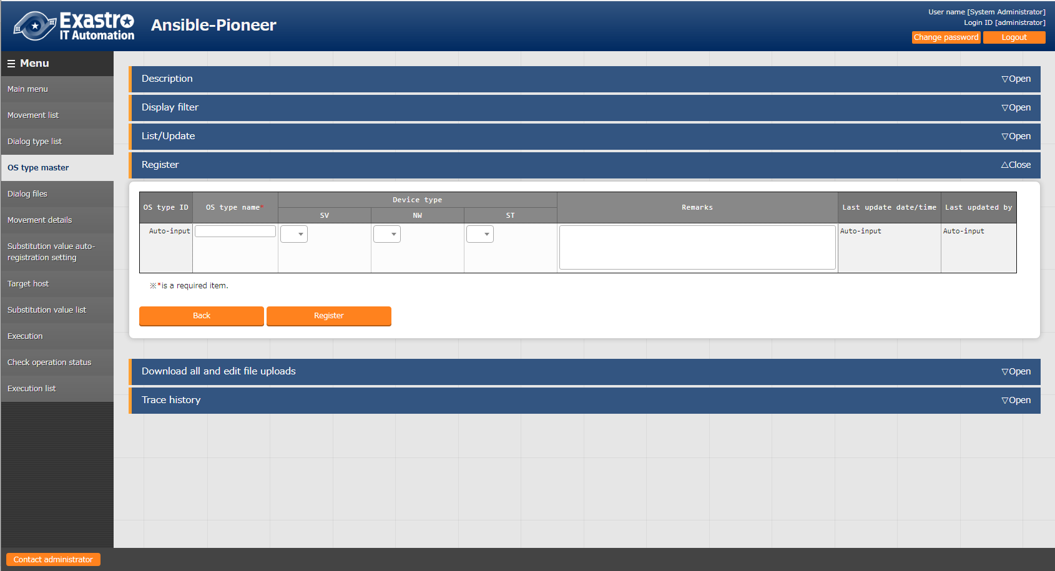

**Figure 5.3-1 Submenu screen (OS type master)**

* + - 1. Click the "Register"-"Start Registration" button to register the OS information.

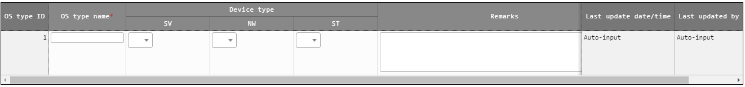

**Figure 5.3-2 registration screen (OS type master)**

(3) Clicking the Dialogue file material collection button will move the user to the target 5.3.6 Dialogue file collection.

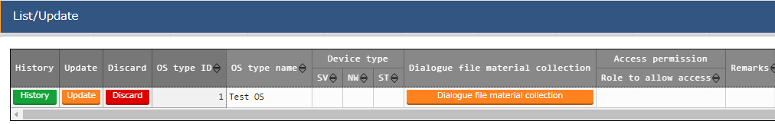**Figure 5.3-3 Sub menu screen (OS Type master)**

(4) The list of items on the registration screen is as follows.

**Table 5.3-2 registration screen item list (OS type master)**

|  |  |  |  |  |  |
| --- | --- | --- | --- | --- | --- |
| **Item** | | **Description** | **Input required** | **Input type** | **Restrictions** |
| OS type ID | | A unique ID that identifies the registration information will be automatically entered. | ○ | Auto | - |
| OS type name | | Enter any device name. | ○ | Manual | Maximum length 256 bytes |
| Model | SV | Select "●" if the equipment type is a server. | - | List | - |
| NW | Select "●" if the device type is network device. | - | List | - |
| ST | Select "●" if the device type is storage device. | - | List | - |
| Remarks | | Free description field. | - | Manual |  |

### Movement list

1. Register/Update/Discard Movement name in "Movement list"

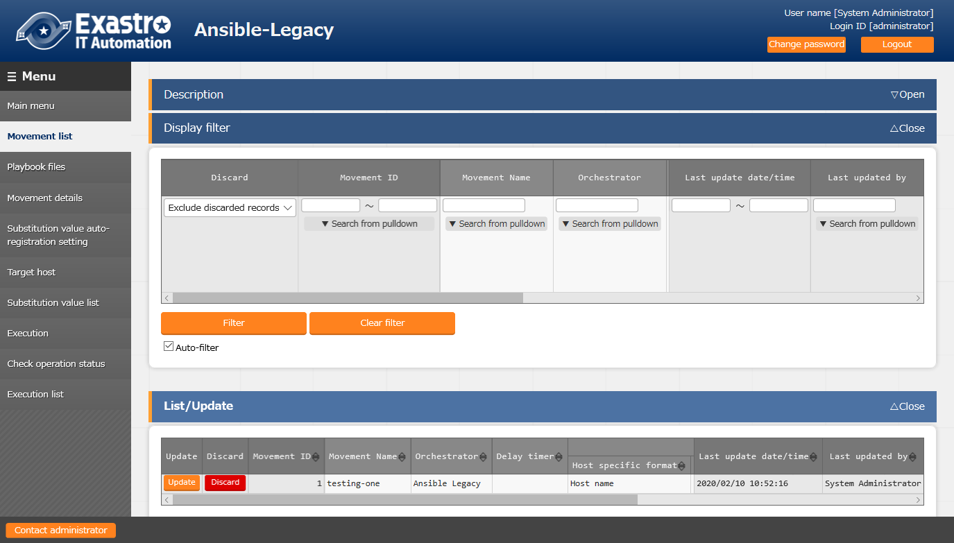

**Figure 5.3-4 submenu screen (Movement list)**

1. Click the "Register" - "Start Registration" button to register the Movement information.

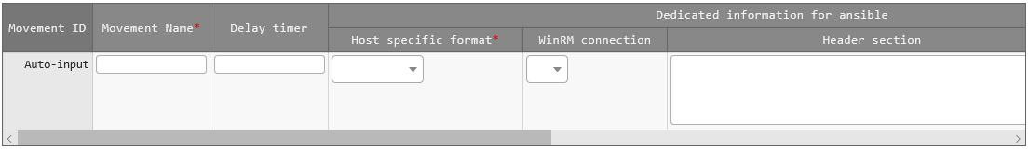

**Figure 5.3-5 Registration screen (Movement list)**

**(3)** Clicking the Movement-Playbook link (Movement-Dialogue type link, Movement - Role link) button will move the user to the target 5.3.7Movement-Playbook link (Movement-Dialogue type link, Movement - Role link).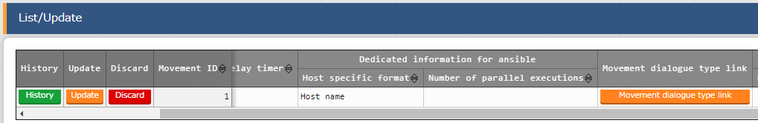

**Figure 5.3-6 Submenu screen (Movement list)**

**(4)**The list of registration screen items are as follows.

Table 5.3-2 Registration screen item list (Movement list)

| Item | Description | **Input required** | **Input type** | **Restrictions** |
| --- | --- | --- | --- | --- |
| Movement name | Enter the name of Movement | ○ | Manual | Maximum length 256 bytes |
| Delay timer | Enter the specified period (1~) if you want the warning of delay status to display when the scheduled time of Movement has delayed. (Unit:minute)  The warning will not display if the column is not entered. | - | Manual | - |
| Host specific format | Select "Host name" if the user wants to specify the host that is not represented by an IP address. Normally IP is recommended | ○ | List | - |
| Number of parallel executions※1  ※Only displayed in the Pioneer Movement list | Enter the number of target hosts that Ansible can execute simultaneously.  ■About the behavior when the column is not entered  ・In the case of Ansible driver, the content of configuration file(/etc/ansible.conf) in the server will be the default values.  ・In the case of AnsibleTower driver, the default value of AnsibleTower will be used. | - | Manual | NULL or Integer |
| WinRM connection ※2 | Select "●" if the target host if WindowsServer. | - | List | - |
| Header section  ※ Not displayed in the Pioneer Movement list | Edit the parent Playbook automatically generated by ITA from the beginning to the tasks or roles section.  The following will be applied if the column is not entered.  Ansible:  - hosts: all  remote_user: \"{{ __loginuser__ }}\"  gather_facts: no  become: yes  Ansible Tower:  - hosts: all  　　　gather_facts: no  become: yes  ※In case of connecting with winrm, become:yes can't be applied. | - | Manual | Maximum length 512 bytes |
| Optional parameter※3 (Not displayed in the Pioneer Movement list) | Enter the Movement-specific optional parameter of Ansible-Playbook command.  In the case that the execution engine is Ansible:  Enter the optional parameter of Ansible-Playbook command.  The -i option is set by ITA  In the case that the execution engine is Ansible Tower:  　 The following option operator can be set  　　-verbosity  　　-f FORKS,--forks=FORKS  　　-l SUBSET,--limit=SUBSET  　　-e EXTRA_VARS,--extra-vars=EXTRA_VARS  EXTRA_VARS: Variable name=specific value Variable name=specific value.  　　-t TAGS,--tags=TAGS  　　-b,--become  　　-D,--diff  　　--skip-tags=SKIP_TAGS  　　--start-at-task=START_AT_TASK  　 The original optional parameters of AnsibleTower are as follows.  　　-ufc,--use_fact_cache　 use fact cache  　　-as,--allow_simultaneous enable simultaneous job execution  　　-jsc,--job_slice_count=　　　 job slice count  For the original optional parameters of AnsibleTower, please refer to the description of job template in the Ansible Tower user guide. | - | Manual | Maximum length 256 bytes |
| **Virtualenv**  **※**Displayed when the execution engine is AnsibleTower | Select the Ansible execution environment where virtualenv is constructed.  The Ansible execution environment used when installing Tower will be used if this column is not selected. | - | List |  |
| Remarks | free description field | - | Manual | Maximum length 4000 bytes |

※1 If the executing engine is Ansible,

You can also set optionial parameter,"--forks", in "Movement list"->"Optionial Parameter".

If you also set the parameters in InterfaceInformation -> Optional parameters, that parameter will be enabled.

If the executing engine is Ansible Tower,

You can also set option parameter"--forks" in "Movement list"->"Optionial Parameter".

If the parameter is also set in InterfaceInformation -> Optional parameters, an error will occur when executing the operation.

※2 If you're using anything else than WindowsServer, make sure choose Blank from the list.

※3 Optional parameters can also be set from "InterfaceInformation ->Optional parameters".

For details regarding how the system operates when the same parameter is defined multiple times, please see the InterfaceInformation section.

**【Notes】**

**In the case of selecting "●" in the WinRM connection column, all connection hosts will be considered as WindowsServer.**

### Playbook file list (Ansible-Legacy only)

1. Register/update/discard the Playbooks created by users in the "Playbook files" menu.  
   ※This menu only exists in the Ansible-Legacy console.

Please refer to " 6.1 Write Playbook (Ansible-Legacy)" about describing Playbook.

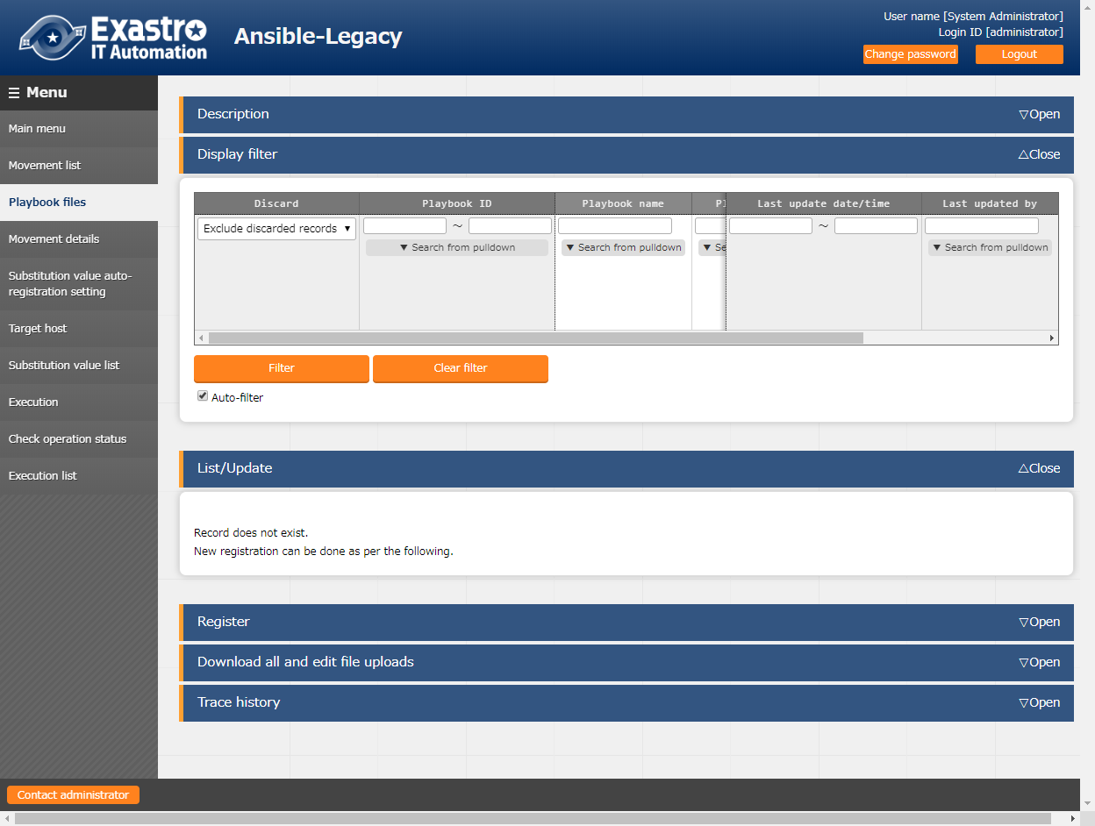

**Figure 5.3-7 Submenu screen (Playbook files)**

1. Click the "Register" - "Start Registration" button to register the Playbook.

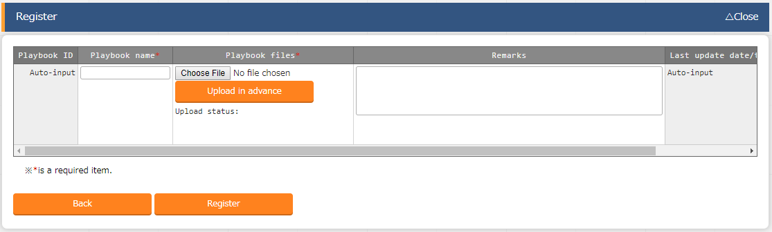

Figure 5.3-8 Registration screen (Playbook files)

1. Clicking the Movement-Playbook link (Movement-Dialogue type link, Movement - Role link) button will move the user to the target 5.3.7Movement-Playbook link (Movement-Dialogue type link, Movement - Role link).

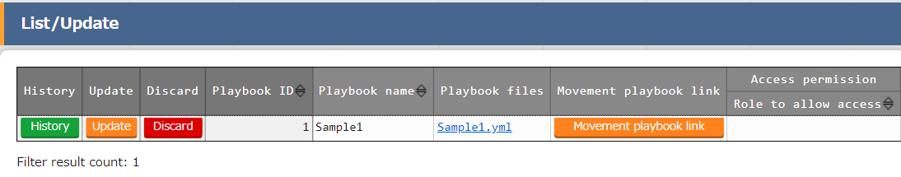

**Figure 5.3‑9 Submenu screen （Playbook files）**

1. The list of registration screen items are as follows.

**Table 5.3-3 Registration screen item list (Playbook files)**

|  |  |  |  |  |
| --- | --- | --- | --- | --- |
| Item | Description | **Input required** | **Input type** | Restrictions |
| Playbook name | Enter the Playbook name to be managed in ITA. | ○ | Manual | Maximum length 256 bytes |
| Playbook files | Upload the created Playbook file.  Please make sure that the playbook file is created with UTF-8 Code when uploading it.  Playbook files other than those with a character code of UTF-8 and without BOM will get an error in uploading. | ○ | File | Maximum size 4GB |
| Remarks | Free description field. | - | Manual | Maximum length 4000 bytes |

Please "Upload in advance (①)" the "Playbook files" before "register". Please click the "Register" button after checking the Playbook file name displayed in the "Upload status(②)".

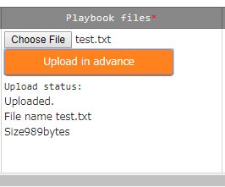

The internal process will extract the variables defined in Playbook files.Users can register specific value of the extracted variables in menu "5.3.9 Substitution value auto-registration setting" and menu "5.3.11 Substitution value list".

Since the timing of extraction is not in real time, it may take some time※1 until the variables can be handled in menu "5.3.9 Substitution value auto-registration setting" and menu "5.3.11 Substitution value list".

※1 The timing of extraction is writed in " 7.2 About the maintenance method", so please refer to it.

### Role package list (Ansible-Legacy Role only)

**(1)** Register/upload/discard the role package file created by the users.

※This menu only exists in Ansible-Legacy Role console.

Please compress the directory of the hiearchy level which contains "roles" into zip file and register role package file with the zip file.

Please refer to " 6.3 Write role package (Ansible-Legacy Role)" for the structure of role package directory.

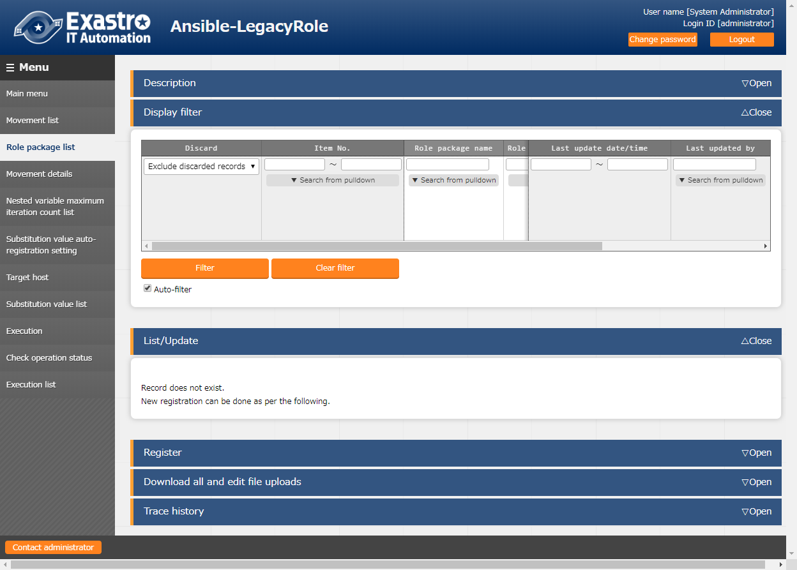

**Figure 5.3-10 Submenu screen (Role package list)**

**(2)** Click the "Register" - "Start Registration" button to register the Playbook.

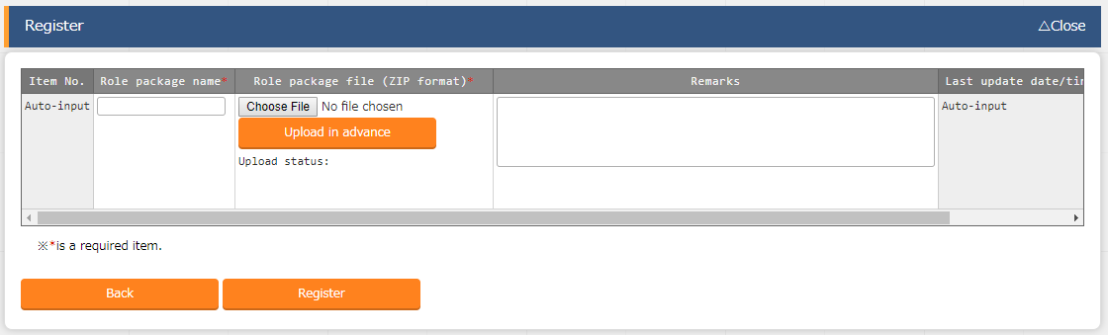

**Figure 5.3-8 Registration screen (Role package list)**

**(3)** Clicking the Movement-role link (Movement-Dialogue type link, Movement - Role link) button will move the user to the target 5.3.7 Movement-Playbook link (Movement-Dialogue type link, Movement - Role link).

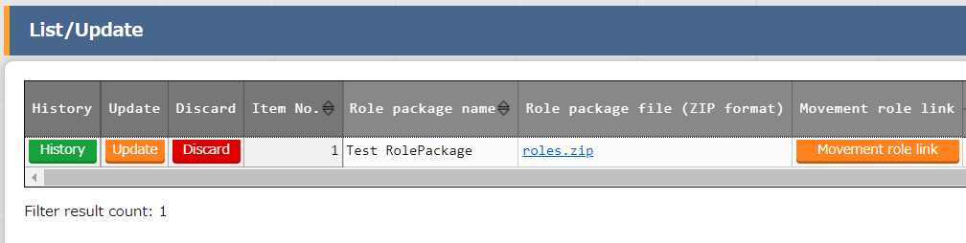

**Figure 5.3-12 Submenu screen (Role package list)**

**(4)** The list of registration screen items are as follows.

**Table 5.3-4 Registration screen item list (Role package list)**

|  |  |  |  |  |
| --- | --- | --- | --- | --- |
| Item | Description | **Input required** | **Input type** | **Restrictions** |
| Role package name | Enter the role package name to be managed in ITA. | ○ | Manual | Maximum length 256 bytes |
| Role package file | Upload the created role package file (zip format).  Please make sure that the role package file is created with UTF-8 Code and without BOM when uploading it.  If a playbook file other than UTF-8 without BOM is included, an error will occur during registration.  For details, plese refer to the 6.3 Role package (Ansible-Legacy Role). | ○ | File | Maximum size 20M bytes |
| Remarks | Free description field. | - | Manual | Maximum length 4000 bytes |

Please "Upload in advance (①)" the "Role package file" before "register".

Please click the "Register" button after checking the role package file name displayed in the "Upload status (②)".

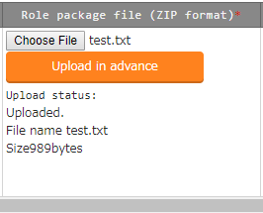

The internal process will extract the variables defined in Role package files.Users can register specific value of the extracted variables in menu "5.3.9 Substitution value auto-registration setting" and menu "5.3.11 Substitution value list".

Since the timing of extraction is not in real time, it may take some time※1 until the variables can be handled in menu "5.3.9 Substitution value auto-registration setting" and menu "5.3.11 Substitution value list".

※1 The timing of extraction is writed in " 7.2 About the maintenance method", so please refer to it.

### Dialog type list (Ansible-Pioneer only)

1. Register/update/discard dialog type in the "dialog type list" menu

This menu only exists in the Ansible-Pioneer console

Ansible-Pioneer defines the differences for each OS type in each dialog file, and combines the same purpose dialog file as dialog type to remove (abstract) the device difference.

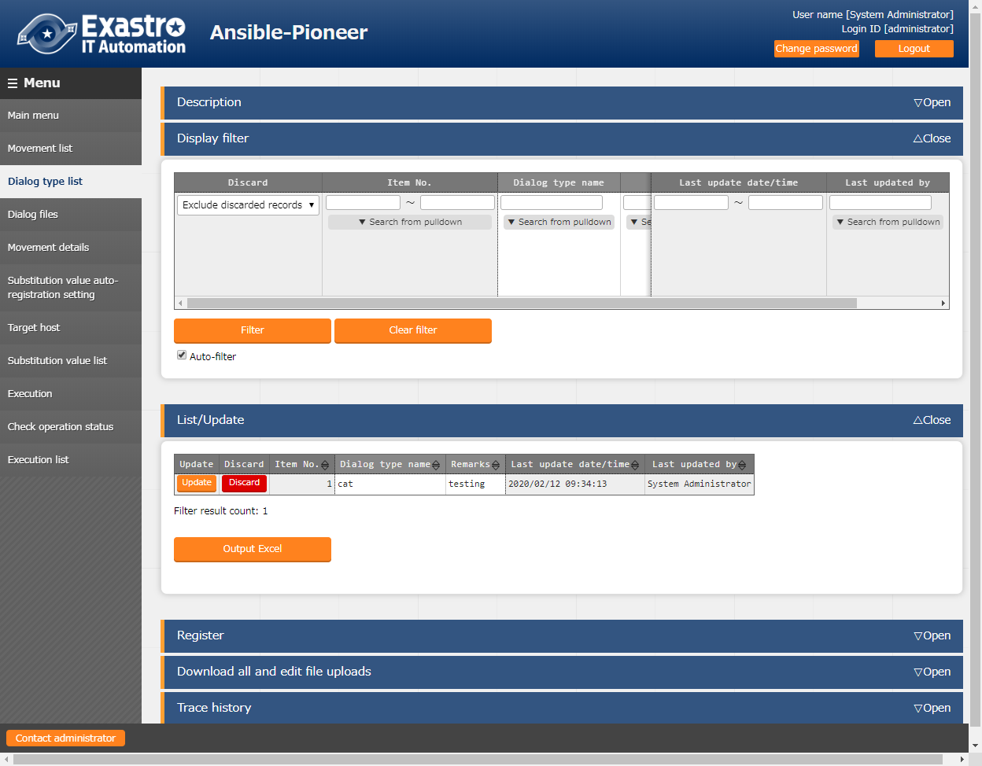

**Figure 5.3-13 Submenu screen (dialog type list)**

1. Click the "Register" - "Start Registration" button to register the operation information.

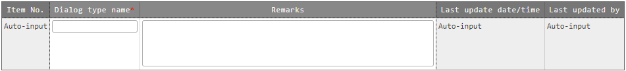

Figure 5.3-14 Registration screen (Dialog type list)

1. Clicking the Movement-dialogue type link (Movement-Dialogue type link, Movement - Role link) button will move the user to the target 5.3.7 Movement-Playbook link (Movement-Dialogue type link, Movement - Role link). Clicking the Dialogue file material collection button will move the user to the target 5.3.6 Dialogue file material collection.  
   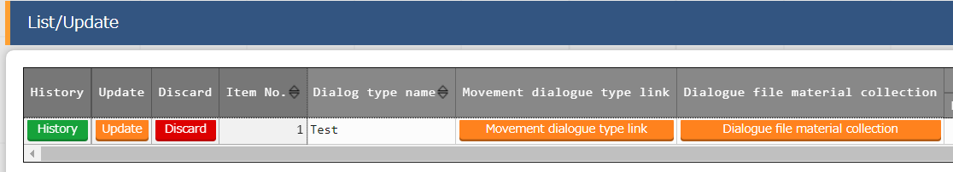

**Figure 5.3-15 Submenu screen (Dialogue type list)**

1. The list of registration screen items are as follows.

**Table 5.3-5 Registration screen item list (Dialog type list)**

|  |  |  |  |  |
| --- | --- | --- | --- | --- |
| Item | Description | Input required | Input type | Restrictions |
| Dialog type name | Enter the name of dialog type | ○ | Manual | Maximum length 256 bytes |
| Remarks | Free description field | - | Manual | Maximum length 4000 bytes |

### Dialog files (Ansible-Pioneer only)

1. Register/update/discard the dialog file created by users in "dialog files" menu.

※This menu only exists in Ansible-Pioneer console.

1. Please refer to " 6.2 Write Dialog file (Ansible-Pioneer)" for describing the dialog file, etc.

Register dialog files for each combination of dialog type and OS type.

Please register dialog file of each "OS type" with the same "dialog type" in the case of supporting multiple OS types with one "dialog type".

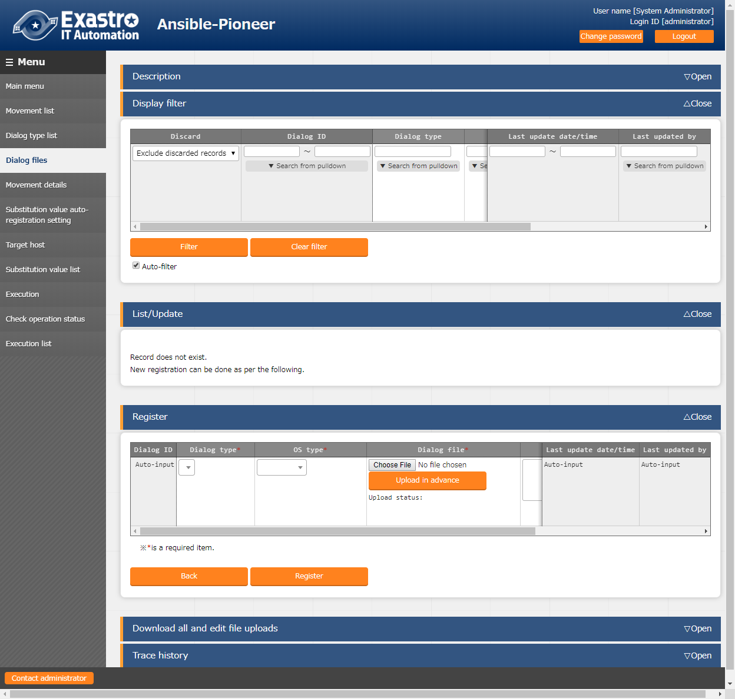

**Figure 5.3-16 Submenu screen (dialog files)**

1. Click the "Register" - "Start Registration" button to register the dialog files.

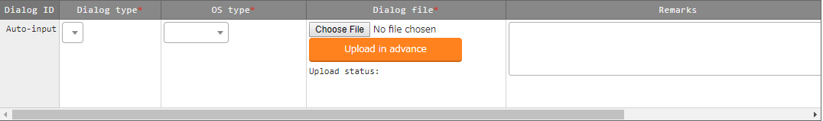

Figure 5.3-17 Registration screen (dialog files)

1. Clicking the list/update’s Dialog type will move the user to the 5.3.5 dialog type list.   
   Clicking the OS Type will move the user to the 5.3.1 OS Type master.

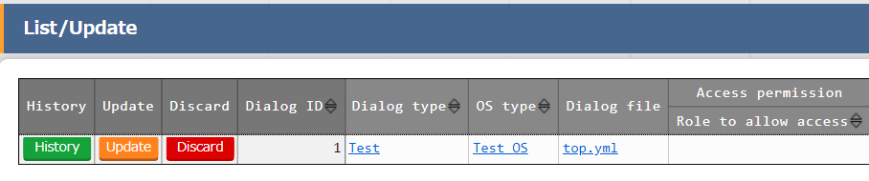  
**Figure 5.3-18 Submenu screen (Dialog files)**

1. The list of registration screen items are as follows.

**Table 5.3-6Registration screen item list (Dialog files)**

|  |  |  |  |  |
| --- | --- | --- | --- | --- |
| Item | **Description** | **Input**  **required** | **Input type** | **Restrictions** |
| Dialog type | The dialog type registered in the dialog type list menu will be displayed. Select the dialog type of dialog file to be registered. | ○ | List | - |
| OS type | The OS type registered in the OS type master menu will be displayed. Select the OS type of dialog file to be registered. | ○ | List | - |
| Dialog file | Upload the dialog file according to the dialog type and OS type.  Please make sure that the file is created with UTF-8 Code and without BOM when uploading it.  An error will occur if the character code is anything else. | ○ | File | Maximum size 4gb |
| Remarks | Free description field. | - | Manual | Maximum length 4000 bytes |

Please "Upload in advance (①)" the "dialog file" before "register".

Please click the "Register" button after checking the dialog file name displayed in the "Upload status(②)".

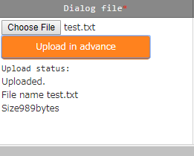

The internal process will extract the variables defined in dialog files.Users can register specific value of the extracted variables in menu "5.3.9 Substitution value auto-registration setting" and menu "5.3.11 Substitution value list".

Since the timing of extraction is not in real time, it may take some time※1 until the variables can be handled in menu "5.3.9 Substitution value auto-registration setting" and menu "5.3.11 Substitution value list".

※1 The timing of extraction is writed in " 7.2 About the maintenance method", so please refer to it.

### Movement details

1. Register/update/discard the files executed in the Movement in "Movement details" menu.

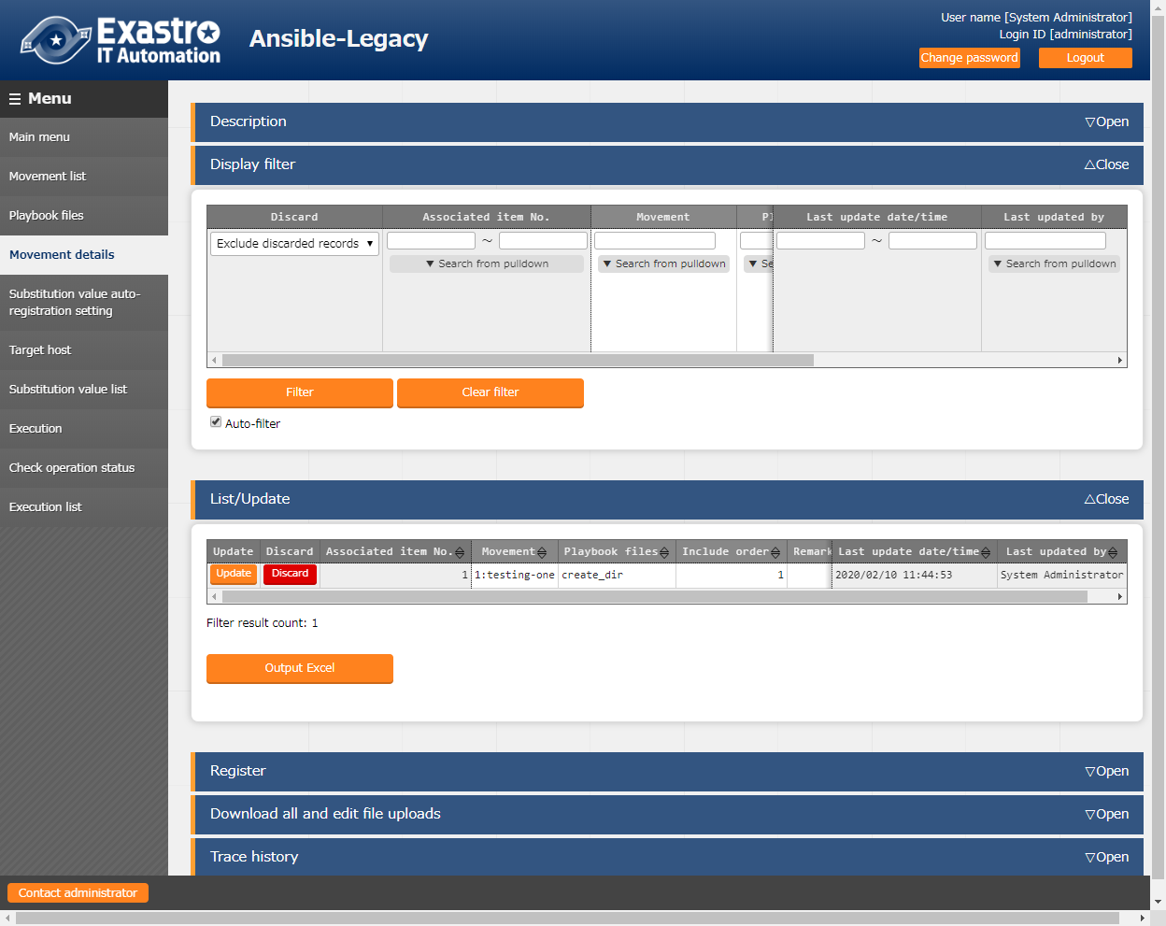

**Figure 5.3-19 Submenu screen (Movement details)**※The screen is from Ansible Legacy.

1. Click the "Register" - "Start Registration" button to register the details of Movement.

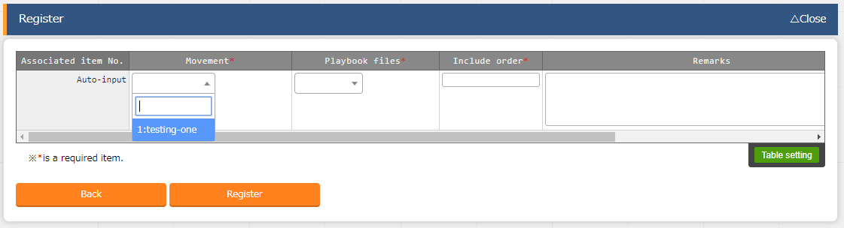

Figure 5.3-20 Registration screen (Movement details)

1. Clicking the Movement button will move the user to the target 5.3.2 Movement list.  
   Clicking the Playbook file button will move the user to the target 5.3.3 playbook files.  
   ※For Movement-dialog type link (Ansible-Pioneer), it will be Movement and Dialoge type.  
   For Movement-Role link (Ansible-Legacy role), it will be Movement and Role package name link.

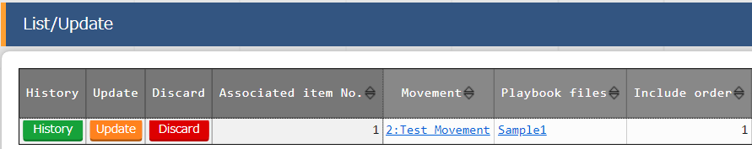

1. The list of registration screen items are as follows.

* **In Ansible-Legacy**

**Table 5.3-7 Registration screen item list (Movement details in Ansible-Legacy console)**

|  |  |  |  |  |
| --- | --- | --- | --- | --- |
| Item | Description | Input required | Input type | Restrictions |
| Movement | The Movement registered in the Movement list will be displayed. Select the Movement. | ○ | List | - |
| Playbook file | The Playbook file registered in "5.3.3 Playbook file list (Ansible-Legacy only)" will be displayed. Select the Playbook file. | ○ | List | - |
| Include order | Enter the execution order of playbook files (unique value starts from 1). Playbook files will be executed as the enetered include order (ascending). | ○ | Manual | Half-width integer |
| Remarks | Free description field. | - | Manual | Maximum length 4000 bytes |

* **In Ansible-Legacy Role**

**Table 5.3-8 Registration screen item list (Movement details in Ansible-Legacy Role console)**

|  |  |  |  |  |
| --- | --- | --- | --- | --- |
| Item | Description | Input required | Input type | Restrictions |
| Movement | Same as Ansible-Legacy | ○ | List | - |
| Role package name | The role package registered in the role package list menu will be displayed.Select the role package to be executed.  Multiple role packages cannot be registered in the same Movement. | ○ | List | - |
| Role name | The role names included in role package selected in role package name are displayed.Select the role in the role package to be executed. | ○ |  | - |
| Include order | Same as Ansible-Legacy | ○ | Manual | Half-width integer |
| Remarks | Free description field. | - | Manual | Maximum length 4000 bytes |

* **In Ansible-Pioneer**

**Table 5.3-9 Registration screen item list (Movement details in Ansible-Pioneer console)**

|  |  |  |  |  |
| --- | --- | --- | --- | --- |
| Item | Description | Input required | Input type | Restrictions |
| Movement | Same as Ansible-Legacy. | ○ | List | - |
| Dialog type | The dialog type registered in “Dialog type list (Ansible-Pioneer list” will be displayed. Select the dialog type of dialog file to be executed.  The dialog file linked with the OS type and dialog type of every host are execution target. | ○ | List | - |
| Include order | Same as Ansible-Legacy | ○ | Manual | Half-width integer |
| Remarks | Free description field. | - | Manual | Maximum length 4000 bytes |

### Nested variable list (Ansible-Legacy Role only)

**(1)** In the "Nested variable list" menu, update the maximum iteration count of member variable array defined as nested array in the nested variable which is defined in the role package registered in "5.3.4 Role package list (Ansible-Legacy Role only)". Click the update button of the member variable that the user want to change and update the maximum iteration count.

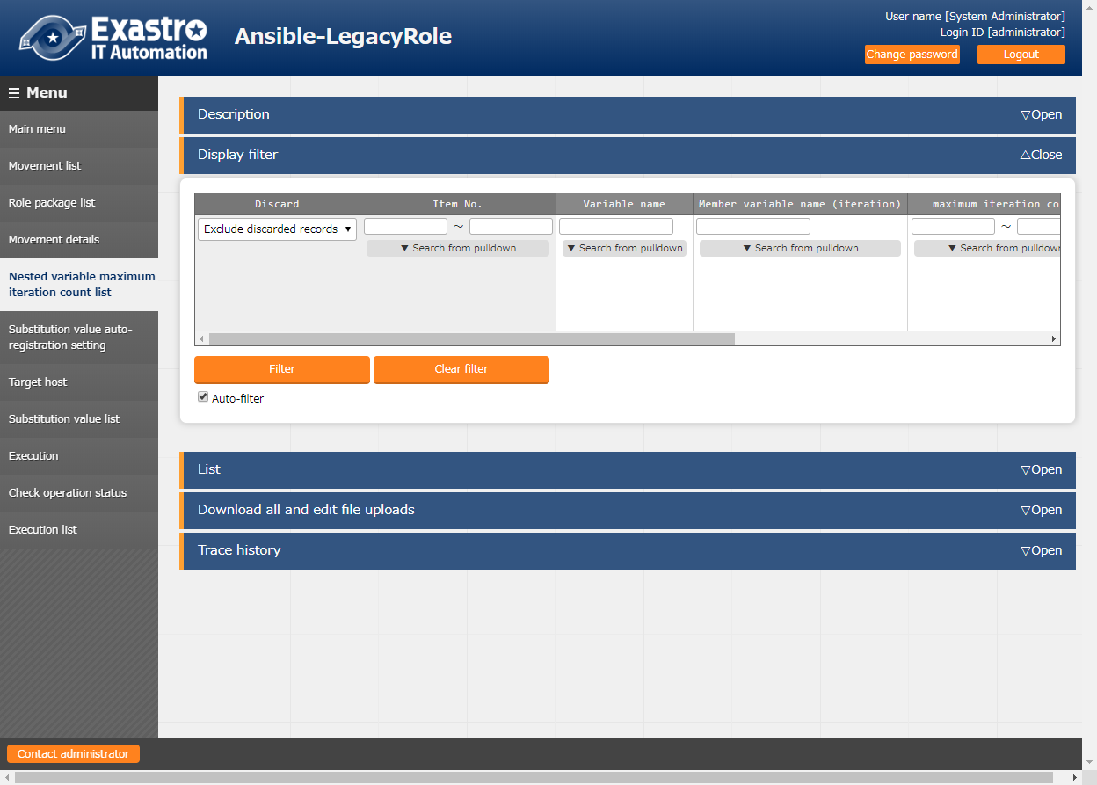

**Figure 5.3-22 Submenu screen (Nested variable list)**

**(2)** Click the "List" - "Update" button to update the maximum iteration count.

**（※Not the registration button）**

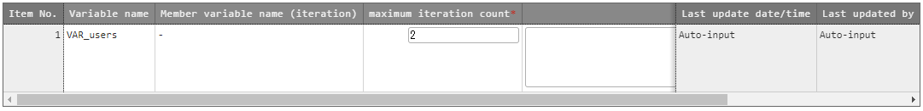

**Figure 5.3-23 Registration screen (Nested variable list)**

**(3)** The list of registration screen items are as follows.

**Table 5.3-10 Registration screen item list (Nested variable list)**

|  |  |  |  |  |
| --- | --- | --- | --- | --- |
| Item | Description | Input required | Input type | Restrictions |
| maximum iteration count | Enter the maximum iteration count of the array in the range of 1~99,999,999. | ○ | Manual | Value 1～99,999,999 |
| Remarks | Free description field. | - | Manual | Maximum length 4000 bytes |

The display of member variable names are the variables of each heriarchy level scoped with ".".

Also, if the first level is nested array, the member variable name will be displayed as "-".

e.g.)

|  |  |
| --- | --- |
| **Variable definition**  VAR_users:  - name: alice  authorized:  - /tmp/alice/onekey.pub  - create_users:  　　　Name: root  password: xxxxxxxxx  - create_users:  　　　Name: mysql  password: xxxxxxxxx | **Display of member variable**  **default value of the**  **maximum iteration count**   * + 1   create_users　　　　　　　　 2 |

The internal process initially registers the iteration count of member variable defined in the nested variable which is defined in the role package. After the initial registration, the iteration count can be updated in the "Nested variable list" menu.

Also, since initial registration and update of iteration count is not in real time, it may take some time※1 until the variables can be handled in menu "5.3.9 Substitution value auto-registration setting" and menu "5.3.11 Substitution value list".

※1 The timing of extraction is writed in " 7.2 About the maintenance method", so please refer to it.

**(4**) Unique list of variable names

Variable name list is unique in all role packages. When using the same variable name across role packages, the number of repetitions set in multistage variable maximum repeat list applies to variables in all role packages.

1. Access permission role

The permission role is set for multistage variable maximum repeat list is set to the role package management permission role for which the variable will be defined. If a variable is defined in more than one role package list, all permission roles in the role package lists will be set. If the permission role is empty, access to all roles will be treated as accessible. If the access permission role for each role package list is blank, the permission role for multistage variable maximum repeat list will be also se to blank. For more information about access permission roles, please refer to the "User_Instruction_Manual_Role-Based Access Control."

|  |  |  |  |  |  |
| --- | --- | --- | --- | --- | --- |
| Role package list | | |  | Multistage variable maximum number of repetitions | |
| Role package | Variable | Access permission role |  | Variable | Access permission role |
| Packeage_A | VAR_nest1 | blank |  | VAR_nest1 | Blank |
| Packeage_A | VAR_nest2 | blank |  | VAR_nest2 | blank |
| Packeage_A | VAR_nest3 | Role_A |  | VAR_nest3 | Role_A,Role_B |
| Packeage_B | VAR_nest2 | Role_A |  | VAR_nest4 | Role_C |
| Packeage_B | VAR_nest3 | Role_B |
| Packeage_B | VAR_nest4 | Role_C |

### Substitution value auto-registration setting

1. Link the parameter sheet created in menu creation function with the variables in the Movement. The registered information will reflected to "substitution value list" menu and "target host" menu by internal process.

The reflection rule is writed in “6.6BackYard contents (2) Substitution value auto-registration setting”.

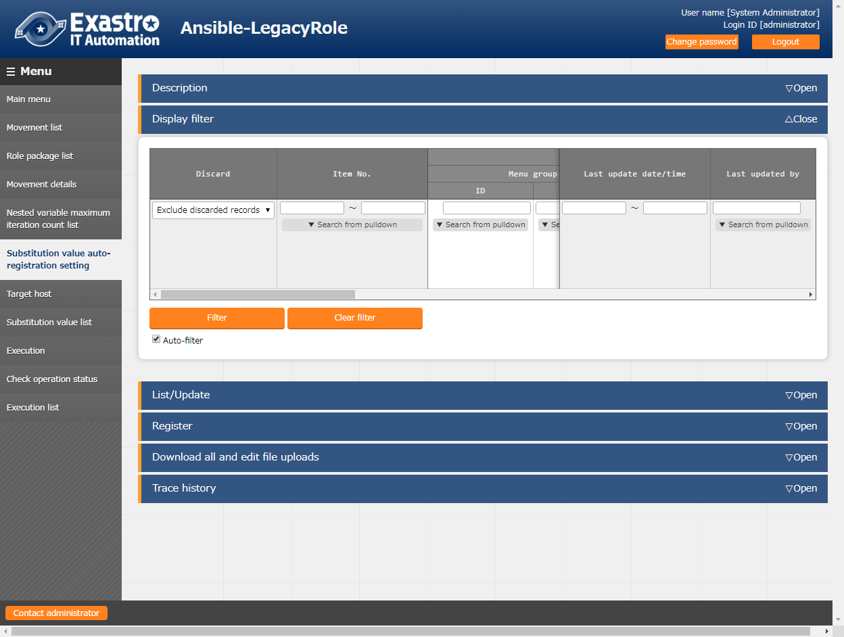

**Figure 5.3-24 Submenu screen (Substitution value auto-registration setting)**

※The screen is from Ansible-Legacy Role

**(2)** Click the "Register" - "Start Registration" button to set the substitution value auto-registration.

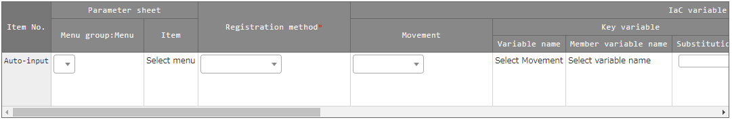

**Figure 5.3-25 Registration screen (Substitution value auto-registration setting)**

**(3)** Clicking the "List/Update" Menu ID/Menu link will move the user to the target menu.。

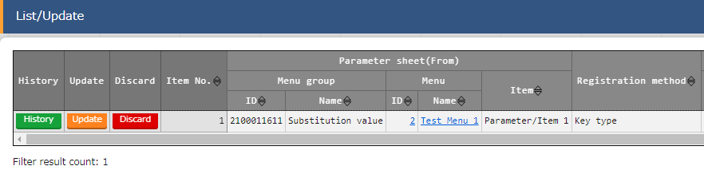

**Figure 5.3-26 Submenu screen (Substitution value auto registration setting)**

**Table 5.3-11 corresponding column list (Substitution value auto-registration setting)**

|  |  |  |  |  |
| --- | --- | --- | --- | --- |
| Column | | Legacy | Legacy Role | Pioneer |
| Menugroup:Menu | | ○ | ○ | ○ |
| Item | | ○ | ○ | ○ |
| Registration method | | ○ | ○ | ○ |
| Movement | | ○ | ○ | ○ |
| Key  variable | Variable name | ○ | ○ | ○ |
| Member variable name | － | ▲ | － |
| Substitution name | △ | △ | △ |
| Value  variable | Variable name | ○ | ○ | ○ |
| Member variable name | － | ▲ | － |
| Substitution name | △ | △ | △ |
| NULL link | | ● | ● | ● |

○: Required

●: Optional  
△: Required only if multiple specific value can be set to the selected variable.  
▲: Required only if the selected variable is nested variable  
－: Not displayed

**(4)** The list of registration screen items is as follows.

**Table 5.3-12 Registration screen item list (Substitution value auto-registration setting)**

| Column | Description | Input required | Input type | Restrictions |
| --- | --- | --- | --- | --- |
| Menugroup:Menu | The menu of parameter list is displayed.  Select the menu of association target. | ○ | List | - |
| item | The item of selected parameter list menu is displayed.  Select the item of association target. | ○ | List | - |
| Registration method | Value type： Select to set the setting value of item as the specific value of the linked variable.  Key type： Select to set the name of item as the specific value of the linked variable.  If the setting value of the item is blank, it cannot be linked.  Key-Value type： Select to set the name(Key) and setting value(Value) of item as the specific value of the linked variable. | ○ | List | - |
| Movement | The Movement registered in the Movement list will be displayed.  Select the Movement. | ○ | List | - |

| Column | | Description | Input required | Input type | Restrictions |
| --- | --- | --- | --- | --- | --- |
| Key  variable | Variable name | The variables used in the file registered in Movement details menu are displayed.  Select the variable to associate with its specific value in key type. | ○  or  ／ | List | Required if the registration method is key type of key-value type. |
| Member variable name | If nested variable is selected in the variable name column, the member variable of nested variable will be displayed.  Select the member variable. | ○  or  ／ | List |  |
| Substitution name | Required only if multiple specific value can be set to the selected variable  Enter the substitution order (1~) of specific value.  Value will be substituted in ascending order following the entered value.  Please enter the substitution order (from 1) even if there are no more specific value. | ○  or  ／ | Manual | Blank or positive integer. |
| Value  variable | Variable name | The variables used in the file registered in Movement details menu are displayed.  Select the variable to associate with its specific value in value type. | ○  or  ／ | Manual | Required if the registration method is key type of key-value type. |
| Member variable name | If nested variable is selected in the variable name column, the member variable of nested variable will be displayed.  Select the member variable. | ○  or  ／ | List | - |
| Substitution name | Required only if multiple specific value can be set to the selected variable  Enter the substitution order (1~) of specific value.  Value will be substituted in ascending order following the entered value.  Please enter the substitution order (from 1) even if there are no more specific value. | ○  or  ／ | Manual | Blank or positive integer. |
| NULL link | | Set whether to register NULL (blank) value to substitution value list menu if the specific value in parameter sheet is NULL (blank).  ・If the "Valid" is set, any value in the parameter sheet will be registered in the substitution value list menu. (NULL value will be registered)  ・If the "Invalid" is set, only specific value in the parameter sheet will be registered in the substitution value list menu (NULL value will not be registered)  ・If the column is blank, the "NULL link" value in Ansible interface information menu will be applied. | - | List | - |
| Remarks | | Free description field. | - | Manual | Maximum length 4000 bytes. |

**※ Please refer to “5.3.11 Substitution value list” for the description of member variable name.**

**(5)** If the "Ansible Common : Template list:Template Variable name / Ansible Common: File list:File embedded variable names." are used as Parameter sheet items in the Substitute value automatic registration settings,

The selected item setting value's linked Variable's specific value (Variable name) will be displayed in the Substitute value list as "{{ Variable name }}"

Parameter sheet definition

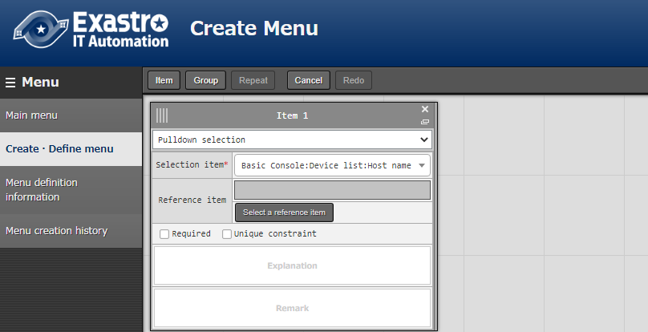

Ansible Common: File list: File embeded variable names

Parameter sheet

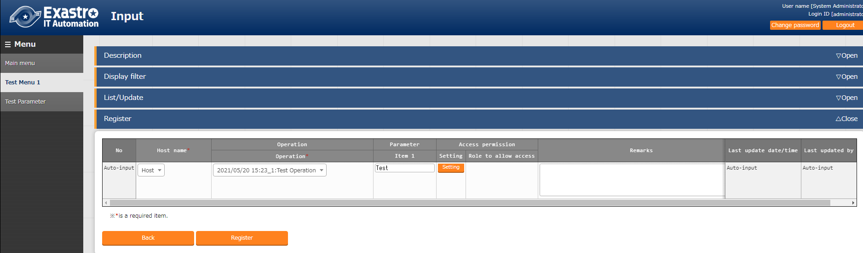

Substitution value auto-registration setting

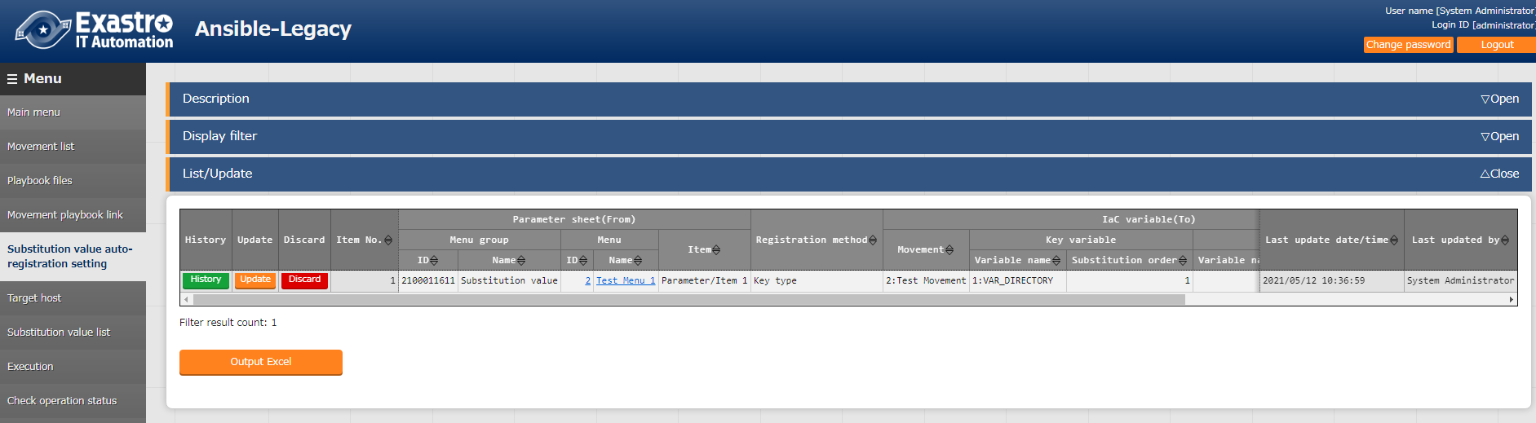

Substitution value list

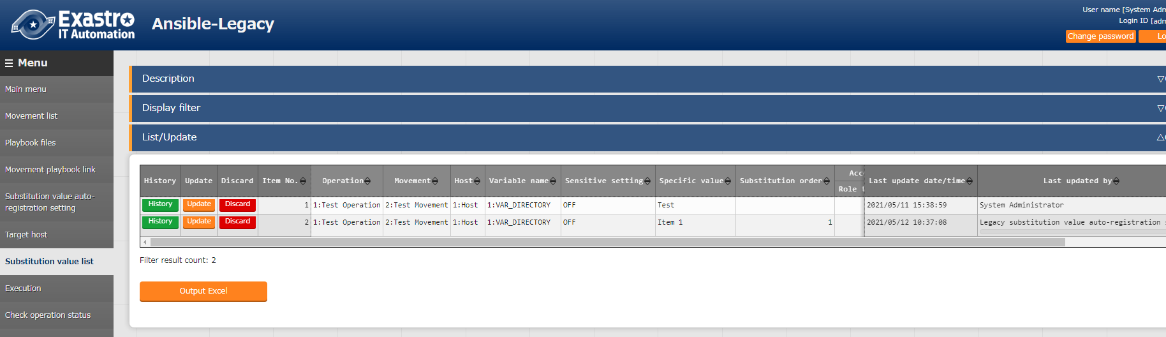

(6) Access permission role

The access permission roles set for the "Substitute value list"and "Operation target hosts" generated from the information in the "Automatic substitute value registration"will be set to the roles that match the access permission roles for each of the hosts (device list) and Operations set in the Movement and parameter sheets set in the "Automatic substitute value registration”. If the permission role is empty, access to all roles will be treated as accessible. Data without any matching role combination in each of the permission roles will not generate data in the "Substitute value list" and the target host. For more information about access permission roles, please refer to the "User_Instruction_Manual_Role-Based Access Control."

|  |  |  |  |  |
| --- | --- | --- | --- | --- |
| Operation | Host | Movement |  | Access permissions deployed to Substitution value list/ Host list |
| Access permission role | Access permission role | Access permission role |  |
| Blank | Blank | Blank |  | Blank |
| Role_A | 空白 | Blank |  | Role_A |
| Role_A | Role_A | Blank |  | Role_A |
| Role_A | Role_A | Role_A |  | Role_A |
| Role_A,RoleB | Role_A,RoleB | Role_A,Role_B,Role_C |  | Role_A,RoleB  Data without any matching role combination in each of the permission roles will not generate data in the "Substitute value list" and the target host. |
| Role_A | Role_B | Role_C |  |

### Target host

1. Register/update/discard the Movement and host linked with Operation in the "Target host" menu.

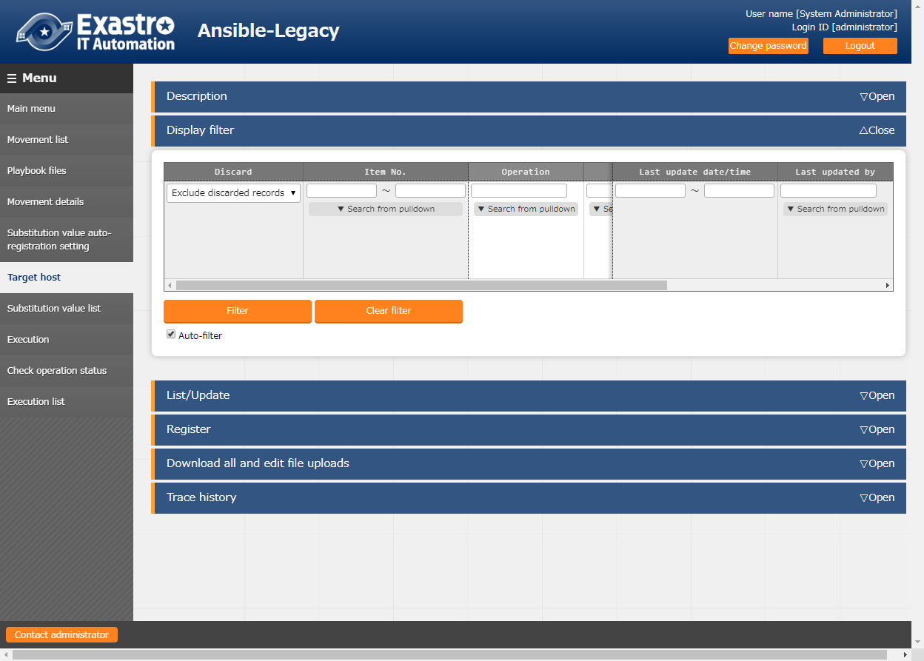

**Figure 5.3-27 Submenu screen (Target host)**

**(2)** Click the "Register" - "Start Registration" button to register the operation target host.

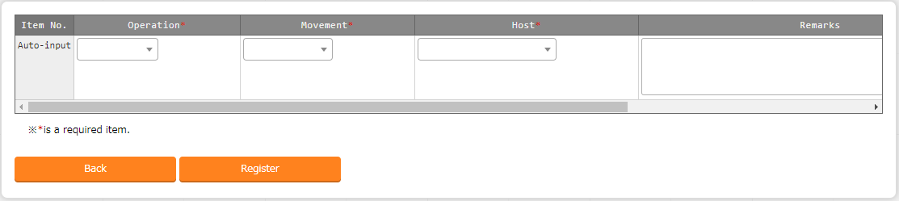

**Figure 5.3-28 Registraton screen (Target host)**

1. Clicking the Movement link in the “List/Update” submenu will move the user to the target 5.3.7 Movement-Playbook Link. Pressing the Substitution value management button will take the user to the target 5.4.11 Substitution value management

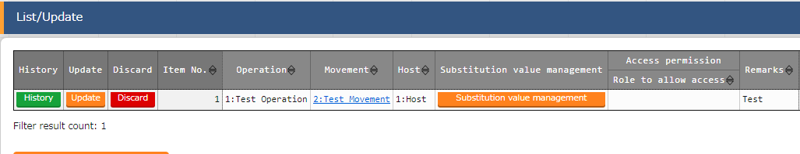

**Figure 5.3-29 Registraton screen (Target host)**

**(3)** The list of registration screen items are as follows.

**Table 5.3-13 Registration screen item list (Target host)**

|  |  |  |  |  |
| --- | --- | --- | --- | --- |
| Item | **Description** | **Input require** | **Input type** | **Restrictions** |
| operation | The Operation registered in the input operation list is displayed.Select the Operation. | ○ | List | - |
| Movement | The Movement registered in the Movement list is displayed. Select the Movement to associate with Operation. | ○ | List | - |
| Host | The host name registered in the device list will be displayed. Select the host to be linked with the Operation. | ○ | List | - |
| Remarks | Free description field. | - | Manual | Maximum length 4000 bytes |

### Substitution value list

1. Register/update/discard the substitution value of variable.

Users can perform maintenance (view/register/update/discard) of the specific values that are substituted with variable “VAR_” of Playbook and template file to be used in target Movement for each operation.

Users can also maintain the specific values that are substituted with variable “LCA_” other than "VAR_" according to the definition of translation table. Please refer to"6.5 Write translation table (Ansible-Legacy Role only)" for details.

The registered variable information will be output into host variable file (under host_vars/) during operation execution.

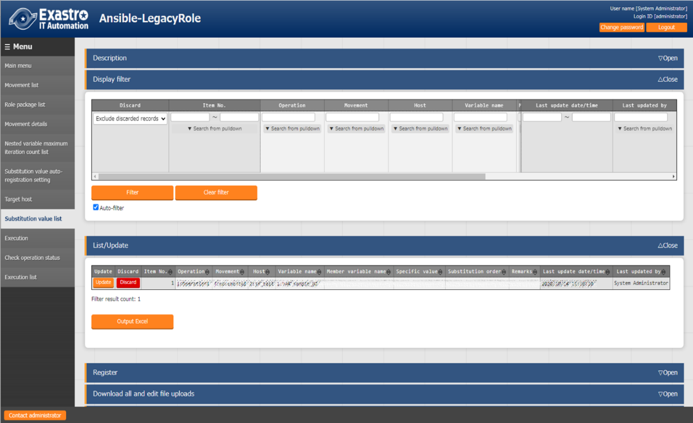

**Figure5.3-21 Submenu screen (Substitution value list)**

※The screen is from Ansible-Legacy Role.

**(2)** Click the "Register" - "Start Registration" button to manage the substitution value.

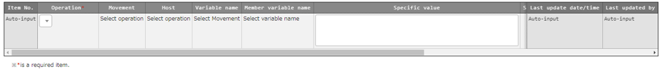

**Figure 5.3-22 Registration screen (Substitution value list)**

The variable name in substitution value list menu is reflected from the uploaded Playbook and the information registered in the substitution value auto-registration setting menu.

※ The timing of extraction is writed in " 7.2 About the maintenance method", so please refer to it.

**(3)** The list of registration screen items are as follows.

**Table 5.3-14 corresponding column list (Substitution value list)**

|  |  |  |  |
| --- | --- | --- | --- |
| column | Legacy | Legacy Role | Pioneer |
| Operation | ○ | ○ | ○ |
| Movement | ○ | ○ | ○ |
| host | ○ | ○ | ○ |
| variable name | ○ | ○ | ○ |
| Member variable name | － | ▲ | － |
| Substitution order | △ | △ | △ |
| Default value(display only) | － | ○ | － |

○: Required

△: Required only if multiple specific value can be set to the selected variable

▲: Required only if the selected variable is nested variable

－: Not displayed

**Table 5.3-15 Registration screen item list (Substitution value list)**

| Item | **Description** | **Input required** | **Input type** | **Restrictions** |
| --- | --- | --- | --- | --- |
| Operation | The Operation registered in the operation target host is displayed. Select the Operation. | ○ | List | - |
| Movement | The Movement linked with the Operation selected from the data registered in the target host menu is displayed. Select the Movement. | ○ | List | - |
| Host | The host linked with the Operation and Movement selected from the data registered in the target host menu is displayed. Select the host. | ○ | List | - |
| Variable name | The variable name attached with the Movement selected from the data registered in the Movement-Playbook link menu is displayed. Select the variable. | ○ | List | - |
| Member variable name | If nested variable is selected in the variable name column, the member variable of nested variable will be displayed. Select the member variable. | ○  or  ／ | List | - |
| Sensitive settings | Select "OFF" or "ON".  If "ON" is selected, the specific value will be encrypted and will not be displayed on ITA.  ・ For Legacy/Legacy-Role  Host variable files passed to Ansible will be set with contents encrypted in Ansible-Vault.  ・ For Pionner  Host variable files passed to Ansible will be set with ITA's original encrypted content. |  | Button |  |
| Specific value 値※１ | Enter the specific value used in Operation / Movement / Host.  File embedded variable "CPF_" and template embedded varaible "TPF_" can be entered in the specific value column.  When describing the variable, enclose the variable name in {{}} as describing them in the Playbook.  e.g. )  Entering TPF_sample as specific value.  '{{△TPF_sample△}}' △: Half-width space  ‘: recommended | ○ | Manual input | Maximum length 1024 bytes |
| Substitution order | Required only if multiple specific value can be set to the selected variable.  Enter the substitution order (1~) of specific value.  Value will be substituted in ascending order following the entered value.  Please enter the substitution order (1~) even if there are no multiple specific value. | ○  or  ／ | Manual input | Blank or positive integer |
| Default value | The specific value of variable selected in the variable name or member variable name column set in the default variable definition file(defaults->main.yml) is displayed  Please refer to " 6.4 Write ITA readme (Ansible-Legacy Role only)" for details.  True is displayed when the specific value is "Yes","Y", or "y".  False is displayed when the specific value is "No","N", or "n". | - | Display  only | - |
| Remarks | Free description field. | - | Manual input | Maximum length 4000 bytes |

※１If you are going to set filed embedded variables (CPF) or template embedded variables (TPF) to the specific values, make sure that the Sensitive settings are set to "OFF".

If the Sensitive settings are set to "ON", the variables will not be used.

【The display content of member variable name】

Selecting member variable is required only if the variable is nested variable.

Only the variable that requires specific value is displayed in the member variables.

The display of variable names of each heriarchy level is scoped with "." .

If the variable is in nested array, the variables are scoped with "[]" at the iteration position (0~).

The iteration array count is set in "5.3.8 Nested variable list (Ansible-Legacy Role only)".

e.g.)

|  |  |
| --- | --- |
| Variable definition  VAR_users:  - name: alice  authorized:  - /tmp/alice/onekey.pub  mysql:  password: mysql-password  hosts:  - "127.0.0.1"  - "localhost"  - name: bob  authorized:  - /tmp/alice/onekey.pub  mysql:  password: mysql-password  hosts:  - "127.0.0.1"  - "localhost" | Display of member variable  [0].name  [0].authorized  [0].mysql.password  [0].mysql.hosts  [1].name  [1].authorized  [1].mysql.password  [1].mysql.hosts  ※mysql is the variable which indicates the hierarchy directory, so is not displayed in member variable. |

The information registered in "substitution value auto registration setting" menu is reflected to "substitution value list" menu and "target host" menu by internal process.

※ The timing of extraction is writed in " 7.2 About the maintenance method", so please refer to it.

1. **Entering the substitution order**

In Ansible-Legacy, if the substitution order is not enetered, the variable will be treated as normal variable.

If the substitution order is entered, the variable will be handled as multiple specific value variable.

Please enter the substitution order although multiple specific value is not required (one specific value is sufficient) if the variable is multiple specific value variable.

In Ansible-Legacy Role, by selecting variable name or member variable name, it is possible to enter substitution order only for multiple specific value variables.

Please enter if the variable is multiple specific value variables.

In Ansible-Pioneer, if the substitution order is not enetered, the variable will be handled as normal variable.

If the substitution order is entered, the variable will be handled as multiple specific value variable

Please enter the substitution order although multiple specific value is not required (one specific value is sufficient) if the variable is multiple specific value variable.

In each mode, it is no problem although the substitution order is not consecutive for specific multiple concrete value variables.

e.g.)

|  |  |  |  |  |  |
| --- | --- | --- | --- | --- | --- |
| **Registration in substitution**  **value list menu** | | | |  | **The content output to the host variable file of HOST_A** |
| Host | Variable | Specific  Value | Substitution  order |  | VAR_std: value1 VAR_list_a:  - value2 VAR_list_b:  - value3  - value4 |
| HOST_A | VAR_std | value1 |  |  |
| HOST_A | VAR_list_a | value2 | 10 |  |
| HOST_A | VAR_list_b | value3 | 100 |  |
| HOST_A | VAR_list_b | value4 | 200 |  |
|  |  |  |  |  |

1. **Output to the host variable file**

The specific value of variable registered in substitution value list menu will be output to host variable file.

In Ansible-Legacy and Ansible-Pioneer, if the specific value of variable used in Playbook or dialog file is not registered in substitution value list menu during operation execution, unexpected error will occur.

In Ansible-Legacy Role, only the variable registered in substitution value list menu the will be output to host variable file during operation execution.

It is same for nested variables that only the member variable registered specific value will be output.e.g.)

|  |  |  |  |  |  |
| --- | --- | --- | --- | --- | --- |
| **Variable definition**  VAR_users:  - name: alice  authorized:  - /tmp/alice/onekey.pub  mysql:  password: mysql-password  hosts:  - "127.0.0.1"  - "localhost"  - name: bob  omitted | **Registration in substitution value list menu** | | | | |
| Host | Variable | Member variable | Specific value | Subsitution order |
| HOST_A | VAR_users: | [0].name | value1 |  |
| HOST_A | VAR_users | [1].authorized | value2 |  |
| **The content ouput to the host variable file of HOST_A**  VAR_users:  - name :value1  - .authorized: value2 | | | | |

1. **Default value check option**

In the "System settings" of "ITA Management console", users can set the parameter to display warning message and not register the specific value when registering the specific value of the variable whose default value does not match between multiple roles.

This parameter is not registered by default. Please register if necessary.

The content to register in system settings is as follows.

Also, please refer to "User instruction manual_Ansible-Management console" for system settings.

**Table 5.3-16 Registration content in system settings**

| Item | **Input value** | **Input required** |
| --- | --- | --- |
| ID | ANSIBLE_DEF_VAL_CHK | ○ |
| Item name | Any desired string | - |
| Setting value | 1： Parameter enabled  Contents other than 1 or record not registered: Parameter disabled. | ○ |
| Remarks | Any desired string |  |

### Check operation status

1. Monitor the status of operation execution.

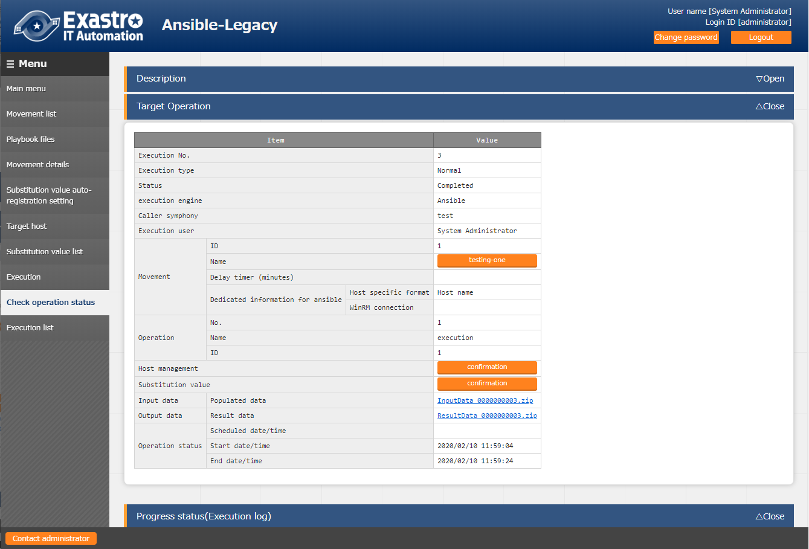

**Figure 5.3-23 Submenu screen (Check operation status)**

1. **Display of execution status**"Status" is displayed according to the execution status.

Also, the details of the execution status is displayed in execution log and error log

In the "execution type", "Dry run" is displayed when performing dry run, "Normal" will be displayed for other cases

If the status ends with an unexpected error, the cause is incomplete registration of web contents, message will be displayed in error log.

In addition, in the case that communication with Ansible RestAPI fails due to incomplete registration in "5.2.1 Interface information", message will not be displayed in error log.

In this case, error information will be record in application log. Please check the application log if necessary.

The symphony which the operation is executed from is displayed in "Caller symphony"

The column will be blank if the operation is executed directly from Ansible-Legacy, Pioneer, LegacyRole driver.

The login user when clicking the "execute" or "dry run" button in the "exeuction" menu will be displayed in "Execution User".

1. **Host management**

By clicking the "confirmation" button, "5.3.10 Target host" will display and the host filtered by the operation and Movement of operation target will be displayed.

1. **Substitution value confirmation**

By clicking the "confirmation" button, "5.3.11 Substitution value list" will display and the substitution value filtered by the operation and Movement of operation target will be displayed.

1. **Emergnecy stop/ Schedule cancellation**

It is possible to stop the construction operation by clicking the "Emergency stop" button

In addition, for the "scheduled execution" operation before execution, the "schedule cancellation" button will display. Cancel the scheduled execution by clicking the "schedule cancellation" button.

1. **Display of execution log**

When AnsibleTower is executed, the Playbook is executed in units of the device to be built grouped by which item value, such as the user password instance group in the list of devices to be built and the ansible execution log is split.

In addition, by specifying the number of job slices in the optional parameters in the Movement list, the grouped device to be built is further divided by the number of job slices, the playbook is executed and the ansible execution log is also divided.

When the execution log is splited, the pull-down of the display log file will be displayed and possible to select the log file you want to display.

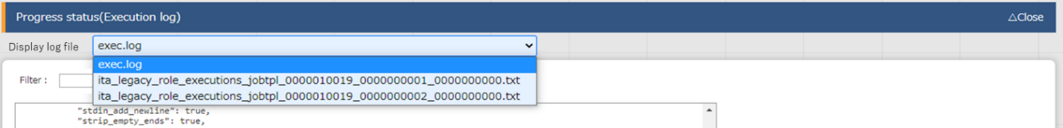

There are two types of log file names displayed in the pull-down of the display log file.

exec.log: This is a log file that summarizes all execution logs.

Without exec.log: Splited execution log file. The file naming conventions is as follows.

Ita_<mode name>_executions_jobtpl_<work number>_<group number>_<serial number

Table 5.3-17 Naming elements for split execution log files.

|  |  |
| --- | --- |
| Element | Content |
| Modename | Executed mode name legacy/pioneer/legacy_role |
| Execution number | Executionnumber of execution list menu. |
| Group number | Serial number from 1 that is grooved by the item value of the user, password, instance groove etc. of the device list and the device to be built. |
| Serial number | Serial number from 1 that divides the group by setting the number of job slices.  If 0, no division of job slicing was done. |

1. **Log filter**

Execution log and error log can be filtered. By entering the string that the user wants to search in the filter box of each log and checking the "Display only corresponding lines" checkbox, only the corresponding line will be displayed.  
The display refresh cycle and the maximum display line count of exeuction and error log can be set in "Status monitoring cycle (milliseconds)" and "Number of rows to display progress status" of "5.2.1 Interface information" menu.

1. **Input data**

Users can download files such as the executed Playbook.

Please refer to “8.1 The linkage between the input data used during Ansible execution and ITA menu” for the configuration of input data.

1. **Result data**

Users can download files such as execution log and error log.

### Execution list

1. The history of operation can be viewed here.

The operation list table and graph will display by specifying criteria and clicking the "filter" button.

By clicking the "Check execution status" button, the screen will transit to "5.3.12 Check operation status" and the details of execution status can be viewed.

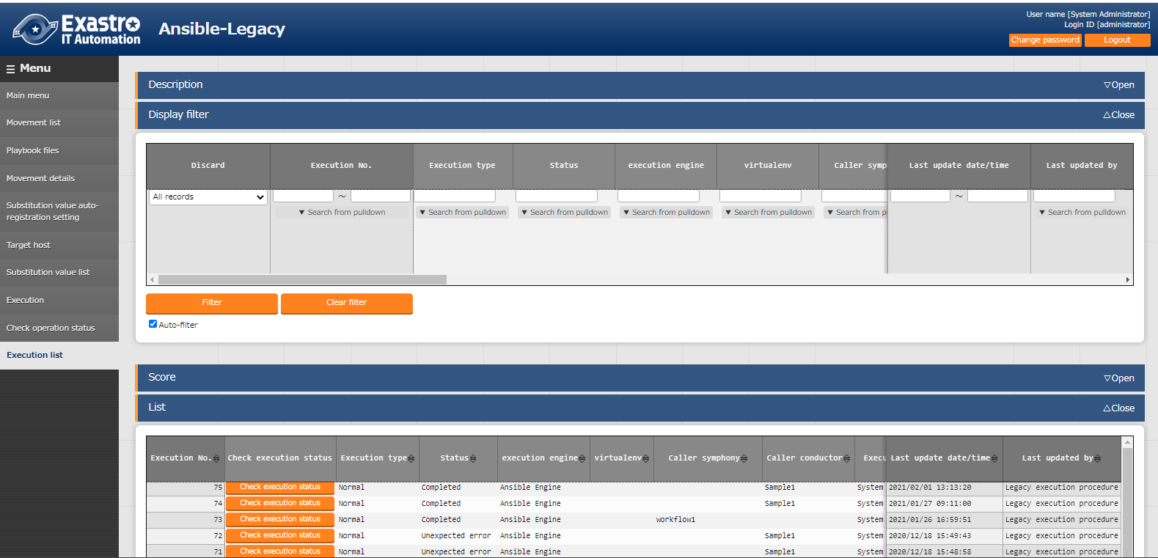

**Figure 5.3-24 Submenu screen (Execution list)**

### Execution

1. Indicate Operation execution. Select the radio button from the Movement list and operation list and click the execution button, the screen will transit to "5.3.12 Check operation status" and the operation will be executed.

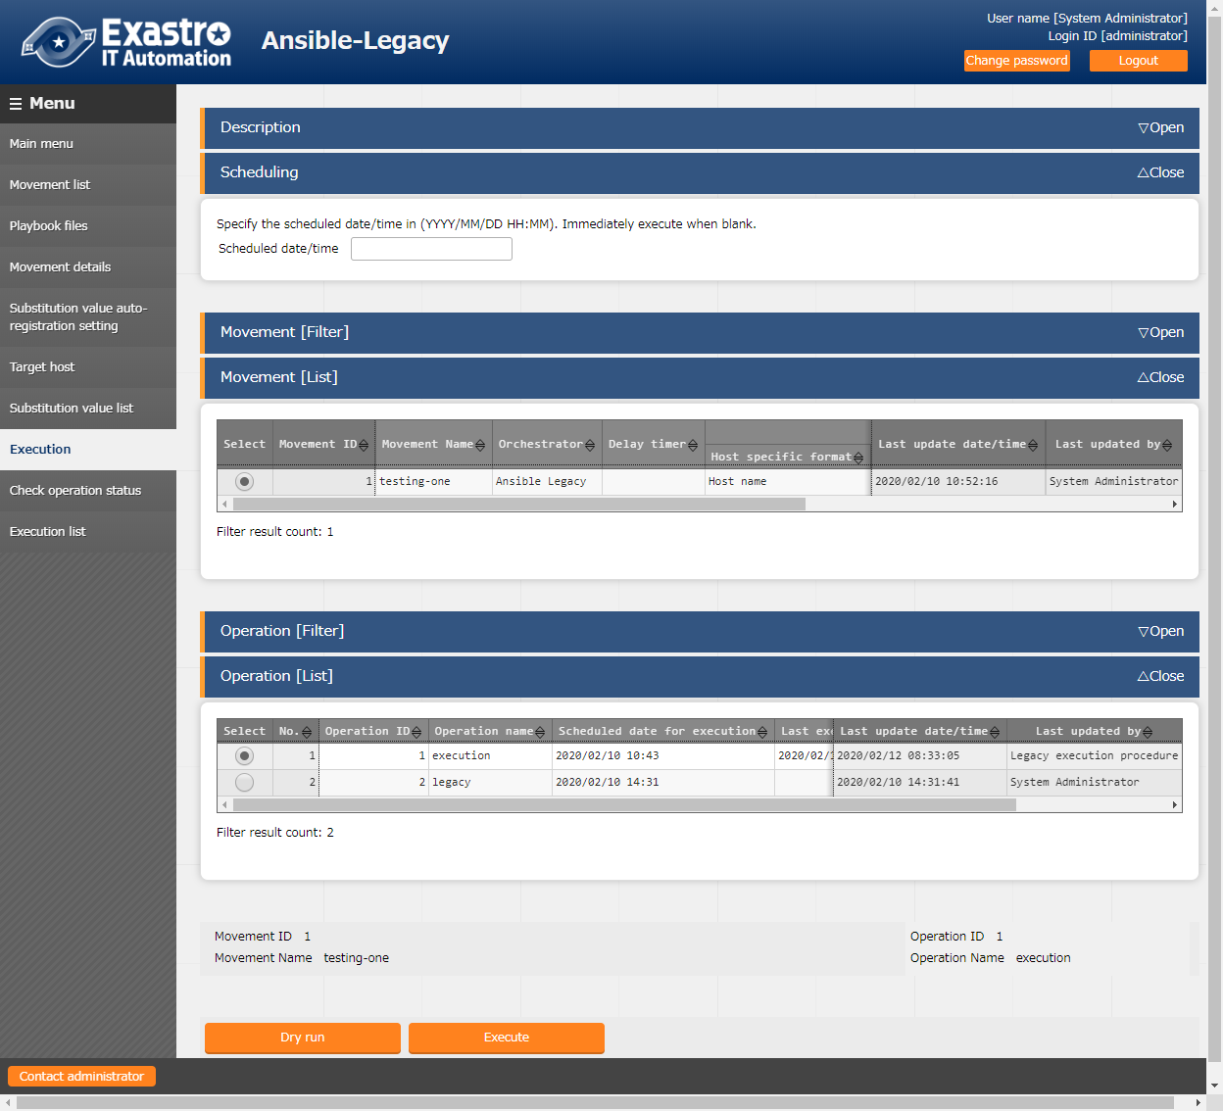

**Figure 5.3-25 Submenu screen (Execution)**

※The screen is from Ansible Legacy

1. **Dry run**

By clicking the "Dry run" button, dry run can be executed without actually constructing the target device. In the case of dry run, the operation of each mode is as follows.

|  |  |
| --- | --- |
| Driver | Action |
| Ansible-Legacy | Execute the playbook by specifying the -check parameter to the Ansible-Playbook command. |
| Ansible-Legacy Role | Execute the role by specifying the - check parameter to the Ansible-Playbook command. |
| Ansible-Pioneer | Only perform the connection check to target device |

1. **Specify scheduled date/time**

Execution can be scheduled by entering “Scheduled date/time” column.

Only future date/time can be registered for "Scheduled date/time"

1. Determining access permission role compatibility when executing

Determines whether there are matching roles for each access permission role in the Movement and Operations selected in the Movement list and Operations list. If there are no matching roles, an error message will be dispalyed and the operation cannot be executed. Matching roles will be set to have access to Operation lists. If the permission role is blank, all the roles will be handled as accessible. If each access permission role is blank, the operation list access permission role will be also set to blank. For more information about access permission roles, please refer to the "User_Instruction_Manual_Role-Based Access Control."

|  |  |  |  |
| --- | --- | --- | --- |
| Movement | Operation |  | Operation list |
| Access permission role | Access permission role |  | Access permission role |
| Blank | Blank |  | Blank |
| Blank | Role_A |  | Role_A |
| Role_B | Role_B |  | Role_B |
| Role_B,Role_C | Role_B,Role_C |  | Role_B  Since the permission roles do not match, the Operation cannot be executed. |
| Role_D | Role_E |  |

# How to write construction code

## Write Playbook (Ansible-Legacy)

Playbooks uploaded to 5.3.3 Playbook file list (Ansible-Legacy only) are included in the Playbook file generated by ITA and excuted in Include format. The Master playbook created by ITA are constructed by the Header section and the Tasks section.

(1) Header section

The playbook does not require a header section when being uploaded.

The header section has a default value, but you can change it in the header section of "5.3.2.Movement List".

Defult value of header section

・For Ansible engine　　　　　　　　　　　　・For AnsibleTower

- hosts: all - hosts: all

remote_user: "{{ __loginuser__ }} "　 gather_facts: no

gather_facts: no become: yes

become: yes

(2) tasks section

Please refer to the official manual for the basic Playbook format.

Please adjust the indent in the Playbook to multlple of 2.

Make sure the character code is UTF-8 without BOM.

e.g.)

-△name: Service script setting

△△template:

△△△△src: "{{ item.src }}"

△△△△dest: "{{ item.dest }}"

△△△△owner: "{{ item.owner is none |ternary('root', item.owner) }}"

△△△△group: "{{ item.group is none |ternary('bacula', item.group) }}"

△△△△mode: "{{ item.mode is none |ternary('0654', item.mode) }}"

～omitted～

△: Half-width space

Uploaded Playbooks are included in the include order of “5.3.7 Movement details”.

http_install.yml

Playbook generated by ITA

Uploaded Playbook

- hosts: all

gather_facts: no

become: yes

tasks:

- include: http_install.yml

- include: mysql_install.yml

Header section

mysql_install.yml

- name: install mysql

yum: name= mysql-community-server state=installed

- name: install httpd

yum: name=httpd state=installed

tasks

section

## Write Dialog file (Ansible-Pioneer)

The dialog file in Ansible-Pioneer incorporates an ITA-specific module into Ansible.

The dialog file is in ITA-specific format.

Please use UTF-8 for the character encoding.

**(1)** Structure of dialog file

The dialog file is constructed with 2 types of section.

|  |  |
| --- | --- |
| Section name | Usage |
| Conf | Specify the timeout value according to timeout parameter.  timeout value: 1~3600(unit:second) |
| exec_list | Construct the target host with 4 kinds of dialog command. |

Write the timeout parameter in the beginning of dialog file then write the dialog comment in the later part.

Comments can be writed in the same format with Ansible basic format.

e.g.)

# Comment

conf:

△△timeout: 10

exec_list:

**※△: Half-width space**

**Please enter 2 half-width space before “timeout:”**

**(2)** Dialog command

There are 4 kinds of dialog commands as follows.

|  |  |
| --- | --- |
| Module | Use |
| exec | Input command to the target host |
| expect | Waiting for the output of expected string (prompt) from the contents that the target host outputs to the standard output. |
| state | Input the command to target host. The contents of the standard output until the prompt is output to the standard output are analyzed by external shell, and the result is determined. |
| command | Loops and conditional branching can be performed before and after inputting commands to the target host. |

1. expect module

Waiting for the output of expected string (prompt) from the contents that the target host outputs to the standard output.

Write the expected string in regular expression.

When the expected string is received, proceed to the next. In addition, if the string is not received within the time specified by the time out parameter, the dialog file will terminate abnormally.

e.g.)　　Waiting for the prompt of password entry via telnet connection

△△-△expect:△’Password’

**※△:** **half-width space**

**Please enter 2 half-width space before “- expect:”**

**It is recommended to enclose the waiting string with quotation.**

1. exec module

Input command to the target host.

exec module and expect module are used in pairs.

e.g.) Wait for the password entry prompt via telnet connection and input password.

△△-△expect:△’Password’

△△△△exec:△itapassword

**※△: Half-width space**

**Please enter 4 half-width space before the description of “exec:”**

**It is recommended to enclose the waiting string with quotation if necessary.**

1. state module

Input the command to target host. The contents of the standard output until the prompt is output to the standard output are analyzed by external shell, and the result is determined.

The format of state module

| Parameter | Required/ Optional | Description |
| --- | --- | --- |
| △△－△state:△xxx | Required | Specify the input command. |
| △△△△prompt:△xxx | Required | Specify the waiting prompt. The prompt can be writed in regular expression. |
| △△△△shell:△xxx | Optional | Specify the shell file name to check the result with the created shell.  If the exit code of the created shell is 0, the result is determined as normal, and the others are abnormal.  This parameter is not required when checking the result with default shell.  The default shell will grep the contents of standard output with the string specified by parameter (-).  If there is at least one matching row, the result is determined normal, and if there is no matching row, the result is determined to be abnormal.  In addition, if the parameter is not specified, the result will be determined as abnormal. In the case of using the parameter to save the command result (standard output) to the file specified by stdout_file, please specifiy yes for ignore_errors. |
| △△△△parameter:  △△△△△△-△xxx  △△△△△△-△xxx | Optional | Specify the string to search for the result (standard output) of the input command. If the shell is specified, the strings will become the parameters during shell execution. Enumerate the criteria strings if there are multiple of them. |
| △△△△stdout_file:△xxx | Optional | The file to save the result (standard output) of the input command. |
| △△△△success_exit:△ xxx | Optional | Please set this file to the shell parameter if the shell parameter if specified.  Specify "yes" to exit the dialog normally if the search result is normal and specify no to proceed to the next. "no" is set on default. |
| △△△△ignore_errors:△ xxx  ※△:Half-width space | Optional | Specify "yes" to proceed to the next even if the search result is abnormal.  "no" is set on default. |

Exp2-3)

cat the hosts file and grep the displayed results with parameter value. If there is line containing 139.0.0.1 or lalhost, the result is determined as normal and proceed to the next. If there is no such line, the result is determined as abnormal and the dialog file is terminated abnormally.

exec_list:

- state: ‘cat /etc/hosts’

prompt: ‘root@{{ __loginhostname__ }}’

parameter:

- ‘139.0.0.1’

- ‘lalhost’  
- expect: root@{{ __loginhostname__ }}

exec: exit

Exp2-5)

cat the hosts file and grep the displayed results with parameter value.If there is line containing 139.0.0.1 or lalhost, the result is determined as normal and proceed to the next.If there is no such line, the result is determined as abnormal and proceed to the next according to the ignore_errors:yes setting.

exec_list:

- state: cat /etc/hosts

prompt: root@{{ __loginhostname__ }}

parameter:

- 139.0.0.1

- lalhost

ignore_errors: yes

- expect: root@{{ __loginhostname__ }}

exec: exit

Exp2-4)

cat the hosts file and grep the displayed results with parameter value.If there is line containing 139.0.0.1 or lalhost, the result is determined as normal and terminate normally according to the success_exit:yes setting. If there is no such line, the result is determined as abnormal and the dialog file is terminated abnormally

exec_list:

- state: ‘cat /etc/hosts’

prompt: ‘root@{{ __loginhostname__ }}’

parameter:

- ‘139.0.0.1’

- ‘lalhost’

success_exit: yes

- expect: root@{{ __loginhostname__ }}

exec: exit

Exp2-7)

cat the hosts file and save the displayed result to the file specified by stdout_file then proceed to the next. If the “no” parameter is set to the default shell, the result will be determined as abnormal.

Set ignore_errors:yes to proceed to the next. exec_list:

- state: cat /etc/hosts

prompt: root@{{ __loginhostname__ }}

stdout_file: {{ __symphony_workflowdir__ }}/hosts

ignore_errors: yes

- expect: root@{{ __loginhostname__ }}

exec: exit

Exp2-6)

cat the hosts file and use the user created shell to grep the displayed results with parameter value. If there is line containing 139.0.0.1 or lalhost, the result is determined as normal and proceed to the next. If there is no such line, the result is determined as abnormal and the dialog file is terminated abnormally

exec_list:

- state: cat /etc/hosts

prompt: root@{{ __loginhostname__ }}

shell: /tmp/grep.sh

stdout_file: /tmp/stdout.txt

parameter:

- 139.0.0.1

- lalhost

User created shell(/tmp/grep.sh)

#!/bin/bash

STDOUT=/tmp/STDOUT.tmp

STDERR=/tmp/STDERR.tmp

cat /tmp/stdout.txt|grep $1|grep $2 | wc -l >${STDOUT} 2>${STDERR}

RET=$?

if [ $RET -ne 0 ]; then

EXIT_CODE=$RET

else

if [ -s ${STDERR} ]; then

EXIT_CODE=1

else

CNT=`cat ${STDOUT}`

if [ ${CNT} -eq 0 ]; then

EXIT_CODE=1

else

EXIT_CODE=0

fi

fi

fi

1. command module

Loops and conditional branching can be performed before and after inputting commands to the target host.

**Command module format**

| Parameter | Required/  Optional | Description |
| --- | --- | --- |
| △△－△command:△xxx | Required | Specify the input command. |
| △△△△prompt:△xxx | Required | Specify the waiting prompt. It can be writed in regular expression. |
| △△△△timeout:△xxx | Optional | Specify the timer to wait for the prompt after the command is sent.  If the parameter is omitted, then conf->timeout is used. |
| △△△△register:△xxx | Optional | Save the information of the standard output to any string specified after sending the command.  When using with_items to loop, the information of the standard output after the last command input is saved. This variable can be used in condition judgment (can only be used in condition judgment). However, saving the information of standard output for every variable name is not possible. Previous information will be overwritten.  1 exec_list:  2 - expect: 'assword:'  3 exec: '{{ __loginpassword__ }}'  4 - command: 'systemctl status httpd'  5 prompt: '{{ __loginuser__ }}@{{ __loginhostname__ }}'  6 register: httpd_status_register  7 - command: 'systemctl restart httpd'  8 when:  9 - httpd_status_register no match(running)  10 prompt: '{{ __loginuser__ }}@{{ __loginhostname__ }}'  11 - command: 'systemctl status mysql'  12 prompt: '{{ __loginuser__ }}@{{ __loginhostname__ }}'  13 register: mysql_status_register  14 - command: 'systemctl restart mysql'  15 when:  16 - mysql_status_register no match(running)  17 prompt: '{{ __loginuser__ }}@{{ __loginhostname__ }}'  18 - expect: '{{ __loginuser__ }}@{{ __loginhostname__ }}'  19 exec: exit 　Since the 6th line, httpd_status_register, has a different value set to the Register variable in the command module on line 11 (mysql_status_register), it is valid all up until line 10. |
| △△△△with_items:  △△△△△△-△**’**{{ VAR_x }}**’**  △△△△△△-△**’**{{ VAR_y }}**’** Enclose the defining variables in single quotation marks. | Optional | If you're looping and inputting commands to with_items, configure multiple variable names.  The scope of each variable is "item.X(X is 0-99).  If you using with_items with prompt, timeout, refer to the following for variable names  prompt： {{△VAR_prompt_XXX△}}  timeout： {{△VAR_timeout_XXX△}}  (△=half-width space. XXX=any half-width alphabetic characters and underscore)  If the number of variable's specific values set to with_items are not the same, it will loop at the maximum number of specific values.  If there are any variables that does not have any specific values, they will have their specific value set to "blank".  Additionally, if you're using with_items with Prompt or Timeout, pay attention to the numbers of specific values.  promt->command->prompt->command->prompt...(Loop)  As it will loop like this, you will need to set 1 additional specific value (Number of commands+1).  If there are any prompt or timeout variables that does not have specific values set, an error will occur when the operation is executed.  If you want to run the following command with Command module, 　・systemctl start httpd  ・systemctl start mysql The dialogue file and the specific values of the variables used in with_items are as follows.  - command: "systemctl {{ item.0 }} {{ item.1 }}"  　prompt: '{{ item.2 }}'  　timeout: '{{ item.3 }}'  with_items:  - '{{ VAR_status_list }}' # item.0  - '{{ VAR_service_list }}' # item.1  - '{{ VAR_prompt_list }}' # item.2  - '{{ VAR_timeout_list }}' # item.3  VAR_status_list: 　　　　　VAR_service_list: - start　　　　　　　　　　- httpd  - start　　　　　　　　　　- mysql VAR_prompt_list: VAR_timeout_list:  - Command prompt - 10  - Command prompt - 10  - Command prompt - 10  The variables defined with with_items can be scoped with item.X (other than register/when)  Exp）  with_items:  － ‘{{ VAR_item1 }}’ **#item.0**  － ‘{{ VAR_item2 }}’ **#item.1**  exec_when:  － ‘{{ item.0 }} == active’  － ‘{{ item.0 }} == {{ VAR_status }}’  － ‘register変数 match({{ item.0 }})  failed_when:  － ‘stdout match({{ item.1 }})’ |
| △△△△when:  △△△△△△-△xxx  △△△△△△-△xxx | Optional | The condition judgement before command executes.  Execute command if the condition matches.  Move to the next “command” line if the condition doesn't match.  Conditional expression  Judging variable definition  VAR_xx is define Variable defined true  VAR_xx is undefined Variable undefined true  Exp)  － ‘VAR_status is define’  － ‘VAR_status is undefine’  ※define/undefine can be specified only for ITA variable(VAR_xx)  Judging variable specific value  VAR_xx/register variable relational_operator string  VAR_xx/register variable relational_operator VAR_xx  VAR_xx/register variable match(Regular expression string /VAR_xx)  VAR_xx/register variable no match(Regular expression string /VAR_xx)  ※Relational operators are 「==」、「!=」、「>」、「>=」、「<」、「<=」  ※The 「>」、「>=」、「<」、「<=」 relational operators are assumed to be used for numerical values.  ※It is not required to enclose string and regular expression string with single or double quotations.  － ‘{{ VAR_status }} match(active)’  － ‘{{ VAR_status }} == active’  － ‘register variable match(active)’  Compound condition with and / or  When processing with or condition, add OR between judge conditions  Exp）  － ‘{{ VAR_status }} == 1　OR {{ VAR_status }} == 2’  When processing with and condition, write the statement in multiple lines.  Exp）  － ‘{{ VAR_status }} == 1　OR {{ VAR_status }} == 2’  － ‘{{ VAR_sub_status }} == 1’ |
| △△△△exec_when:  △△△△△△-△xxx  △△△△△△-△xxx | Optional | Judge condition for every loop (continue condition)  Perform condition judgement if with_items is writed.  If the condition matches, execute command of the corresponding loop.  If the condition doesn't match, move on to the next loop.  Conditional expression  Same format as “when:” |
| △△△△failed_when:  △△△△△△-△xxx  △△△△△△-△xxx  ※△: half-width space | Optional | Condition judgment for the stdout content after command execution(for every loop)  Perform condition judgment even if with_items is not writed  If the condition matches, the result is normal  If the condition doesn't match, the result is abnormal and the dialog file is terminated abnormally  Conditional expression  Judging variable specific value  stdout relational_operator string  stdout relational_operator VAR_xx  stdout match(regular expression string/VAR_xx)  stdout no match(regular expression string/VAR_xx)  ※Relational operators are 「==」、「!=」、「>」、「>=」、「<」、「<=」  ※The 「>」、「>=」、「<」、「<=」 relational operators are assumed to be used for numerical values.  ※It is not required to enclose string and regular expression string with single or double quotations.  VAR_status match(active)　　 VAR_status == active  Compound condition with and / or  Same format as “when:” |

Exp3-1)

conf:

timeout: 30

exec_list:

# If waiting for strings other than prompt is required, use the combination of expect/exec.

# In the case that the password is required.

- expect: 'password:'

exec: '{{ __loginpassword__ }}'

# If the ITA variable, VAR_hosts_make, is writed in host variable file, cat the host file.

# If the variable is not writed, skip the command.

- command: cat /etc/hosts

prompt: root@{{ __loginhostname__ }}

when:

- VAR_hosts_make is define

- expect: root@{{ __loginhostname__ }}

exec: exit

Exp3-2)

conf:

timeout: 30

exec_list:

# If waiting for strings other than prompt is required, use the combination of expect/exec.

# In the case that the password is required.

- expect: 'password:'

exec: '{{ __loginpassword__ }}'

# If the ITA variable, VAR_hosts_make, is writed in host variable file, cat the host file.

# If the variable is not writed, skip the command."

# Use cat to save the contents of the standard output hosts file to result_stdout.

- command: cat /etc/hosts

prompt: root@{{ __loginhostname__ }}

register: result_stdout

when:

- VAR_hosts_make is define

# If the ITA variable, VAR_hosts_make, is writed in host variable file, cat the host file.

# If the variable is not writed, skip the command.

# Execute the command for the numbers of the specific values of the multiple specific value

# variable set in the with_items.

# From the result of condition judgment for each loop, if "ip address host name" does not

# correspond to the hosts file, execute command.

# Add "IP_address host_name" to the last line of hosts file by using echo.

- command: 'echo {{ item.0 }} {{ item.1 }} >> /etc/hosts'

prompt: 'root@{{ __loginhostname__ }}'

when:

- VAR_hosts_make is define

with_items:

- '{{ VAR_hosts_ip }}' # item.0

- '{{ VAR_hosts_name }}' # item.1

exec_when:

- result_stdout no match({{ item.0 }} *{{ item.1 }})

- expect: root@{{ __loginhostname__ }}

exec: exit

Exp3-3)

conf:

timeout: 30

exec_list:

# If waiting for strings other than prompt is required, use the combination of expect/exec.

# In the case that the password is required.

- expect: 'password:'

exec: '{{ __loginpassword__ }}'

# Execute the command for the numbers of the specific values of the multiple specific value

# variable set in the with_items

# Execute auto startup configuration.

- command: 'systemctl enable {{ item.0 }}'

prompt: 'root@{{ __loginhostname__ }}'

with_items:

- '{{ VAR_service_name_list }}' # item.0

# Execute the command for the numbers of the specific values of the multiple specific value

# variable set in the with_items

# Execute service startup

- command: 'systemctl start {{ item.0 }}'

prompt: 'root@{{ __loginhostname__ }}'

with_items:

- '{{ VAR_service_name_list }}' # item.0

Execute the command for the numbers of the specific values of the multiple specific value variable set in the with_items.

Output the service status to standard output.

If the content of result output to standard output contains the regular expression of item.1, the result is right.

For example, in the case that the specific value of VAR_service_status_list is set to running and the service is running, "running" in "Active: active(running)" matches so the result is right. (Move on to the next loop)

In the case that condition doesn't match, the result is determined as abnormal and the dialog file terminates abnormally.

- command: 'systemctl status {{ item.0 }}'

prompt: 'root@{{ __loginhostname__ }}'

with_items:

- '{{ VAR_service_name_list }}' # item.0

- '{{ VAR_service_status_list }}' # item.1

failed_when:

- stdout match({{ item.1 }})

- expect: root@{{ __loginhostname__ }}

exec: exit

Exp3-4)

conf:

timeout: 30

exec_list:

# If waiting for strings other than prompt is required, use the combination of expect/exec.

# In the case that the password is required.

- expect: 'password:'

exec: '{{ __loginpassword__ }}'

# Execute the command for the numbers of the specific values of the multiple specific value

# variable set in the with_items.

# When describing the command with "{{item.0}}" only, enclose it with double-quotation.

# Please note the numbers of specific value when using with_items in prompt or timeout.

# prompt→command→prompt→command→prompt…(loops thereafter), it is required to plus 1 # to the command count. (Same for timeout)

- command: "{{ item.0 }}"

prompt: '{{ item.1 }}'

timeout: '{{ item.2 }}'

with_items:

- '{{ VAR_command_list }}' # item.0

- '{{ VAR_prompt_list }}' # item.1

- '{{ VAR_timeout_list }}' # item.2

- expect: root@{{ __loginhostname__ }}

exec: exit

|  |  |
| --- | --- |
| Variable name | Specific value |
| VAR_command_list | systemctl status {{ item.1 }} |
| VAR_service_name_list | ky_pioneer_execute-workflow.service |

Exp5)

conf:

timeout: 30

exec_list:

# If waiting for strings other than prompt is required, use the combination of expect/exec.

# In the case that the password is required.

- expect: 'password:'

exec: '{{ __loginpassword__ }}'

# Execute the command for the numbers of the specific values of the multiple specific value

# variable set in the with_items.

# Setting the specific value of substitution value list to {{item.X}} is possible. In that case, please

# make the numerical value writed in the specific value of item.X which is writed in the

# dialog file grows.

# The command executed in this example is "systemctl status ky_pioneer_execute-workflow.service".

- command: "{{ item.0 }}"

prompt: 'root@{{ __loginhostname__ }}'

with_items:

- '{{ VAR_command_list }}' # item.0

- '{{ VAR_service_name_list }}' # item.1

- expect: root@{{ __loginhostname__ }}

exec: exit

Exp6)

conf:

timeout: 30

exec_list:

# If waiting for strings other than prompt is required, use the combination of expect/exec.

# In the case that the password is required.

- expect: 'password:'

exec: '{{ __loginpassword__ }}'

# Example of compound condition using and / or.

# When processing with or condition, write the if statement horizontally.

# When processing with and condition, describing the statement in multiple lines.

# "when" is used as the example here but the same applies to exec_when and failed_when.

- command: echo aaa

prompt: 'root@{{ __loginhostname__ }}'

when:

- 10 == 9 OR 10 != 9 OR 10 >= 9

- 10 > 9 OR 10 <= 9 OR 10 < 9

- expect: root@{{ __loginhostname__ }}

exec: exit

and条件

and condition

1. localaction module

Execute command on Ansible/Ansible Tower server.

Localation module format

| Parameter | Reguired/  Optional | Description |
| --- | --- | --- |
| △△－△localaction:△xxx | Required | Specifiy the command to be executed. |
| △△△△ignore_errors:△ xxx  ※△:Half-width space | Optional | Specify “yes” to continue if the execution result of the command is abnormal.  If “no” is specified, the dialog will end if the result of execution is abnormal.  Default is “no”. |

Exp4-1)

During Symphony execution, create a directory to output the hosts file for every host in the shared directory ({{ __symphony_workflowdir__ }}) of each Movement.

exec_list:

- localaction: mkdir -p 755 {{ __symphony_workflowdir__ }}/{{ __loginhostname__ }}

ignore_errors: yes

- state: cat /etc/hosts

prompt: '{{ __loginuser__ }}@{{ __loginhostname__ }}'

stdout_file: {{ __symphony_workflowdir__ }}/{{ __loginhostname__ }}/hosts

ignore_errors: yes

- expect: root@{{ __loginhostname__ }}

exec: exit

- expect: root@{{ __loginhostname__ }}

exec: exit

**(3)** Regular expression

The strings writed in the following command and parameter are evaluated in regular expression.

・expect module

・The prompt parameter of state module

・The prompt parameter of command module

When the string is writed in regular expression contains metacharacter "(){}.", etc., inserting escape character "\" before metacharacters is required.

Exp1)

When waiting for the following command, the red characters are metacharacters.

XAMPP Developer Files **[**Y**/**n] exec_list:

　Inserting escape character "\" before metacharacters is required.

　　XAMPP Developer Files \**[**Y\**/**n\] exec_list:

State module and command module extracts the result (standard ouput) of the executed command. The notes of the extraction are as follows.

* 1. The delimitation between the result (standard ouput) of the executed command and the prompt.

The delimitation between the result (standard ouput) of the executed command and the prompt is performed by the string specified in the prompt parameter. When judging the result of the executed command (standard output) or saving it to a file, please do not write a preceding match with .* in regular expression. The result (standard ouput) of the executed command can not be extracted.

　.* Example of preceding match with .* in regular expression.

　　　‘**.\***[\#\$\%] $’

* 1. Support of escape sequence

Depending on the target device, an Operating System Command sequence may be added immediately before the prompt sent from the target device.

Escape sequences immediately before the string specified by the prompt parameter are excluded.

**(4)** Notes when using multiple specific value variable

The only parameter in the dialog file that can use multiple specific value variable is the with_items parameter of command module. If multiple specific value variable is used in other cases, the operation execution will turn out to be error.

**(5)** Things to be aware of when processing prompts other than command prompts.

If you want to process prompts other than command prompts, combine exec module and expect module and create a dialogue file.

Command and State modules cannot be processed.

If you want it to return

If you are using variables, leave the specific values blank.

If you are not using variables, input an empty string (with two quotations).。  
exec: '’

Variable

Specific Value

VAR_id_rsa_path

Set file path of the secret key

VAR_passphrase

Set passphrase

Exp)  
Process ssh-keygen in a dialogue file

conf:

timeout: 10

exec_list:

# ssh connection　Password authentication

- expect: 'assword:'

exec: '{{ __loginpassword__ }}'

# ssh-keygen command execution

- expect: '{{ __loginuser__ }}@{{ __loginhostname__ }}'

exec: ssh-keygen

　# The following is the process for prompts other than the command prompt.

# Set file path of the secret key

# Since expect is evaluated in regular notation, the escape character (\) must be inserted for meta characters that need to be escaped.

- expect: 'id_rsa\):'

exec: '{{ VAR_id_rsa_path }}'

# Set passphrase

- expect: ' passphrase\):'

exec: '{{ VAR_passphrase }}'

# Confirm passphrase

- expect: ' passphrase again:'

exec: '{{ VAR_passphrase }}'

# Confirm the created secret key file.

- expect: '{{ __loginuser__ }}@{{ __loginhostname__ }}'

exec: 'ls -al {{ VAR_id_rsa_path }}'

# Close ssh connection

- expect: '{{ __loginuser__ }}@{{ __loginhostname__ }}'

exec: exit

**(6)** Things to be aware of when ending dialogue files.

Make sure to input a command that ends the session at the end of the dialogue file.

Ending the last line of the module closes the session.

If the final line is a file copy or any other process that takes time, the session will close before the command is finished and may end up ending abnormaly.

Exp)

conf:

timeout: 10

exec_list:

# ssh connection　password authentication

- expect: 'assword:'

exec: '{{ __loginpassword__ }}'

# File copy

- expect: '{{ __loginuser__ }}@{{ __loginhostname__ }}'

exec: ‘cp –rfp {{ VAR_src_path }} {{ VAR_dest_path }}

# Write a line that waits for the previous command to end in the command prompt and inputs an exit command at the end of the dialogue file.

- expect: '{{ __loginuser__ }}@{{ __loginhostname__ }}'

exec: exit

**(7)** Things to keep in mind when writing dialogue files in yaml format.

Dialogue files are treated as yaml format files.If there are lines or descriptions that do not follow the YAML format, an error will occur when uploading the dialogue module or when executing the operation. See example below.

・If a variable is written in the parameter of each module and the whole parameter is not enclosed in quotation marks.

・If the parameters are only written in constants, the constant doesnt end in ":", or other cases where parameters are not enclosed in quotations.

We recommend to enclose all the module parameters in quotation marks.

Example when not written in YAML Format  
(Red text)

- expect: **assword:**

exec: **{{ __loginpassword__ }}**

- expect: **{{ __loginuser__ }}@{{ __loginhostname__ }}**

exec: ls

- command: echo {{ item.0 }}

prompt: **{{ __loginuser__ }}@{{ __loginhostname__ }}**

exec_when:

- **{{ item.1 }} == run**

with_items:

- **{{ VAR_echo }}**

- **{{ VAR_exec_when }}**

- **{{ VAR_failed_when }}**

failed_when:

- stdout == match({{ item.2 }})

- state: **{{ VAR_command }}**

prompt: **{{ __loginuser__ }}@{{ __loginhostname__ }}**

parameter:

- **{{ VAR_p1 }}**

- **{{ VAR_p2 }}**

success_exit: yes

Closing the parameters when the description is not written in YAML format.

- expect: **'**assword:**'**

exec: **'**{{ __loginpassword__ }}**'**

- expect: **'**{{ __loginuser__ }}@{{ __loginhostname__ }}**'**

exec: **'**ls**'**

- command: **'**echo {{ item.0 }}**'**

prompt: **'**{{ __loginuser__ }}@{{ __loginhostname__ }}**'**

exec_when:

- **'**{{ item.1 }} == run**'**

with_items:

- **'**{{ VAR_echo }}**'**

- **'**{{ VAR_exec_when }}**'**

- **'**{{ VAR_failed_when }}**'**

failed_when:

- stdout == match({{ item.2 }})

- state: **'**{{ VAR_command }}**'**

prompt: **'**{{ __loginuser__ }}@{{ __loginhostname__ }}**'**

parameter:

- **'**{{ VAR_p1 }}**'**

- **'**{{ VAR_p2 }}**'**

success_exit: **'**yes**'**

Variables listed in with_items should be enclosed in single quotes.

## Write role package (Ansible-Legacy Role)

Please refer to the Ansible best practices official manual for the basic format.

Please use UTF-8 for the character encoding.

This section writes the directory that is required to be in the zip file of role package file uploaded in "5.3.4 Role package list (Ansible-Legacy Role only)" and the process in ITA.

**(Parent directory)**

**│**

**├─site.yml site.yml(master Playbook) is created in ITA.**

**│ The file will be overwritten if exists.**

**│**

**├─hosts hosts file is created in ITA.**

**│ The file will be overwritten if exists.**

**│**

**├─group_vars host group variables are not handled.**

**│ The group_vars directory will be removed if exists.**

**│**

**├─host_vars Host variables are created in ITA.**

**│ This directory will be overwritten if it exists.**

**│**

**├─ITA readme ITA readme is defined for every role. Error doesn't occur even if the file deosn't exist**

**│ The naming rule of ITA readme file name:**

**│ ita_readme_[role_name].yml**

**│ e.g.)**

**│ Role name: mysql File name: ita_readme_mysql.yml**

**│ Role name: mysql/install File name: ita_readme_mysql%install.yml**

**│ ※If role is in a deep directory hierarchy,**

**│ replacing “/” in the role name with “%” is required.**

**│**

**├─translation table Translation table is defined for every role. Error doesn'st occur even if the file deosn't exist**

**│ The naming rule of translation table file name**

**│ ita_translation-table_[role_name].txt**

**│ e.g.)**

**│ Role name: mysql File name: ita_translation-table_mysql.txt**

**│ Role name: mysql/install File name: ita_translation-table_mysql%install.txt**

**│ ※If role is in a deep directory hierarchy,**

**│ replacing “/” in the role name with “%” is required.**

**│**

**│ ITA does not concern if other directory or file exists other the directory or file above.**

**│**

**└─roles** **Error occur during upload if the roles directory does not exist.**

**│**

**├─[role name①] Error occur during upload if the role name directory does not exist.**

**│ │ Handle the directory containing tasks directory as a role.**

**│ │ Errors doesn't occur even if the directory hierarchy is deep.**

**│ │**

**│ ├─readme.mc ITA does not concern with the file.**

**│ ├─tasks The tasks directory is required.**

**│ │ ├ main.yml Error occur during upload if main.yml does not exist.**

**│ │ └ user_files** **Files other than main.yml can be placed here.**

**│ │ └ user.yml Files other than main.yml can be placed in subdirectory.**

**│ │**

**│ ├─handlers Doesn't concern if handlers directory exists or not.**

**│ │ ├ main.yml** **Doesn't concern if main.yml exists or not**

**│ │ └ user_files** **Files other than main.yml can be placed here.**

**│ │ └ user.yml Files other than main.yml can be placed in subdirectory.**

**│ │**

**│ ├─templates** **Doesn't concern if templates directory exists or not.**

**│ │ ├ hosts.j2** **Files can be placed in subdirectory.**

**│ │ └ user_files**

**│ │ └ user.j2**

**│ │**

**│ ├─files** **Doesn't concern if files directory exists or not.**

**│ │ sudoers Doesn't concern if file and subdirectory exists or not.**

**│ │ The file content is not concerned.**

**│ │**

**│ ├─vars** **Doesn't concern if vars directory exists or not.**

**│ │ main.yml Doesn't concern if file and subdirectory exists or not.**

**│ │ The file content is not concerned.**

**│ │**

**│ ├─defaults** **Doesn't concern if defaults directory exists or not.**

**│ │ ├ main.yml** **Doesn't concern if main.yml exists or not.**

**│ │ └ user_files** **Files other than main.yml can be placed here.**

**│ │ └ user.yml** **Files other than main.yml can be placed in subdirectory.**

**│ │**

**│ ├─meta Doesn't concern if meta directory exists or not.**

**│ │ main.yml** **Doesn't concern if file and subdirectory exists or not.**

**│ │ The file content is not concerned.**

**│ │**

**│ ITA does not concern if other directory or file exists other the directory or file above.**

**│**

**└─[role name②]** **There is no specific limit on the number of roles.**

1. Master playbook

The master Playbook you create in ITA consists of a hedder section and a roles section.

* + 1. header section

The default value of the header section is fixed, but you can change it in the header section of "5.3.2. Movement list".

Defult value of vector section

・For Ansible engine　　　　　　　　　　　・For AnsibleTower

- hosts: all - hosts: all

remote_user: "{{ __loginuser__ }} "　　 gather_facts: no

gather_facts: no become: yes

become: yes

* + 1. roles section

Execute the roles in the uploaded role package in the role according to the included order in “5.3.7Movement details”.

- hosts: all gather_facts: no

become: yes

roles:

- role: Sample_role1

- role: Sample_role1

Playbook generated by ITA

Uploded role package

Sample.zip

header section

Roles

Sample_role1

Sample_role2

roles section

1. Unique management of variable name

The variable information registered in the substitution value list of ITA is handled as host variable.

Variable names in all role packages of each drivers are uniquely managed.

When using same the variable name between roles with different variable structure, error will occur during upload

For example, in the case that the normal variable and nested variable or the nested structure is different between nested variables, etc.

1. ITA original specification of default variable definition file (defaults-> main.yml)

There is ITA original specification of the description (variable definition) of default variable definition.

Please refer to the attachment file "User Instruction Manual - Ansible-driver attachment Ansible usage guideline with additional rules" for details.

1. Notes on subdirectories of a predetermined directory in Ansible Role Directory Structure

If a subdirectory that has the same name of the predetermined directory is created under the predetermined directory in Ansible Role Directory structure (For example, a "files" directory under the "files" directory, etc.), error will occur during operation execution.

1. Points to note when the role name in the role package is set to the directory hierarchy.

The following directory hierarchy role package will be explained as an example.

**└─roles**

**├─parent**

**│ ├─sample_role1**

**│ │ ├─defaults**

**│ │ └─tasks**

**│ └─sample_role2**

**│ ├─defaults**

**│ ├─sample_role3**

**│ │ ├─defaults**

**│ │ └─tasks**

**│ ├─sample_role4**

**│ │ ├─defaults**

**│ │ └─tasks**

**│ └─tasks**

**├─sample_role5**

**│ └─defaults**

**└─sample_role6**

**├─defaults**

**└─tasks**

1. The directory recognized as a role is the directory containing the tasks directory.

In this example. There are three directory hierarchies (role names) to be handled by roles.

In this example. There are three directory hierarchies (role names) to be handled by roles.

・parent/sample_role1

・parent/sample_role2

・sample_role6

1. Exclude directory hierarchies with multiple tasks directories

There are tasks directories in parent/sample_role2/sample_role3 and parent/sample_role2/sample_role4, but parent/sample_role2 has a tasks directory and recognizes it as a role, so it is not handaled as a role.

## Write ITA readme (Ansible-Legacy Role only)

The substitution value management function interpretes the variable type defined in defaults variable definition file and sets the variable value of each variable and its' member variable.

In the cases such as not wanting to define variable directly in the Playbook, etc. if variable is not defined in defaults variable definition file, variable value can be specified in the substitution value management function by setting the variable definition in ITA readme file.

**(1)** Naming rule of file name of ITA readme

　ita_readme_[role name].yml

　　　　e.g.)

　　　　 Role name: mysql File name: ita_readme_mysql.yml

　　　　 Role name: mysql/install File name: ita_readme_mysql%install.yml

※If the role's directory hierarchy is deep, it is necessary to replace "/" in the role name with "%".

**(2)** The format of translation table

The format is YAML format.

Make sure the character code is UTF-8 without BOM.

The relation between ITA readme file and substitution value management function is as the following figure.

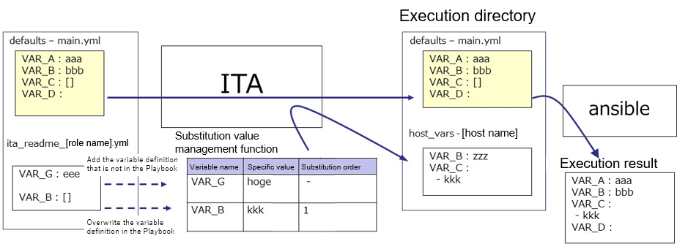

If the variable that is not in Playbook is defined in ITA readme file, the value of defined variable can be set in the substitution value management function.

Furthermore, if a type different from the variable in the Playbook is defined in the ITA readme file, the value can be registered in the substitution value management function with the overwritten variable type.

The value set in the substitution value management function is output to the variable definition file (host_vars) of each host, and is executed on each host by using the original Playbook and variable definition file as input in Ansible.

ITA readme file is only used to provide variable definition to substitution value management function, the variable and variable value defined in ITA readme don't affect the excecution of Ansible.

It is optional to create ITA readme. If the variable definition in ITA readme and defaults variable definition file overlaps, the following rules will be used to handle the situation.

**Table 6.4-1 variable adoption rule**

|  |  |  |
| --- | --- | --- |
| defaults variable definition file | ITA readme | Adoption source of variable definition |
| defined | undefined | defaults variable definition file |
| undefined | defined | ITA readme |
| defined | defined | ITA readme |

In addition, the default value displayed in "5.3.11 Substitution value list" is processed following the rule below.

**Table 6.4-2 default value display rule**

|  |  |  |
| --- | --- | --- |
| defaults variable definition file | ITA readme | The method to handle the default value |
| defined | undefined | Adopt the defaults variable definition file. |
| undefined | defined | Handle as no default value. |
| defined | defined | Adopt the defaults variable definition file. However, the rule is applied only when the definition variable matches. If the variable definition doesn't match, the variable is handled as no default value. |

ITA readme is seperated from role package during work execution.

The variable and specific value registered in ITA readme can't be applied.

## Write translation table (Ansible-Legacy Role only)

The translation table is a file set for making setting the specific value of variable other than "VAR_xxx" defined in defaults varaiable definiton file or ITA readme in "5.3.11 Substitution value list" possible.

Define the link between the “arbitrary variable” defined in the default variable definition file or ITA readme with the “substitution variable” handled in substitution management function.

**(1)** Naming rule of file name of ITA readme

　ita_readme_[role name].txt

　　　　e.g.)

　　　　 Role name: mysql File name: ita_translation-table_mysql.txt

　　　　 Role name: mysql/install File name: ita_translation-table_mysql%install.txt

※If the role's directory hierarchy is deep, it is necessary to replace "/" in the role name with "%".

**(2)** The format of translation table

The format is as follows in text format.

Make sure the character code is UTF-8 without BOM

The combination of substitution variable and arbitrary variable has to be unique within single role.

Substitution variable($s*):($s+)arbitrary variable

substitution variable：LCA_***

***：half-width alphanumeric character and underscore(_) can be used.

(Minimum length: 1byte, Maximum length: 256 bytes)

Arbitrary variable: (Minimum length: 1byte, Maximum length: 256 bytes)

($s*)： More than 0 half-width space

($s+)： More than 1 half-width space

e.g.)

LCA_var1: var1

# The line starts with # is comment line

LCA_var2: var2

The relationship of substitution value management function is as the following figure.

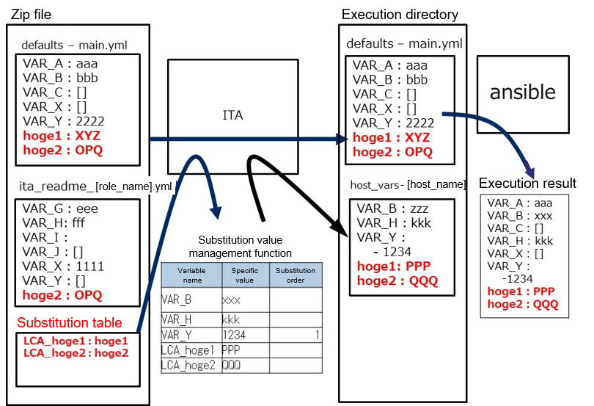

**(2)** Notes

Listing the notes when creating translation table.

|  |  |  |
| --- | --- | --- |
| Case | ITA behaviour | Remarks |
| The translation table exists but defaults variable definition file and ITA readme doesn't exist. (For every role) | Translation table can’t be read. |  |
| The variable begins with VAR_ is defined as arbitrary variable | Error occurs when uploading role package. |  |
| Uses any variables not defined in the defaults variable definition file and ITA readme | Error occurs when uploading role package. |  |
| Definition of substitution variables are duplicated in the role | Error occurs when uploading role package. | Package A->Role A  LCA_A: user_A/LCA_A: user_B |
| Definition of arbitrary variables are duplicated in the role | Error occurs when uploading role package. | Package A->Role B  LCA_A: user_A/LCA_B: user_A |
| The structure of arbitrary variable differs between roles | Error occurs when uploading role package. | Package A->Role A/B　　LCA_C: user_C |
| The combination of substitution variable and arbitrary variable is not unique in role package | Error occurs when uploading role package. | Package A  Role A　　LCA_D: user_D Role B　　LCA_D: user_E |
| The structure of arbitrary variable differs between role packages | Error doesn't occurs when uploading role package, but the substiution variable is not displayed in substitution value list. | Package A->Role A  LCA_F: user_F Package B->Role A  LCA_F: user_F |
| Nested arbitrary variable is defined between role packages | The nested structure is the same so error does not occur but the setting of nested iteration count is common setting for each package. | Package A->Role B  LCA_H: user_H Package B->Role A  LCA_H: user_H |

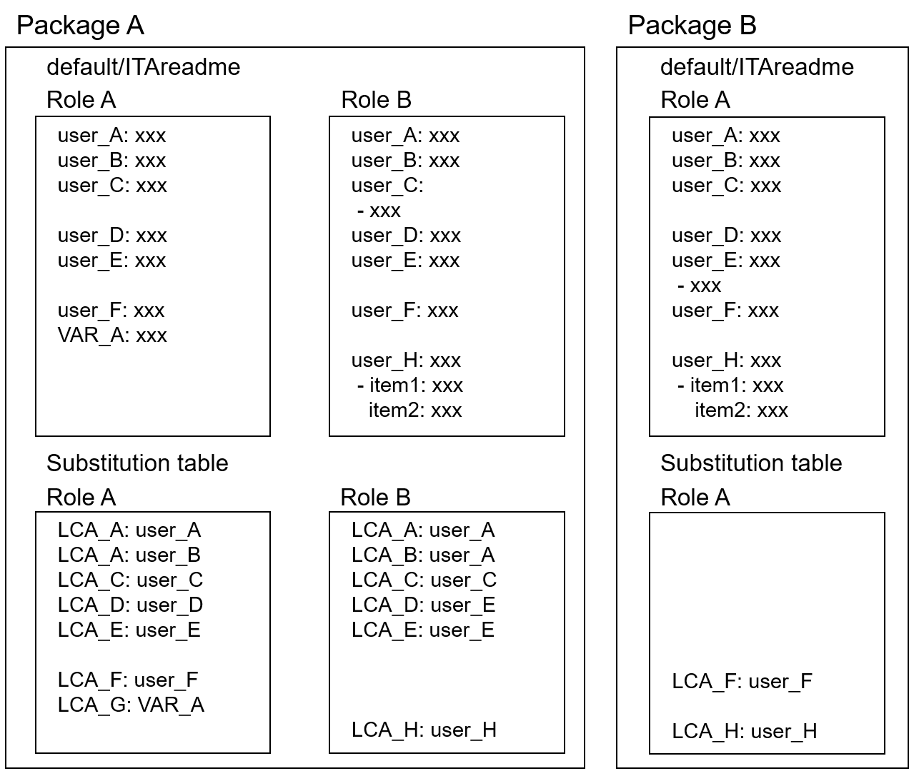

## ita_readme file and translation table (Ansible-Legacy Role only)

This chapter lists 9 different ita_readme and translation table usecases.

This section presumes that the Ansible-Legacy Role (roles directory) is acquired from an external source.

The following figure illustrates the process of using the ita_readme file and translation table to upload and checking the results. 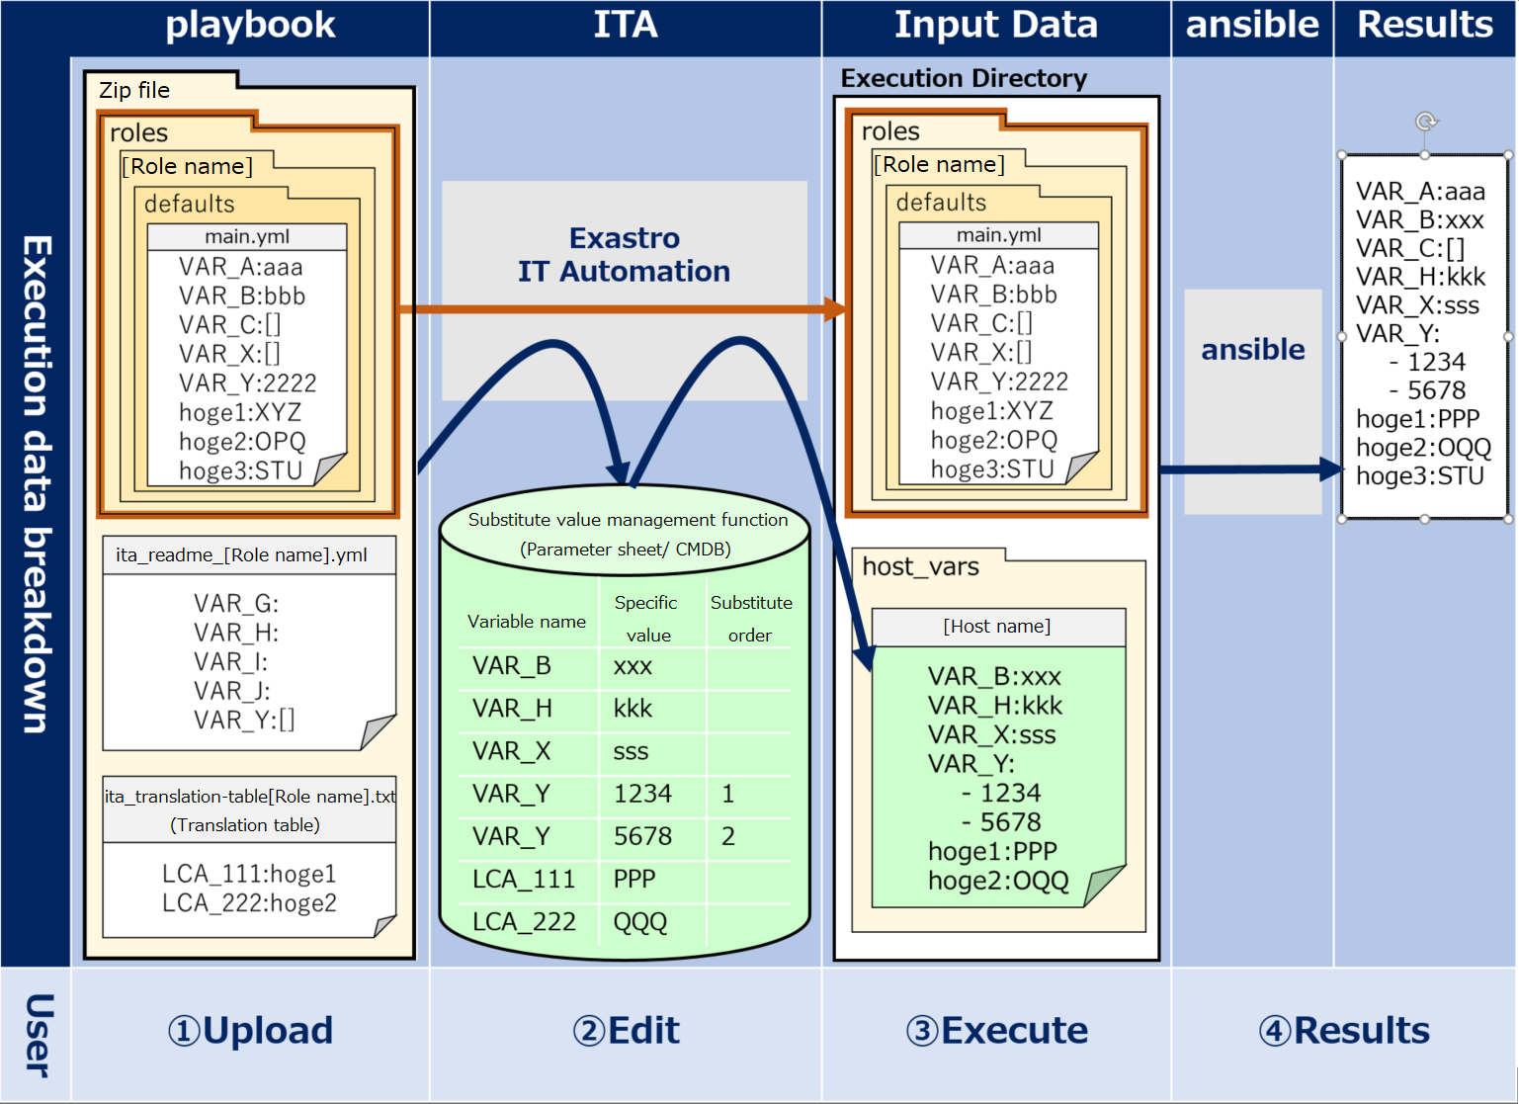

Figure 6.6-1 Overview image

The 9 usecases introduced in this chapter uses the figure above as a base.

|  |  |
| --- | --- |
| **No.** | **Usecase** |
| 1 | Using Ansible-Legacy Role without modifying it. |
| 2 | ita_readme and translation table role |
| 3 | Variable definitions and default values described in the "defaults/main.yml" file. |
| 4 | "host_vars" files and ITA/CMDB |
| 5 | Adding variables to “defaults/main.yml” |
| 6 | "VAR_" Prefix |
| 7 | Linking "ita_readme" and translation table |
| 8 | Applying Playbook Length evaluation |
| 9 | Applying Playbook Defined evaluation |

* **Case 1. Using Ansible-Legacy Role without modifying it**

Users can use Ansible-Legacy Role (roles directory) acquired from anexternal source without modifying it.

Therefore, users can put the ita_readme file and/or substitute table in the “roles” directory and assign parameters to the variables used inside the directory.

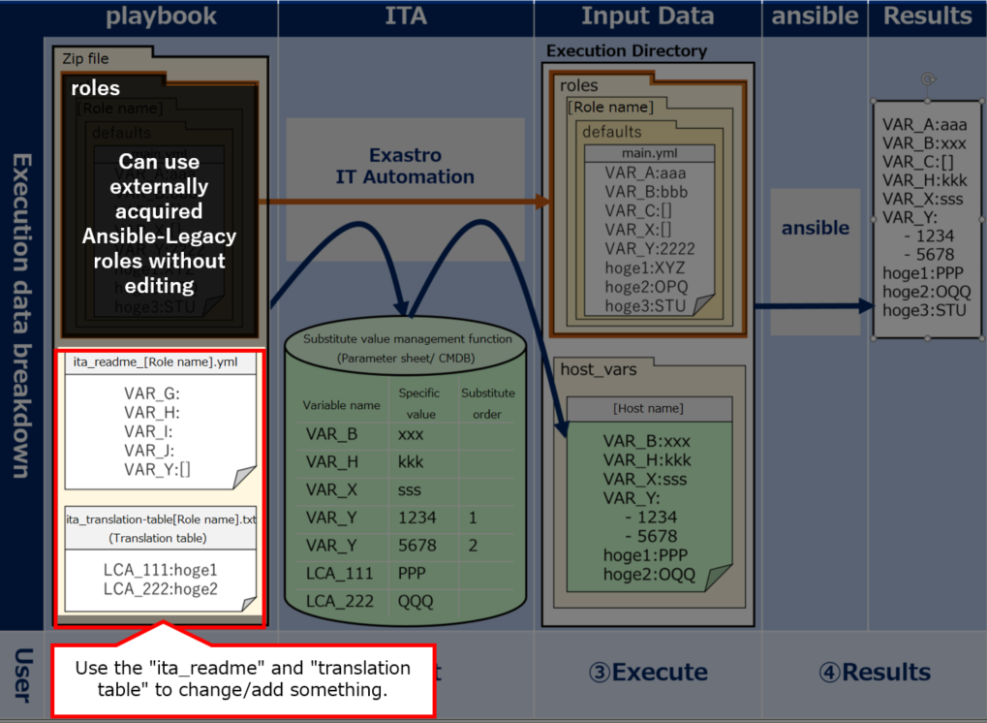

Figure 6.6-2 Case 1

* **Case 2. ita_readme and translation table role**

Both the ita_readme file and translation table are used to send variables/variable types to ITA.

In other words, they are not used to define specific values (Parameters).

ITA will not be able to read any specific values written in them.

Please see the other cases below for information on how to assign specific values.

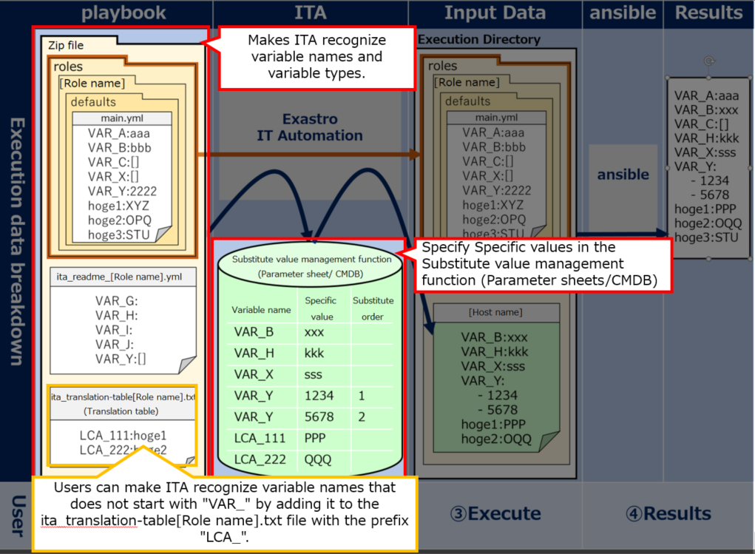

Figure 6.6-3 Case 2

* **Case 3. Variable definitions and default values described in the "defaults/main.yml" file.**

The "defaults/main.yml" file stored under "roles" is automatically passed to ansible.

The file will be automatically sent as long only if no variables or default values are defined in host_vars.(E.g: "VAR_A：aaa").

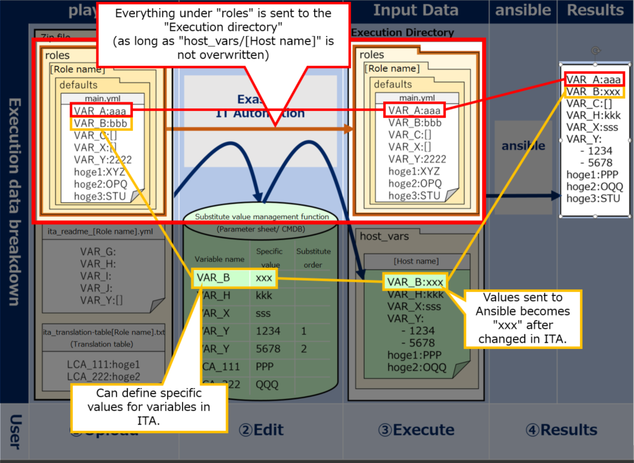 Figure 6.6-4 Case 3

* **Case 4. ”host_vars” files and ITA/CMDB**

Host_vars files are automatically created everytime ITA's CMDB (parameter sheet) executes something.

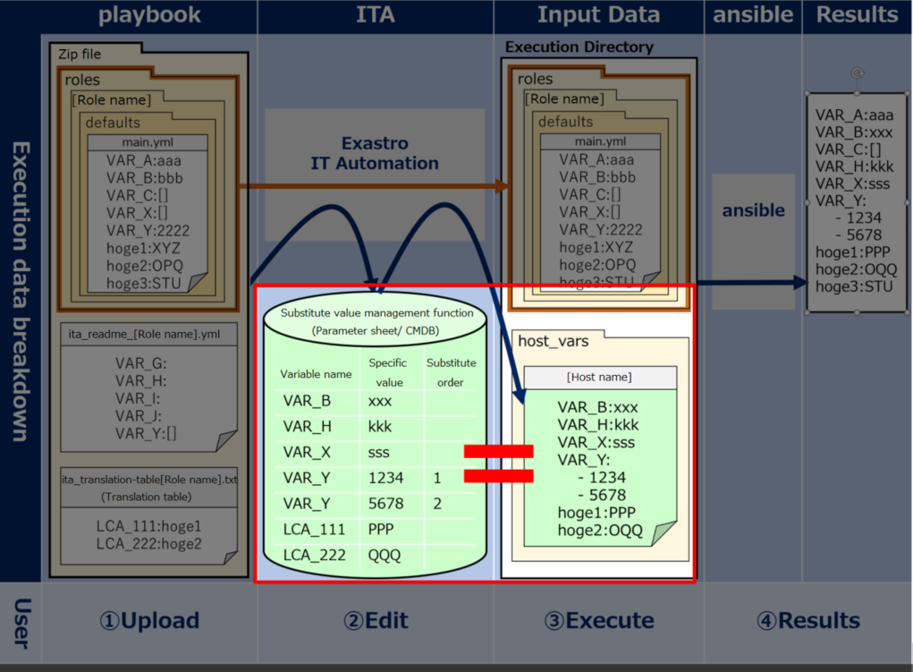

Figure 6.6-5 Case 4

* **Case 5. Adding variables to “defaults/main.yml”**

If you want to add any changes to Ansible-Legacy Role ("roles" directory), users can describe variable names/types in the "ita_readme" file.

Users do not have to define any variables in the ita_readme file that are already defined in the "defaults/main.yml" file.

If there are different definitions for the same variables in the files, the ones in the "ita_readme" file will be prioritized.

※The figure below illustrates that it is possible to add variables by describing a variable(VAR_H) in the ita_readme file

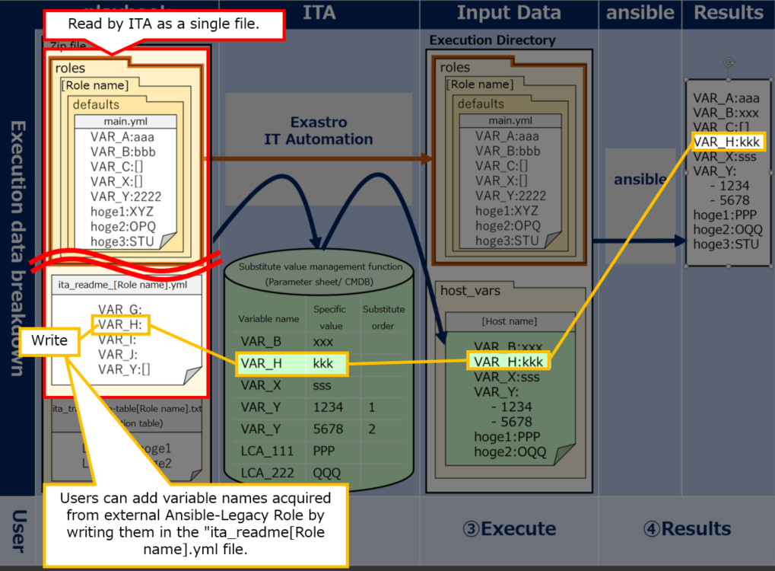

Figure 6.6-6 Case 5

* **Case 6. “VAR_” Prefix**

ITA manages only variables in the "defaults/main.yml" that starts with the prefix "VAR_".

If the user want to manage variables that does not start with "VAR_", use the "Translation table".

Users can define variables that does not start with "VAR_" by writing them in the Translation table and adding prefix "LCA_".

If the user can of course refrain from using the translation table if they want to execute an operation without giving parameters from ITA to "defaults/main.yml" variables (those without the "VAR_" prefix") .

※See the variable "hoge" in the figure below

※Translation tables are only active when they contain a definition that starts with "LCA_".

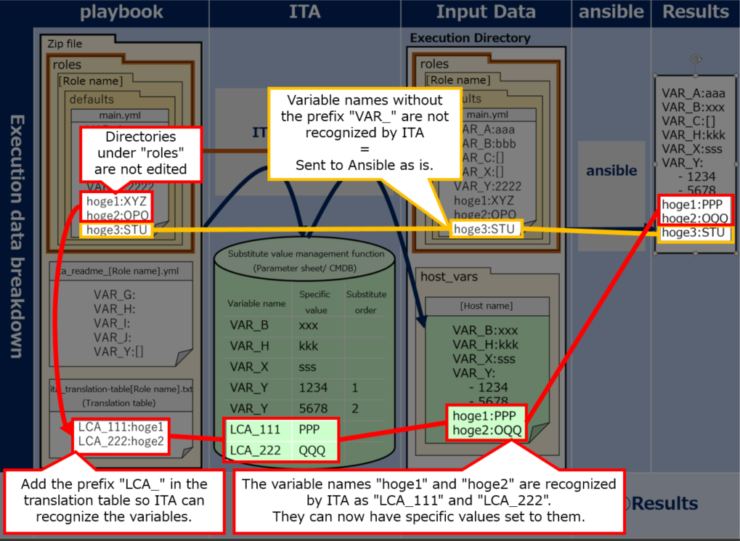

Figure 6.6-7 Case 6

* **Case 7. Linking “ita_readme” and translation table**

Users can give Parameters from ITA to variables in "tasks/main.yml"(Playbook) that does not start with "VAR_" and are not defined in "default/main.yml" by using both the "ita_readme" file and a "translation table".

For example as shown in the figure below, if the "hoge" variable under the "tasks/main.yml" is used, users can follow the following steps in order to send it to ITA.

① Add the variable name "hoge" to the "ita_readme" file.  
② Add the "hoge" to the "Translation table" with the "LCA_" prefix.

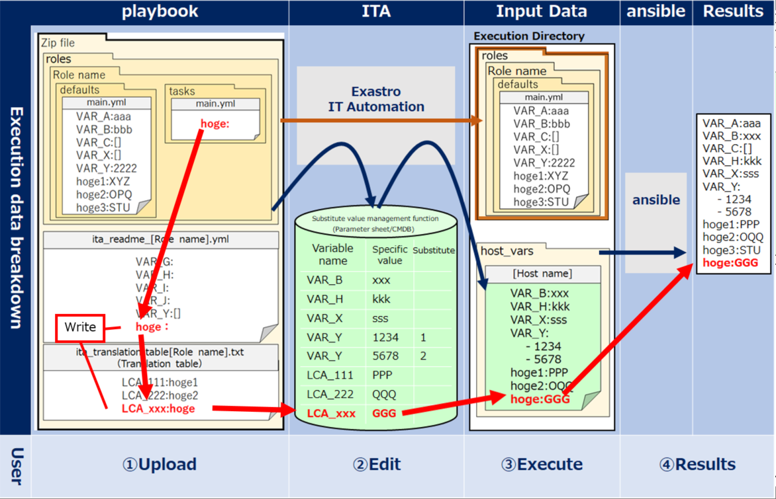

Figure 6.6-8 Case 7

* **Case 8. Applying Playbook Length evaluation**

Depending on whether a variable has a concrete value or not, it can be used as a conditional branch for length evaluation.

For example if "VAR_C：[]" is written in "defaults/main.yml", the length will equal 0 if the operation is executed with no specific value set to "VAR_C".

On the other hand, doing the same with a specific value set will have length be <0 (length<0). (E.g.: VAR_X：sss)

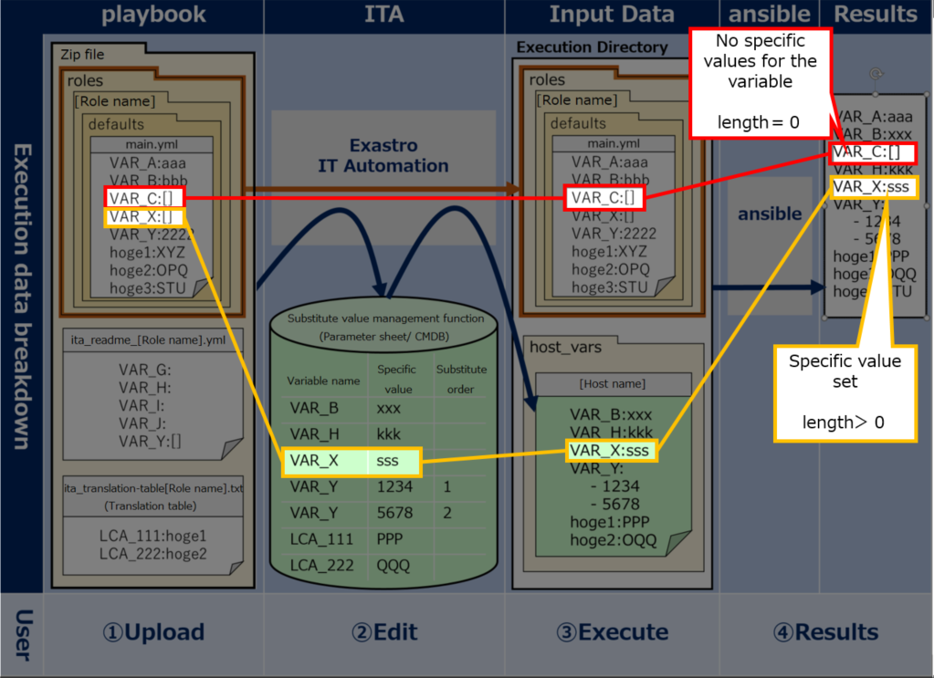

Figure 6.6-9 Case 8

* **Case 9. ：Applying Playbook Defined evaluation**

Depending on whether a variable has a concrete value or not, it can be used as a conditional branch for defined valuation.

For example, first write a definition for the variables "VAR_G" and "VAR_H" in the "ita_readme" file. By doing so, they can be used by ITA's CMDB.

Running an operation without giving a specific value to "VAR_G" while it is not defined in "defaults/main.yml" or "host_vars" will turn "defined" to "false".

On the other hand, if the specific value "kkk" is added to "VAR_H", "defined" will turn into "true".

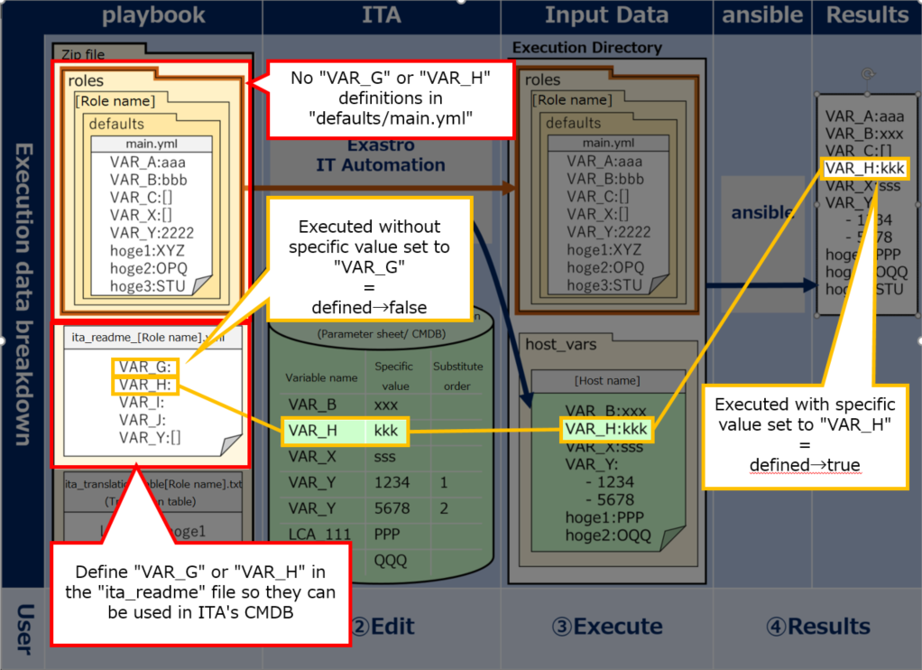

Figure 6.6-10 Case 9

## BackYard contents

1. **Variable auto registration**

When the variable analysis target file is uploaded, extract variable from the uploaded file.

Table 6.6-1 Variable handling of the file uploaded in each mode

|  |  |  |  |
| --- | --- | --- | --- |
| Menu | Legacy | Legacy Role | Pioneer |
| Playbook files | ○ | × | × |
| Role package list | × | ○ | × |
| Dialog files | × | × | ○ |

The extract timing depends on the startup cycle of the automatic process.

※Unique management of variable name

The extracted variable names in all role packages of each mode are uniquely managed.

Since the variable structure is defined in the default variable definition file, the notes when the variable stucture is different in each file are as follows

●Single role package

When using same the variable name between roles with different variable structure.

※In the case that the normal variable and nested variable or the nested structure is different between nested variables, etc.

**=>** Error occurs during file upload.

●All role package

When using same the variable name between role packages with different variable structure.

**=>** Error occurs during file upload.

1. **Substitution value auto-registration setting**

The Operation of parameter sheet and Movement linked with the item setting value of every host and the variable information are reflected to Target host menu and Substitution value list menu as the association target.

The reflection timing also depends on the startup cycle of the automatic process as writed above.

Target host and substitution value list menu is updated by multiple operators. Reflection will not be performed if the last updater is other operator (not Backyard).

When user wants to reflect the data in substitution value auto-registration setting menu, please perform operations such as discard the applicable record in substitution value list value or disable the applicable record in other BackYard process.

The reflection rules to Target host menu and Substitution value list menu are as follows.

1. When reflecting the information registered in substitution value auto-registration setting to substitution value list.

|  |  |  |  |  |  |
| --- | --- | --- | --- | --- | --- |
| **The status of substitution value list** | **Doesn't exist applicable record** | **Exist applicable record** | | | **Applicable record is being discarded** |
| **=** **Specific value** | **≠** **Specific value** | |
| **Last updated by** | |
| **BackYard process** | **Other operators** |
| **Reflection in substitution value list** | Add new record | - | Update the specific value of the applicable record | - | Restore the  discarded record |

※Applicable record: The record that has same Operation+host+Movement+variable name + (member variable)+(include order)

1. When reflecting the information that is not registered in "substitution value auto-registration setting" menu (registered only in "substitution value" menu) to substitution value list

|  |  |  |
| --- | --- | --- |
| **The status of substitution value list** | **Exist applicable record** | |
| **Last updated by** | |
| **BackYard process** | **Other operators** |
| **Reflection in substitution value list** | Discard the applicable record | - |

1. When reflecting the information registered in substitution value auto-registration setting to target host menu

|  |  |  |  |
| --- | --- | --- | --- |
| **The status of operation target host** | **Doesn't exist applicable record** | **Exist applicable record** | **Applicable record is being discarded** |
| **Reflection in operation target host** | Add new record | － | Restore the discarded record |

※ Applicable record: The record that has same Operation+host+Movement

1. When reflecting the information that is not registered in substitution value auto-registration setting(only registered in target host menu) to target host menu

|  |  |  |
| --- | --- | --- |
| **The status of substitution value list** | **Exist applicable record** | |
| **Last updated by** | |
| **BackYard process** | **Other operators** |
| **Reflection in substitution value list** | Discard the applicable record | - |

1. When link to multiple items is registered to for the same Movemeny, variable, and substitution order.

When multiple parameter sheets are linked with same operation and host, one item is selected randomly and reflected to substitution value list.

|  |  |  |  |  |  |  |  |  |
| --- | --- | --- | --- | --- | --- | --- | --- | --- |
| **Parameter sheet: sheetA** | | |  |  |  | **Substitutuion value**  **auto-registration setting** | | |
| **No** | **Operation** | **host** | **Item 1** |  |  | **Parameter sheet** | | **Movement** | **Registration method** | **IaC variable** | |
| **1** | **Op1** | **Host01** | **Value1** |  |  | **Menu** | **Item** | **Value variable** | **Substitution order** |
| **2** | **Op1** | **Host02** | **Value2** |  |  | **sheetA** | **Item 1** | **setting** | **Value** | **VAR_val** |  |
|  |  |  |  |  |  | **sheetB** | **Item 1** | **setting** | **Value** | **VAR_val** |  |
| Since Operation: Op1 amd host: Host01 is linked with multiple parameter sheet, the setting value of the item in the random selected parameter sheet: sheetA is reflected to substitution value list. | | | |  |  |  |  |  |  |  |  |
|  | | | |  |  |  |  |  |  |  |  |
|  | | | |  |  |  |  |  |  |  |  |
|  | | | |  |  |  |  |  |  |  |  |
|  | | | |  |  |  |  |  |  |  |  |
| **Parameter sheet: sheetB** | | |  |  |  | **Substitutuion value list** | | |  |  |  |
| **No** | **Operation** | **host** | **Item 1** |  |  | **Operation** | **host** | **Movement** | **Variable name** | **Substitution order** | |
| **1** | **Op1** | **Host01** | **Value4** |  |  | **Op1** | **Host01** | **setting** | **VAR_val** | **Value1** | |
| **2** | **Op1** | **Host03** | **Value3** |  |  | **Op1** | **Host02** | **setting** | **VAR_val** | **Value2** | |
|  |  |  |  |  |  | **Op1** | **Host03** | **setting** | **VAR_val** | **Value3** | |

## Ansible usage guideline ITA additional rules

A Playbook creation guideline for using ITA to execute on Ansible.

Please refer to the attachment "User Instruction Manual - Ansible-driver attachment- Ansible usage guideline with additional rules" for details.

# Application operation

The operation to utilize ITA system contains not only inputs by user from the browser screen of client PC but also operations according to system operation and maintenance. The available operation and maintenance are as follows.

## Maintenance

The required file to start/stop/restart Ansible driver independent processes are as follows.

|  |  |
| --- | --- |
| **Description** | **Target file name** |
| Legacy/pioneer/legacyRole execution monitor  Execute the unexecuted Operation. | ky_legacy_execute-workflow.service |
| legacy variable automatic registration  Extract variable from the uploaded file. | ky_legacy_varsautolistup-workflow.service |
| legacy automatic registration setting  Reflect the information set in auto-registration setting to substitution value list and operation target host menu. | ky_legacy_valautostup-workflow.service |
| pioneer automatic registration setting  Reflect the information set in auto-registration setting to substitution value list and operation target host menu. | ky_ pioneer_valautostup-workflow.service |
| legacyRole variable automatic registration  Extract variable from the uploaded file. | ky_legacy_role_varsautolistup-workflow.service |
| legacyRole automatic registration setting  Reflect the information set in auto-registration setting to substitution value list and operation target host menu. | ky_legacy_role_valautostup-workflow.service |
| AnsibleTower data synchronization  Obtain setting information from Ansible-tower. | ky_ansible_towermasterSync-workflow.service |

The target files are stored in “/usr/lib/system/system”.

The method to start/stop/restart process are as follows.

Please execute the command with root privilege.

1. Start process

# systemctl start ky_legacy_execute-workflow.service

1. Stop process

# systemctl stop ky_legacy_execute-workflow.service

1. Restart process

# systemctl restart ky_legacy_execute-workflow.service

Please substitute each target file name to start/stop/restart the process.

## About the maintenance method

1. Change to NORMAL level

Rewrite the 8th line of the following file from “DEBUG” to “NORMAL”.  
Log level setting file： <insallation direcotory>/ita-root/confs/backyardconfs/ita_env

1. Change to DEBUG level  
   Rewrite the 8th line of the following file from “NORMAL” to “DEBUG”.  
   Log level setting file： <installation direcotory>/ita-root/confs/backyardconfs/ita_env
2. Change the startup cycle

Change the 5th parameter of ExecStart in each target file. (Unit: second)

Please use the default value of startup cycle excluding exceptions.

ExecStart=/exastro/ita-root/backyards/common/ky_loopcall-php-procedure.sh /usr/local/bin/php /usr/local/bin/php /exastro/ita-root/backyards/ansible_driver/ky_pioneer_varsautolistup-workflow.php /exastro/ita-root/logs/backyardlogs **10** NORMAL > /dev/null 2>&1

After rewriting the file, **the change takes effect after restarting the process.**

Log file output destinaton： <installation directory>/ita-root/logs/backyardlogs

# Appendix

## The linkage between the input data used during Ansible execution and ITA menu

Extract information from each ITA menu and create the "input data" that is required for Ansible execution.At that time, the password in device list menu is encrypted. Ansible-Legacy and Ansible-LegacyRole encrypts with ansible-vault, while pioneer encryptes with the original method of ITA.

The "Input data" can be downloaded from "5.3.12 Check operation status" in ZIP format. Executing the following command in Ansible directly is also possible.

The relationship between various data and the ITA menu is as follows.

### Ansible-Legacy input data

【Parent directory】

|  |  |  |  |  |
| --- | --- | --- | --- | --- |
|  |  |  |  |  |
| **―** | child_playbooks | The directory containing user created Playbooks. | | |
|  |  |  | | |
|  |  | Ansible-Legacy | Playbook files | Playbook file |
|  |  | Ansible-Legacy | Movement details | Include order |
|  |  |  |  |  |
| ― | template_files | The directory containing the template file used in Playbook that is going to be executed. | | |
|  |  |  | | |
|  |  | Ansible-Legacy | Template list | Template file |
|  |  | Ansible-Legacy | Movement details | Include order |
|  |  |  |  |  |
| ― | copy_files | The directory containing the file that is going to be deployed on operation target server. | | |
|  |  |  | | |
|  |  | Ansible-Legacy | Contents list | Files |
|  |  | Ansible-Legacy | Movement details | Include order |
|  |  |  |  |  |
| ― | host_vars | The directory containing the host information of the operation target host and the definition file of various variable. | | |
|  |  |  | | |
|  |  | Ansible common | Global variable list | Variable name/specific value |
|  |  | Ansible-Legacy | Substitution value list | Variable name/specific value |
|  |  | Ansible-Legacy | Template list | Template file |
|  |  | Ansible-Legacy | Contents list | File variable name |
|  |  | Ansible-Legacy | Movement details | Include order |
|  |  | Ansible-Legacy | Interface information | Data relay storage path(ITA) |
|  |  | Ansible-Legacy | Interface information | Symphony instance data relay storage path(Ansible) |
|  |  | Basic console | Device list | Protocol |
|  |  | Basic console | Device list | Login user ID |
|  |  | Basic console | Device list | Login password  ※Encrypted with ansible-vault |
|  |  | Basic console | Device list | Host name |

|  |  |  |  |  |  |  |
| --- | --- | --- | --- | --- | --- | --- |
|  |  |  |  | | |  |
| ― | ssh_key_files | The directory in which the specified ssh authentication key file is stored when using key authentication as the authentication method. | | | | |
|  |  |  | | | | |
|  |  | Basic console | Device list | | | ssh authentication key file |
|  |  |  |  | | |  |
| ― | winrm_ca_files | The directory in which the file that defines the connection information when connecting to WinRM is stored. | | | | |
|  |  |  | | | | |
|  |  | Basic console | Device list | | WinRM connection information | |
|  |  |  |  | | |  |
|  | AnsibleExecOption.txt | Parameter for AnsiblePlaybook execution | | | | |
|  |  |  | | | | |
|  |  | Ansible common | Interface information | | | Option parameter |
|  |  | Ansible-Legacy | Movement list | | | Number of parallel executions |
|  |  |  |  | | |  |
|  | hosts | The file describing the operation execution target host | | | | |
|  |  |  | | | | |
|  |  | Basic console | Device list | | | host name |
|  |  | Basic console | Device list | | | IP address |
|  |  | Basic console | Device list | | | Login user ID |
|  |  | Basic console | Device list | | | Login password  ※Encrypted with ansible-vault |
|  |  | Basic console | Device list | | | Connection options |
|  |  |  |  | ※The parameter of ansible_ssh_extra_args | | |
|  |  | Basic console | Device list | | | ssh authentication key file |
|  |  | Basic console | Device list | | | Server certificate |
|  |  | Basic console | Device list | | | Inventory file additional option |
|  |  |  |  | | |  |
|  | playbook.yml | The file calls the whole information of playbook and host information and executes Ansible. | | | | |
|  |  |  | | | | |
|  |  | Ansible-Legacy | Playbook files | | | Playbook file |
|  |  | Ansible-Legacy | Movement details | | | Include order |
|  |  | Ansible-Legacy | Movement details | | | gather_facts |
|  |  |  |  | | |  |

### Ansible-Pioneer input data

【Parent directory】

|  |  |  |  |  |  |  |
| --- | --- | --- | --- | --- | --- | --- |
|  |  |  |  | | |  |
| ― | template_files | The directory containing the template file used in Playbook that is going to be executed. | | | | |
|  |  |  | | | | |
|  |  | Ansible-Pioneer | Template list | | | Template file |
|  |  | Ansible-Pioneer | Movement details | | | Include order |
|  |  |  |  | | |  |
| ― | copy_files | The directory containing the file that is going to be deployed on operation target server. | | | | |
|  |  |  | | | | |
|  |  | Ansible-Pioneer | Contents list | | | Files |
|  |  | Ansible-Pioneer | Movement details | | | Include order |
|  |  |  |  | | |  |
| ― | ssh_key_files | The directory in which the specified ssh authentication key file is stored when using key authentication as the authentication method. | | | | |
|  |  |  | | | | |
|  |  | Basic console | Device list | | | ssh authentication key file |
|  |  |  |  | | |  |
| ― | winrm_ca_files | The directory in which the file that defines the connection information is stored when connecting to WinRM. | | | | |
|  |  |  | | | | |
|  |  | Basic console | Device list | | WinRM connection information | |
|  |  |  |  | | |  |
| ― | host_vars | The directory in which the host information of the operation target host and the definition file of various variable is stored. | | | | |
|  |  |  | | | | |
|  |  | Ansible common | Interface information | | | Data relay storage path(ITA) |
|  |  | Ansible common | Interface information | | | Symphony instance data relay storage path(Ansible) |
|  |  | Ansible common | Global variable list | | | Variable name/specific value |
|  |  | Ansible-Pioneer | Substitution value list | | | Variable name/specific value |
|  |  | Ansible-Pioneer | Template list | | | Template file |
|  |  | Ansible-Pioneer | Movement details | | | Include order |
|  |  | Ansible-Pioneer | Contents list | | | File variable name |
|  |  | Ansible-Pioneer | Movement details | | | Include order |
|  |  | Basic console | Device list | | | Login password |
|  |  |  |  | ※Encrypted with ITA original method | | |
|  |  | Basic console | Device list | | | Host name |
|  |  | Basic console | Device list | | | Connenction options |
|  |  | Basic console | Device list | | | Protocol |
|  |  | Basic console | Device list | | | Login user ID |
|  |  |  |  | | |  |
|  |  |  | | | | |
| ― | dialog_files | The directory in which user created dialog files is stored. | | | | |
|  |  |  | | | | |
|  |  | Ansible-Pioneer | Dialog files | | | Dialog file |
|  |  | Ansible-Pioneer | Movement details | | | Include order |
|  |  |  | | | | |
|  | AnsibleExecOption.txt | Parameter for AnsiblePlaybook execution. | | | | |
|  |  |  |  | | |  |
|  |  | Ansible common | Interface information | | | Option parameter |
|  |  |  |  | | |  |
|  | hosts | The file describing the operation execution target host | | | | |
|  |  |  | | | | |
|  |  | Basic console | Device list | | | Host name |
|  |  | Basic console | Device list | | | IP address |
|  |  | Basic console | Device list | | | Login user ID |
|  |  | Basic console | Device list | | | Login password |
|  |  |  |  | ※Encrypted with ITA original method | | |
|  |  | Basic console | Device list | | | ssh authentication key file |
|  |  | Basic console | Device list | | | Inventory file additional option |
|  |  |  |  | | |  |
|  | playbook.yml | The file calls the whole information of playbook and host information and executes Ansible. | | | | |
|  |  |  | | | | |
|  |  | Ansible-Pioneer | Interface information | | | Data relay storage path(ITA) |

### Ansible-LegacyRole input data

【Parent directory 】

|  |  |  |  |  |  |
| --- | --- | --- | --- | --- | --- |
| ― | copy_files | The directory in which the file that is going to be deployed on operation target server is stored. | | | |
|  |  |  | | | |
|  |  | Ansible-LegacyRole | Contents list | | Files |
|  |  | Ansible-LegacyRole | Movement details | | Include order |
|  |  |  |  | |  |
| ― | roles | The directory containing the user created role. | | | |
|  |  |  | | | |
|  |  | Ansible-LegacyRole | Role package list | | Role package file (ZIP format) |
|  |  |  |  | |  |
| ― | ssh_key_files | The directory in which the specified ssh authentication key file is stored when using key authentication as the authentication method. | | | |
|  |  |  | | | |
|  |  | Basic console | Device list | | ssh authentication key file |
|  |  |  |  | |  |
| ― | winrm_ca_files | The directory in which the file that defines the connection information when connecting to WinRM is stored. | | | |
|  |  |  | | | |
|  |  | Basic console | Device list | WinRM connection information | |
|  |  |  |  | |  |
| ― | host_vars | The directory containing the host information of the operation target host and the definition file of various variable. | | | |
|  |  |  | | | |
|  |  | Ansible common | Interface information | | Data relay storage path(ITA) |
|  |  | Ansible common | Interface information | | Symphony instance data relay storage path(Ansible) |
|  |  | Ansible common | Global variable list | | Variable name/specific value |
|  |  | Ansible-LegacyRole | Substitution value list | | Variable name/specific value |
|  |  | Ansible-LegacyRole | Template list | | Template file |
|  |  | Ansible-LegacyRole | Movement details | | Include order |
|  |  | Ansible-LegacyRole | Contents list | | File variable name |
|  |  | Ansible-LegacyRole | Movement details | | Include order |
|  |  | Basic console | Device list | | Protocol |
|  |  | Basic console | Device list | | Login user ID |
|  |  | Basic console | Device list | | Login password  ※Encrypted with ansible-vault |
|  |  | Basic console | Device list | | Host name |

|  |  |  |  |  |  |
| --- | --- | --- | --- | --- | --- |
|  |  |  |  | |  |
|  | AnsibleExecOption.txt | Parameter for AnsiblePlaybook execution. | | | |
|  |  |  | | | |
|  |  | Ansible common | Interface information | | Option parameter |
|  |  | Ansible-LegacyRole | Movement list | | Number of parallel executions |
|  |  |  |  | |  |
|  | hosts | The file describing the operation execution target host. | | | |
|  |  |  | | | |
|  |  | Basic console | Device list | | host name |
|  |  | Basic console | Device list | | IP address |
|  |  | Basic console | Device list | | Login user ID |
|  |  | Basic console | Device list | | Login password  ※Encrypted with ansible-vault |
|  |  | Basic console | Device list | | Connection options |
|  |  |  |  | ※The parameter of ansible_ssh_extra_args | |
|  |  | Basic console | Device list | | ssh authentication key file |
|  |  | Basic console | Device list | | Server certificate |
|  |  | Basic console | Device list | | Inventory file additional option |
|  |  |  |  | |  |
|  | site.yml | The file calls the whole information of playbook and host information and executes Ansible. | | | |
|  |  |  | | | |
|  |  | Ansible-Legacy | Playbook files | | Playbook file |
|  |  | Ansible-Legacy | Movement details | | Include order |
|  |  | Ansible-Legacy | Movement details | | gather_facts |
|  |  |  |  | |  |

### Directly executing the input data

(1)Create a directory where the input data will be decompressed.

Create the two following directories and extract the input data into directory 1

1. /Base Directory/Driver path/Operation No./in

2. /Base Directory/Driver path/Operation No./out

　　　　　　Base Directory: Interface information=>Data relay storage path(Ansible/Ansible Tower)

Driver path: 　　　 legacy: legacy/ns　 Legacy-role: legacy/rl pioneer: pioneer/ns

　　　　　　Operation No.:　Number of the Operation when executed. The whole number is 10 numbers. The operation number is then moved to the right and the rest of the numbers are filled with “0”.

Operation No.: 12345 => 0000012345

The input file does not include the secret key file uploaded to the device list.If chosen authentication method requires a secret key file, open the inventory file "hosts" included in the input data and copy the path of the secret key file set to "ansible_ssh_private_key_file".

Inventory file”hosts”  
all:

children:

hostgroups:

hosts:

target_host_1:

ansible_ssh_user: keyauth_user

**ansible_ssh_private_key_file: /exastro/data_relay_storage/ansible_driver/legacy/ns/0000000060/in/ssh_key_files/0000000006-keyauth_user_id_rsa**

(2) Commands that directly executes input data.

Ansible-Legacy

ansible-playbook (Option) –i hosts --vault-password-file Password file playbook.yml

Ansible-Pioneer

ansible-playbook (Option) –i hosts --vault-password-file Password file playbook.yml

Ansible-LegacyRole

ansible-playbook (Option) –i hosts --vault-password-file Password site.yml

The Password file name can be whatever you want.  
The password set in the password file should be the value of the contents of ITA-Installation-directory/ita-root/confs/commonconfs/ansible_vault_accesskey.txt, decoded in the order rot13, base64.

## Result data created during Ansible execution

The result of executing [Input data] with ansible is saved as [Result data] in ZIP format.

[Result data] can be downloaded in ZIP format from "5.3.12 Check operation status".

### Legacy/LegacyRole List of files saved in result data

Table 8.2.1-1 Legacy/LegacyRole List of files where result data is saved

|  |  |  |  |
| --- | --- | --- | --- |
| **File name** | **Record content** | **In Ansible  Engine** | **In Ansible Tower** |
| result.txt | Record the execution checking of Ansible | 〇 |  |
| xxx.pid | A file that records the process ID of the Ansible-playbbok command.  xxx: Process ID of the Ansible-playbbok command | 〇 |  |
| error.log | Error output destination file when ITA outputs an error message due to some error when executing work, or when the Ansible-playbbok command outputs an error message due to some error.  The contents displayed in the error log of work execution confirmation. | 〇 | 〇 |
| exec.log | A log file that is a partial processing of the execution log output by Ansible-playbbok. Contents displayed in the execution log of work execution confirmation. | 〇 | 〇 |
| exec.log.org | Execution log output by ansible-playbook | 〇 | 〇 |
| Ita_<mode name>_  executions_jobtpl_  <execution no.>_<group no.> | Splited execution log file.  For the naming convention of the file name, please refer to ⑥ Execution log display of 5.3.12 Check operation status. |  | 〇 |
| forced.txt | Record file in emergency stop | 〇 |  |
| user_files | The directory where the file is recorded when some kind of file is output to the ITA original variable 「__workflowdir__」 in the executed playbook. | 〇 | 〇 |

### List of files saved in Pioneer result data

Table 8.2.1-2 List of files for which Pioneer results data is stored

|  |  |  |  |
| --- | --- | --- | --- |
| **File name** | **Record content** | **In Ansible  Engine** | **In Ansible Tower** |
| result.txt | Record the execution result of Ansible | 〇 |  |
| xxx.pid | A file that records the process ID of the Ansible-playbbok command.  xxx: Process ID of the Ansible-playbbok command | 〇 |  |
| error.log | The error destination file when the ITA outputs an error message due to some error when executing or if the Ansible-playbbok command outputs an error message due to some error.  The contents will be displayed in the error log of execution confirmation. | 〇 | 〇 |
| exec.log | A log file that is a partial processing of the execution log output by Ansible-playbbok. Contents displayed in the execution log of execution confirmation. | 〇 | 〇 |
| exec.log.org | Execution log output by ansible-playbook | 〇 | 〇 |
| Ita_<mode name>_  executions_jobtpl_  <execution no.>_<group no.> | Splited execution log file.  Please refer to (6) execution log display of 5.3.12 check operation status for the naming convention of the file name. |  | 〇 |
| forced.txt | Record file in case of emergency stop. | 〇 |  |
| user_files | A directory where files are recorded when some file is output to ITA's original variable "__workflowdir__" in the playbook executed. | 〇 | 〇 |

* + - 1. Legacy-Role

Table 9.2.1-3 Legacy-Role list of files where result data is saved

|  |  |  |  |
| --- | --- | --- | --- |
| **File name** | **Record content** | **In Ansible  Engine** | **In Ansible Tower** |
| result.txt | Record the execution result of Ansible | 〇 |  |
| xxx.pid | A file that records the process ID of the Ansible-playbbok command.  xxx: Process ID of the Ansible-playbbok command | 〇 |  |
| error.log | The error destination file when the ITA outputs an error message due to some error when executing or if the Ansible-playbbok command outputs an error message due to some error.  The contents will be displayed in the error log of execution confirmation. | 〇 | 〇 |
| exec.log | A log file that is a partial processing of the execution log output by Ansible-playbbok. Contents displayed in the execution log of execution confirmation. | 〇 | 〇 |
| exec.log.org | Execution log output by ansible-playbook | 〇 | 〇 |
| Ita_<mode name>_  executions_jobtpl_  <execution no.>_<group no.> | This is a divided execution log file.  Please refer to (6) execution log display of 5.3.12 check operation status for the naming convention of the file name. |  | 〇 |
| forced.txt | Record file in case of emergency stop. | 〇 |  |
| user_files | A directory where files are recorded when some file is output to ITA's original variable "__workflowdir__" in the playbook executed. | 〇 | 〇 |